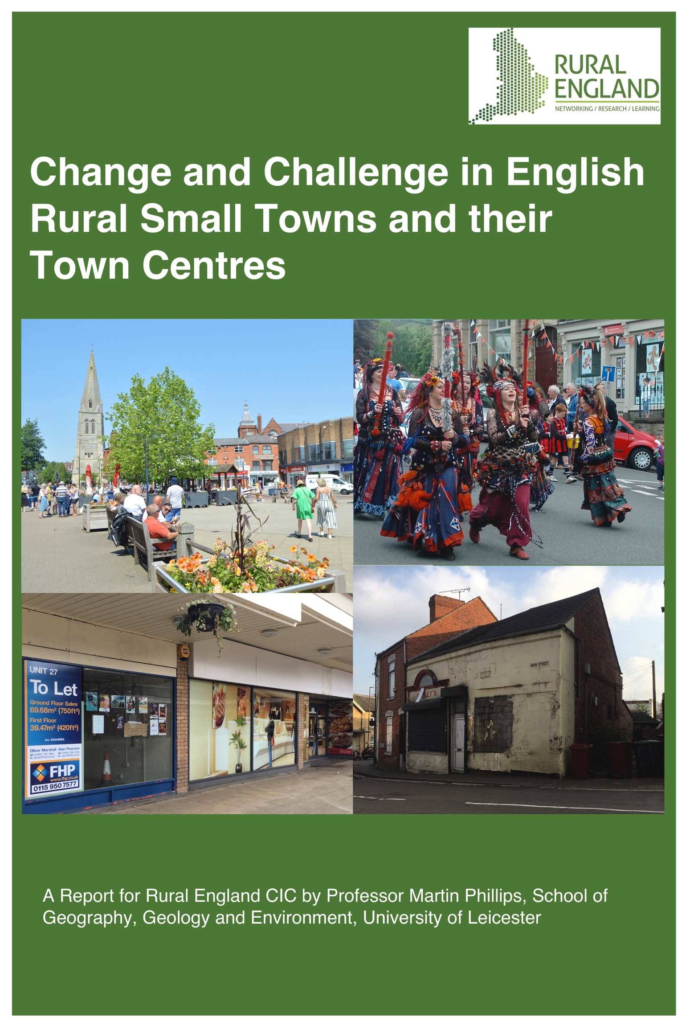

Change and Challenge in English Rural Small Towns and their Town Centres

A Report for Rural England CIC

by

Professor Martin Phillips
University of Leicester

Contents List

List of Figures ii
List of Tables iii
Context v
Summary v
Policy Implications and Recommendations viii
Report on Change and Challenge in English Rural Small Towns and their Town Centres 1
Introduction 1
Context of Study 2
The Delimitation of Small Rural Towns in England. 5
Central Government Support: Analysis of the Towns and Future High Streets Funds 9
The Contemporary Socio-Economic Character of English Small Towns 19
Social inequalities, deprivation and social class differences 19
Change in Small Town Economies 32
Small Towns and the Agricultural Economy 32
Small Towns as Retail and Service Centres 35
Small Towns as Places of Industry and an Emerging Green Economy 43
Small Towns and the Visitor and Creative Economies 48
Socio-Economic Change and Challenge in Rural Small Town Centres 53
Marketplaces and Public Spaces in Small Towns 53
Changing Retail and Service Provision 59
The Small-Town Festival Economies 67
Public and Private Transport 68
Environmental Change, Small Rural Towns and the Green, Hi-Tech Economy 71
The impact of the Covd-19 Pandemic 75
Conclusion and Policy Recommendations 79
Appendix 1: Socio-Economic Indices for Small Towns, including Former Coalfield Areas 85
References 89
Notes 97

List of Figures
Figure 1: Locations Addressed in Questionnaire Responses and Documentary Analysis 2
Figure 2: Built-Up Areas in England with between 1,500 and 40,000 residents, 2011
and 2021 6
Figure 3: Population Distribution of Built-Up Areas with 1,500 to 40,000 Residents, 2021 7
Figure 4: Small Towns in England, 2021, by Rural Urban Classification 8
Figure 5: Population Distribution of Small Towns, 2021, by Rural -Urban Classification 9
Figure 6: LLSOA within Small Towns, by Rural-Urban Classification and Ranking of Indices of Multiple Deprivation 2019 10
Figure 7: Small Towns with LLSOAs in the Highest Decile of Index of Multiple Deprivation
2019 12
Figure 8: Small Towns Eligible and in Receipt of Support from the Towns Fund 13
Figure 9: Small Towns in Receipt of or Applied for Support from the Future High Streets
Fund 16
Figure 10: Small Tows with LLSOAs in the Lowest Decile of the Index of Multiple Deprivation 2019 20
Figure 11: Proportion of Middle-Class Residents in Small Towns, 2021 22
Figure 12: Proportion of Middle-Class Residents in Small Towns with areas in the
Lowest Decile of the Index of Multiple Deprivation 2019 23
Figure 13: Small Towns with High Proportion of Residents 65 and Over 25
Figure 14: Proportion of Self-Reported ‘Non White’ Ethnicities in Small Towns, 2021 28
Figure 15: Population Change in Small Towns. 2011 to 2021 29
Figure 16: Household Change in Small Towns, 2011 to 2021 30
Figure 17: Small Towns with High Proportion of Residents Under 20 31
Figure 18: Percentage Employed in Agriculture, Water and Energy in Small Towns, 2021 34
Figure 19: Retail Provision in 2022 in Two Small Towns in the Borough of Pendle 40
Figure 20: Percentage of People Employed in Public Administration, Education and Health in Small Towns, 2021 41
Figure 21: Percentage of People Employed in Distribution, Hotels and Restaurants in Small Towns, 2021 42
Figure 22: Percentage of People Employed in Manufacturing in Small Towns, 2021 44
Figure 23: Percentage of People Employed in Finance, Real Estate, and Professional and Administrative Activities in Small Towns, 2021 47
Figure 24: Percentage of People Employed in Small Towns within the Arts, Entertainment, Recreation and Other Services,2021 52
Figure 25: Use of Mock Shop Fronts 61
Figure 26: Levels of Broadband Connectivity in Small Towns and Other Settlement Types 73
Figure 27: The Distribution of Small Town Transition Groups in England, by Population
2021 74

List of Tables

Table 1: Built-Up Areas Between 1,500 and 40,000 Residents, by Rural-Urban Classification 7
Table 2: Towns Fund: Prioritisation and Awards 10
Table 3: Future High Street Fund, Successful and Unsuccessful Applications 15
Table 4: Engagement with Central Government Funding Scheme by Small-Town
Administrations 17
Table 5: Maximum and Minimum Indices of Multiple Deprivation 2019 within Small Towns 23
Table 6: Employment in Small Towns, by Economic Activities and Rural-Urban Classification 33
Table 7: Type and Size of Retail Centres in Small Towns, by Rural-Urban Classification 36
Table 8: Extent of Retail Centres in Small Towns, by Rural-Urban Classification 38
Table 9: Small ‘Culture Towns’ Identified in the ‘North Devon Culture Strategy, 2022-2027 50
Table 10: Transition Groups in Small Towns, by Population 2021 74

Context of the Report
The state of rural services has been a topic of considerable concern, not least since the Covid-19 pandemic, which as highlighted in Rural England’s (2022) ‘The State of Rural Services 2021’, created both a series of potentially transformative new challenges and processes of change as well as reinforced some longer running ones. Many of the services used by rural residents are provided from small towns, and this report focuses on assessing the significance of changes and challenges impacting these settlements and their central areas, which have historically been places focused on retail and service provision.
Small rural towns have, however, undergone considerable change in their economic structure over recent decades, linked to declines in activities that historically provided economic rationales for these settlements, such as the sale of agricultural produce, the supply of agricultural goods, and the provision of retail, financial and welfare services to local communities within and beyond their immediate boundaries.
Retailing and service provisions have undergone significant change in small towns since at least the 1990s, with concerns raised about the impact on their high streets of service rationalisation and declinging price competitiveness of their shops as increasing personal mobility encourages travel to ‘out-of-town’ shopping centres, retail parks and outlet stores, which expanded rapidly in number from the 1980s.
In many rural small towns, householders facing poverty and deprivation live in close proximity to households of relative affluence, so average figures often will render them largely ‘invisible’, a point recognised in many policy documents related to small towns and comments from local government officials and representatives working in these settlements. One of those interviewed for this report, for example, remarked that the town they were responsible for had a population that ranged “from out-of-work, on benefits, to the just-about-managing, to the well-off and to wealthy landowners". Another argued,
“Whilst the area is generally wealthy, the town includes two specific areas that appear in the bottom 20% and 30% in the Index of Multiple Deprivation. Recent analysis suggested that child poverty is higher than the national average … deprived areas are surrounded by very wealthy areas”.
This respondent also highlighted some of the multiple forms of disadvantage and deprivation that can exist in rural small towns
“Examples of where this [deprivation] applies are public transport (poor and reducing as most do not use it), housing (prices are significantly above the national average, putting huge pressure on very limited social housing), dentistry (it is in effect impossible to register with an NHS dentist - most dentists appear well-served by wealthier private patients and there is no incentive to accept NHS patients). Wages and job security are poor across significant parts of the economy (seasonal tourism, and hospitality, for example). Schools are satisfactory, but access to post-16 education opportunities is poor. Young people (particularly women) move away from the area post-18 for improved life chances".

Summary of Findings
This report examines the current socio-economic character of rural small towns and the changes and challenges faced by people in these settlements, including those that stem from the Covid-19 pandemic. It focuses particularly on central areas of these towns, and also considers the extent to which their local governments have engaged with recent central government funding initiatives, such as the Towns Fund and Future High Streets Fund, created to support transformations in the economies and central areas of towns.
These central government initiatives do not specifically address the changes and challenges faced by small towns, and as this report shows, they are often structured in ways that effectively exclude many small towns, particularly those with populations under 5,000.
This report discusses the delimitation of small towns in England and employs a classification based on built-up areas that have a population of between 1,500 and 40,000 residents recorded in the 2021 Census. Drawing on data from this Census, as well as other secondary data and published reports, an online questionnaire survey distributed in 2023 to local authority officers and representatives with responsibilities for small towns in England, and interviews with local councillors, officials and charitable bodies in four contrasting small towns, the report discusses the contemporary socio-economic conditions, changes and challenges facing rural small towns in England, particularly regarding their central areas.
The report highlights the presence of high levels of deprivation and inequalities in many small towns, as well as significant socio-economic differences in their populations. High levels of deprivation are particularly prevalent in small towns in coastal and former coalfield areas, with many of these also having a high proportion of residents aged 65 and over. However, different dynamics are often at play in these two sets of towns, with retirement and pre-retirement in-migration often being highly significant in many coastal settlements, but in the former coalfield areas, in-migration is much less substantial, with the dominant dynamic being out-migration of working-age populations. Small towns in former coalfield areas also figure as locations with low numbers of self-reported ‘non-White’ ethnicities in the 2021 Census, although on average only just under 4.4% of the population of small towns so identified. It was, however, notable, that levels of over 13% were evident in many small towns in the South East, around London.
Analysis of the 2021 Census also indicated that many small towns have seen significant rises in household numbers, at the same time as their total populations have declined. This suggests that household size is declining in these settlements, despite claims that household size in the UK is currently quite stable. This difference between small towns and national trends may reflect, first, the significance in small towns of processes that drive declining household size, such as an ageing population and associated increases in single-person and ‘empty nest’ households, limitations in housing availability and an increase in the number of more affluent middle-class households; and, second, the relative insignificance in many of these settlements of dynamics that are increasing household size more generally in the UK, such as heightened international in-migration by young adults. The out-migration of younger people from rural areas is associated, at least in part, with the unaffordability of housing, poor digital connectivity and lack of employment opportunities. It should also be noted that not all small towns have an ageing population, with the report identifying that many small towns in or close to National Landscape Areas in southern England have relatively high proportions of people under 20.
Amongst the challenges facing small rural towns is how to adapt to changes in their economic function, such as declines in marketing and supply roles within agriculture and retail and service provisioning of populations within and beyond their bounds. High street bank closures and reductions in public transport both have significant impacts on footfall and therefore the viability of smaller rural market towns. The report demonstrates the relative insignificance of agriculture-related employment within many small towns, although points to its continuing economic significance in a small number of food-processing centres, as well as the significance of agricultural markets to the place identities and built fabric of many small towns. Marketplaces and halls in many small towns have ceased to function as agricultural markets, and many are little used and falling into disrepair, as are many other public buildings, such as town halls, libraries, fire and police stations, hospitals and churches. This loss of functionality and poor physical condition poses major challenges to local councils with responsibilities for these buildings, as well as creating significant service accessibility problems for local residents.
The bulk of retailing in small English rural towns appears to be provided by businesses that lie towards the smaller and localised end of a retail spectrum, often characterised and valued as dominated by independent retailers, although the report highlights evidence of considerable variation and turnover within small-town retailing.
The impacts of changes in the retail sector are also examined, including the rise of online and out-of-town retailing. These are widely viewed as posing significant challenges to face-to-face retailing, and an important contributor to both the presence of vacant premises within many small-town retail areas and shops that come to be occupied by a series of independent retailers who struggle to maintain viability. Attention is also drawn to the lack of retail and service provision in many new-build housing areas within and around small towns.
A range of responses to retail-store closures in central areas of towns have been advanced, and in small towns these seemed to often focus on improving the visual appearance of shops and the public realm in retail areas, in the hope that this helps support existing retail and attracts new stores. In many small rural towns an emphasis is often placed on the role of the visitor, food and creative economies in generating retail business, as well as these sectors also potentially contributing to a repurposing of retail premises to other uses.
A striking element in attempts to diversify the economy and use of buildings in small rural towns was engagement with a festival or event economy. Many small towns have established a series of festivals or other events across the year, themed seasonally and/or around local historical events and activities. These were viewed as supportive of a visitor, and thereby retail economy, as well as fostering local creative and agri-food businesses, and, in many cases, the conservation of historic built environments and buildings, including marketplaces and halls.
Many local authority officials and organisations with responsibilities for economic development in small towns viewed visitor and creative economies as key contributors to their current and future economies. The extent to which these views reflect current and planned conditions in all these towns is questionable, as many of these officials and organisations also referred to weaknesses in the development of these economies or present them as desired, but not currently realised, elements. It is also suggested that the development of creative economies might be conditioned by two different forms of migration, with some locations being sought out by artists and others seeking a remote rural escape whilst other settlements are valued because they provide connectivity to urban cultural centres, alongside a rural amenity setting. Rural locations which fall outside of these requirements may struggle to establish a creative economy.
The report also identifies two other economies as significant in English small rural towns. The producer-services economy relates to the provision of banking, finance, marketing, research and design, and property management and other services, to businesses rather than consumers. In England, such services have historically been concentrated in London and the South-East, although it has been suggested they have dispersed since the 1970s to encompass small towns with commuter access to London, including towns in northern England with a pre-industrial character. Towns linked to this economy are likely to have highly affluent residents, although they may be surrounded by settlements that have populations on much lower incomes.
Small rural towns have also long been sites of industrial manufacture, and this remains significant in many, particularly within northern and eastern England and the Midlands. New industrial businesses have been able to draw on the legacies of earlier and wider industrialisation, including access to nearby industrial businesses and residential consumers, workers skilled in industrial production, and, in some instances, properties or brownfield sites released by the closure of industrial firms. These properties include some in industrial estates set up in the mid-twentieth century to attract firms to locate in rural areas, which have now, in some cases, become underused and dilapidated, or the focus of redevelopment activities to establish new buildings focused around attracting firms in hi-tech, sectors, including green, digital and creative economies.
A striking feature of many local, neighbourhood and town plans produced for small towns is the significance given to issues of environmental sustainability and climate change. In part this may relate to concerns about the scale and frequency of flood events that could potentially impact these settlements, and associated needs to establish local adaptation measures. However, much more widespread were references to developing a green economy in small towns.
The report also examines the short- and long-term economic impacts of the Covid-19 pandemic in small rural towns, particularly in relation to town centre retailing. While some small towns had experienced significant declines in tourist visitors and retail footfall, and resultant closures of some businesses, in many cases pandemic impacts had been short-term and many small-town economies bounced back to close to their pre-pandemic state, and the pre-existing challenges associated with these. The long-term impacts of the pandemic may, hence, have been to exacerbate existing processes of transformation, and clearly have also become entangled with subsequent events and pressures, including rising prices and restrictions on government spending and activity.

Policy Implications and Recommendations
It is clear that central government and many local authorities recognise that towns are experiencing both short-term and longer-term changes and challenges. This report, however, has highlighted that small towns are often effectively excluded from accessing central government support. One key aspect of this is the delimitation and categorisation of towns, with classifications employed by central government, such as ONS (2019), excluding almost 63% of the built-up areas defined in this study as small towns. Population thresholds used as the basis for settlement categorisations have clearly been of considerable financial significance in recent central government initiatives, and one implication of this report is that more attention should be given to the appropriateness of current thresholds, and also to variations in the conditions and challenges faced by settlements of different sizes. Currently, there is also often little explicit policy differentiation between types of towns, although this report has reinforced the arguments of the National Audit Office (2020) that award decisions in the Towns Fund may have drawn on implicit assumptions about the relative needs of certain types of towns. This report, for instance, highlights how awards in both the Towns Fund and Future High Streets Fund were heavily focused on small towns in coastal and former coalfield areas, as well as how few small towns were selected.
The report also highlights concerns about a lack of direct access to central government funding by town and parish councils, and a consequential reliance on the recognition of the needs of small towns by higher levels of local government, which is often either not present or is marginalised by concerns related to other settlement needs within these authorities. There was also widespread concern over the general lack of central government funding to local governments, and consequential reductions in public service provision and employment within small towns. Not only are the capabilities of local governments to act in small towns being reduced by financial restrictions, but these reductions can themselves have direct and significant adverse impacts on the economic and social conditions of small towns.
One area of impact highlighted in this study is the closure and/or lack of maintenance of public buildings, many of which are major physical and symbolic entities in the built environments of small towns. This report indicates that in many small towns, a range of public buildings have become dilapidated and/or ceased to be used, such that their future condition is a focus of concern and deliberation. The poor physical condition of these buildings often stemmed from insufficient investment in maintaining and repairing the buildings, but the costs of renovation and refurbishment, let alone repurposing and redevelopment, are often beyond the current financial capacity of local councils, although many had prepared plans and were seeking sources of finance from governmental, charitable and private development sources.
A continuing lack of investment in public buildings is likely to increase problems surrounding their physical condition, while cuts and spatial rationalisations in public service provisions are likely to induce further declines in their use within small towns. This means current problems over their maintenance and use are likely to increase in the future, suggesting that a governmental policy response would be of value. Furthermore, the impacts of service closures within small towns needs to be recognised, with concerns being expressed in many places about their impacts, particularly on vulnerable groups. The involvement of private developers and the repurposing of buildings away from public service provision, towards use as private housing or within creative, food, festival and visitor economies, raises issues of gentrification and displacement which also warrant policy recognition.
It is evident that many local authorities with responsibilities for small towns, view the creative, food, festival and visitor economies as central components of their future development, although this report also highlights that opportunities for developing these may be limited for some groups of small towns. However, more widespread opportunities may lie in the green economy, which figures as an aspiration within many plans related to small towns.

Report on Change and Challenge in English Rural Small Towns and their Town Centres

Introduction
The State of Rural Services 2021 (Rural England 2022) highlighted changes in retail and service provision in rural areas, caused in part by the Covid-19 pandemic and associated measures to restrict mobility and social interaction, as well as longer running processes. This report examines the provision of Government support to small rural towns, that have long been viewed as key locations for the provision of such services to rural areas, but have also been seen as settlements experiencing considerable socio-economic change, including some related to the Covid-19 pandemic as well as longer running changes in employment, retail and service provisions. The report will particularly focus on changes in the central areas of these towns, and the impacts that change within these areas has on particular socio-economic groups within and beyond these towns. It will also consider the extent to which local authorities, business and community groups have engaged with central government funding initiatives, and identify policy lessons and recommendations for addressing the challenges facing particular groups of small rural towns.
The report begins by briefly considering existing research on small rural towns and UK policy initiatives that in recent decades have highlighted the socio-economic changes experienced in these settlements. It will then discuss the delimitation of small towns in England and explore the distribution of Government support to these settlements through two recent funding schemes – the Towns Fund and Future High Streets Fund – before presenting the results of an extensive analysis of their socio-economic character based principally on data from the 2021 Census. It will draw on the results of an online questionnaire survey distributed in 2023 to local authority economic development officers, local economic partnerships and to town and parish councils of a selection of small towns in England, as well as a series of localised studies and reports on settlements identified as small towns. The questionnaire was distributed via the Rural Service Network's (RSN) 'Market Town Group' and the Principal Councils in RSN membership, as well as through emails to Local Economic Partnerships and to local authorities and town and parish councils. Figure 1 shows the towns for which documentary information was gathered or for which there was a questionnaire response. Following the analysis of this material, interviews were conducted in four contrasting towns, and some of these interviews are also incorporated into this report.
The specific objectives of the research discussed in this report were to produce better understandings of:
- The contemporary socio-economic conditions and challenges facing rural small towns in England, particularly with respect to their central areas;
- The extent to which the Covid-19 pandemic has exerted lasting impact on small towns, particularly in relation to retail and service provision;
- The degree to which local authorities, businesses and community groups have engaged with central government funding initiatives;
- Local policies, initiatives and actions that have emerged to address some of the challenges facing small rural towns, and/or capitalise on their assets and potential.

Figure 1: Locations Addressed in Questionnaire Responses and Documentary Analysis
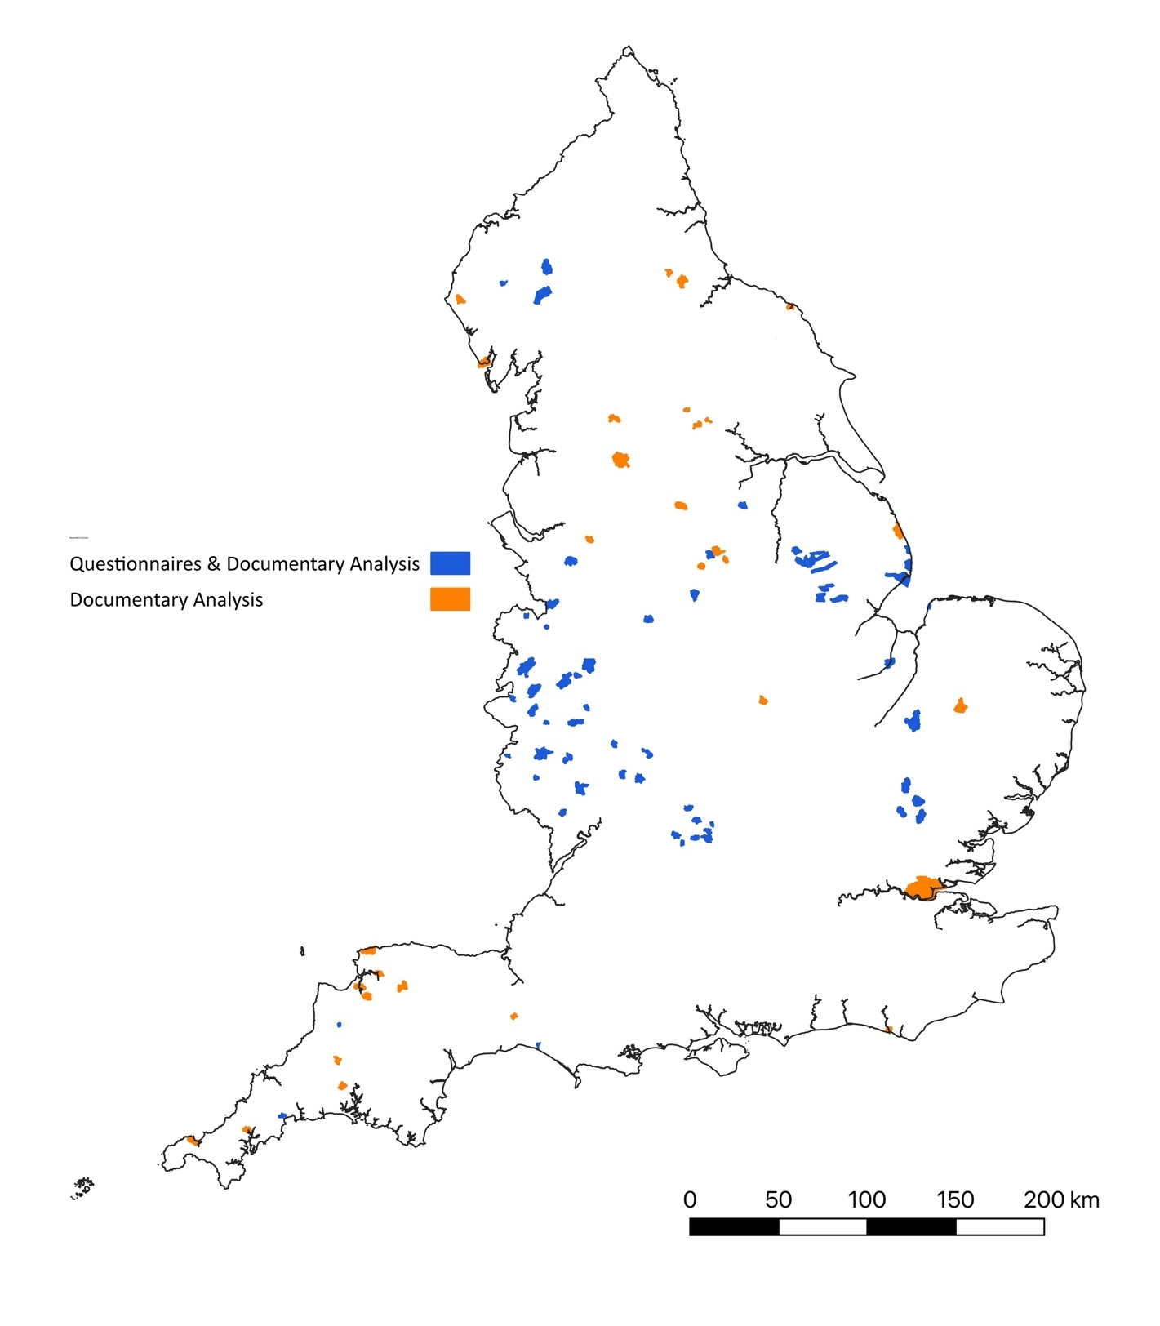
Context of Study
The socio-economic fortunes of rural towns have long been a subject of concern. In 2001, for example, a ‘Market Town's Initiative’ was launched by the Countryside Agency, following the Labour Government’s 2000 Rural White Paper that expressed concern about the future of rural towns. Subsequent research highlighted variations between rural towns, with studies recognising both economic decline and growth (e.g. Courtney and Errington, 2000). Accounts of the former frequently stressed declines in historically important functional roles within rural economies, such as these towns’ roles as sites for the sale of agricultural produce and the supply of goods to agriculture, as well as centres for the provision of retail, financial and welfare services to surrounding rural hinterlands (e.g. Courtney and Errington, 2000; Powe and Shaw, 2004). Changes in agri-food distribution and service rationalisation by government and private sector businesses, as well as the rise of out-of-town shopping centres, led to significant reductions in the performance of service functions by many small rural towns, although heightened personal mobilities also encouraged a "diverse range of firms and individuals" (Courtney et al. 2007: 1219) to move into some of these settlements. Such movements, along with tourism, often fostered economic vibrancy in some small rural towns, and in some cases also fostered a ‘multi-branch economic structure’ (Bański, 2022: 16), although, conversely, where movements of people were unaccompanied by business establishments, rural towns were often transformed into so-called dormitory settlements (Smith 2017).
The forces of change in the 2000s continue through to the present, although they have also been supplemented by further transformations that have impacted these, and many other settlements as well. These additional drivers of change include the rise of internet shopping, which received a significant boost via the Covid-19 pandemic and associated restrictions on physical mobility and social congregation. Florida et al (2021: 3) have argued that the pandemic forced experimentation in "employment, shopping, workplace and residential choice", which will "leave a legacy" on how these activities are conducted into the future. These legacies might include greater use of local stores and migration from cities to smaller towns, both of which may benefit rural towns. However, the pandemic has also been seen to represent a further challenge to the future of the retail 'high street', which has been seen as being in crisis in many areas of the UK since the financial crisis of 2007-8 (Hubbard 2017).
There have hence been calls to rethink the function of central areas of towns, turning them more into recreational and amenity destinations, as reflected in the Government's 'Build Back Better High Streets Strategy', which refers to supporting "the evolution of high streets into thriving places to work, visit and live" (MHCLG, 2021; Grimwood et al. 2021). In the early 2020s the Government also established a series of related strategy documents and funding channels, including the ‘Reopening High Street Safely Fund’ (DLUHC, 2020), the ‘Welcome Back Fund’ (DLUHC, 2021b), ‘Hospitality Strategy: Reopening, Recovery, Resilience’ (BEIS, 2021) and ‘Build Back Better High Streets’ (MHCLG, 2022). In 2023 the Government also published ‘Our Long Term Plan for Towns’, which contained references to towns having “high streets lined with empty shops and neighbourhoods scarred by crime and anti-social behaviour”, a jobs growth rate since the financial crisis of “half of that in cities, and a quarter of that in London”, and a perception amongst “Generations of young people … that the only way to get on, is to get out” (DLUHC, 2023: 4). This plan also announced the formation of a ‘Towns Taskforce’, reporting directly to the Prime Minister, as well as describing: i) the delivery of a ‘Towns Fund’, “to drive economic and productivity growth” in 101 English towns; ii) an associated ‘Future High Streets Fund’, to support the creation of “thriving high streets in the future”; iii) a ‘Levelling Up Fund’ to support local “regeneration, town centre improvements, transport, and culture projects”; iv) further support available through a ‘UK Shared Prosperity Fund’, ‘Levelling Up Partnerships’, a ‘Community Ownership Fund’, a ‘Coastal Communities Fund’, and a ‘High Streets Task Force’ (ibid.: 4-11). The opposition Labour Party has also produced a ‘5-Point Plan to Breathe Life into Britain’s High Streets’, focused on supporting small independent businesses by speeding up payments to them by large businesses and replacing business rates with a system of business property taxation more favourable to high street businesses, plus strengthening community right to buy empty town centre properties, creating ‘banking hubs’ to guarantee face-to-face banking in retail high streets, and also increasing the number of neighbour police and police community support officers to assist in reducing anti-social behaviour and shoplifting.
This range of schemes might suggest that considerable central government support is being provided or planned to support small towns, not only economically but also in relation to transport and communication infrastructure, and socially and culturally, However, funding currently is often distributed on a competitive basis, with many more locations failing to receive awards than are granted support, and neither the Government or opposition party plans include any specific focus on small towns. This is despite there being evidence that rural areas in general receive lower levels of government funding per head than regions with extensive urban settlements (Pragmatix Advisory, 2021). Furthermore, questions have been raised about the distribution of these funding schemes, with the House of Commons’ Public Accounts Committee suggesting that the selection rationale employed by the Ministry of Housing, Communities and Local Government in the Towns Fund appeared to be “vague and based on sweeping assumptions”, with this acting to create “accusations of political bias in the selection process” (House of Commons Public Accounts Committee, 2020: 3). The Committee further argued that it was “still far from clear what impact the Department expects from the Towns Fund, when it expects to see the benefits, and how it will measure success both at the town level and across the whole programme” (ibid.). Focusing more specifically on the rural dimensions of the Towns Fund, the Rural Services Network (2021b: 5) argued that the approach used by the Ministry “was patently unfair towards smaller (rural) towns”, highlighting four major limitations in the methodology employed, including that it automatically placed towns with populations of less than 15,000 population in a ‘low priority’ category and that towns with populations of 5,000 people or less were completely excluded from the scheme despite these being “essential employment and service centres in many rural areas”.
The impacts of the pandemic and other forces of change have been variable (e.g. Rural England 2022), with there not only being spatial variations between different places but also inter-sectorial variations. It has, for instance, been identified that pubs, cinemas, theatres, and music venues may have been particularly impacted by the pandemic, as were rural bus services, which might act to further undermine rural town servicing of a hinterland. However, there has hitherto been little research addressing the distribution of such changes or the extent to which policies to mitigate or minimise them have been implemented. Recent rises in energy and supply prices, alongside rising living costs, are also likely to provide a further challenge to many businesses, and may particularly impact those located in rural settlements, including small towns.
Overall, it appears that many towns have been experiencing a series of long-term transformations, as well as some shorter-term challenges linked to the Covid-19 pandemic and various economic crises, including recent energy and supply-price increases. However, the transformations and challenges do not impact all towns equally, with some locations potentially experiencing considerable economic and demographic growth, whilst others are subject to processes of long-term economic decline and out-migration. Whilst there has been policy recognition of the changes and challenges facing town-centre areas, the degree to which effective measure responses have reached rural small towns appears highly uncertain.

The Delimitation of Small Rural Towns in England
As highlighted in the above discussion of the Towns Fund, the delimitation of settlements can have significant funding implications. In relation to the identification of small rural towns, a range of different categorisations have been employed.
For example, the Defra/ONS Urban Rural Classification (Defra 2017b) delimits rural settlements (including rural towns) as having populations below 10,000, although in its local authority variant, so-called 'hub towns' of between 10,000 and 30,000 people are included in the definition of rural, providing they have the potential to act as business and service centres for a surrounding rural area (Defra 2017a). Earlier, DETR/MAFF (2000) suggested a boundary of 2,000-20,000 for ‘rural market towns’, while the House of Commons Library recently developed a settlement classification that included a delimitation of ‘small towns’ as having a population range of 7,500 to 24,000 (Baker, 2018). A year later, ONS (2019) identified small towns as having a population of 5,000-20,000, with this classification being employed in the Towns Fund, although, as noted previously, its lower limit was criticised as being too high by Rural Service Network (2021b).
A larger population span, extending the range at both the upper and lower ends, was employed by Shepherd (2009), who used population thresholds of 1,500 and 40,000 to delimit 1,607 'smaller towns'. Shepherd’s categorisation can be seen to encompass all of the other definitions, extending the population boundaries to both encompass Defra’s ‘hub towns’ and slightly smaller settlements than those included in DETR/MAFF (2000). It was, therefore, decided that Shepherd’s classification would be used in this study.
Employing a similar methodology to Shepherd for the 2011 Census, whereby the populations of formally designated ‘built-up areas’ (or BUAs) are used to delimit the settlements for study, produced a figure of 1,598 ‘small towns’ within England, which is reduced to 1,562 when the maximum is reduced to 30,000. Employing it with the 2021 Census resulted in a figure of 2,456 locations within England, which was reduced to 2,378 when the maximum is reduced to 30,000. This represents an increase in the number of recorded built-up areas of 54% or 52% respectively (see Figure 2), although much of this increase stemmed from changes in the classification of these areas between the 2011 and 2021 Censuses, with the latter often disaggregating built-up areas recorded as single areas in the previous Census, even when these areas have contiguous boundaries.
Figure 2: Built-Up Areas in England with between 1,500 and 40,000 residents, 2011 and 2021
2011 2021
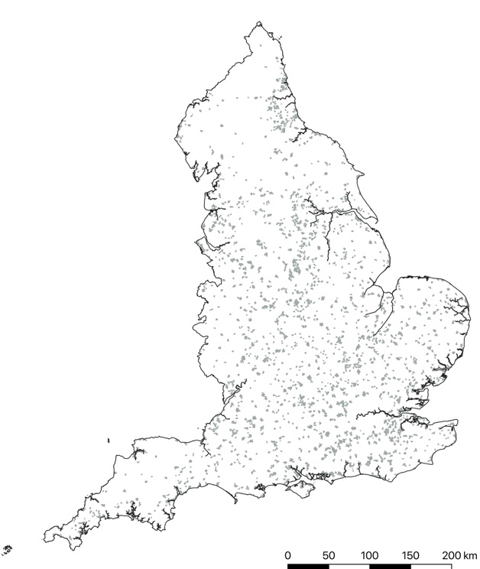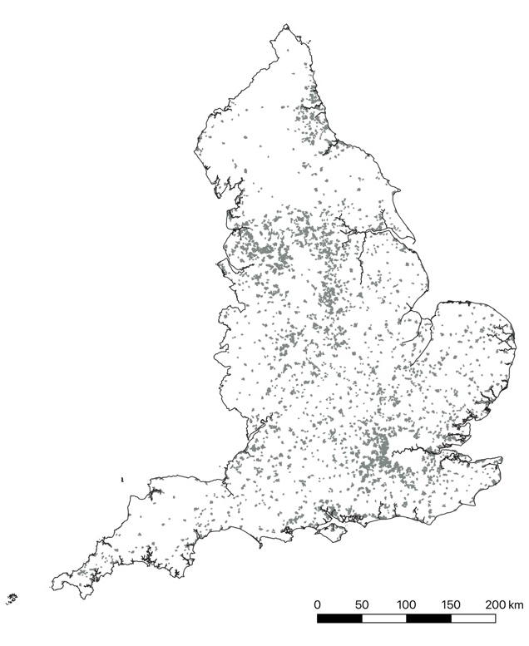

These changes in the delimitation of built-up areas create problems when using population cut-offs, as an area previously deemed to have a population of, say, over 40,000, might now appear as a series of smaller areas each with populations under 40,000. To address this, areas which were categorised as a single built-up area in 2011 with a population of over 40,000, were removed from the analysis of 2021 small towns. This reduced the number of distinct built-up areas with populations of between 1,500 and 40,000 in 2021 to 1,747. This is still just over 9% higher than the 2011 figure, with some of this increase being clearly still related to the disaggregation of 2011 built-up areas into smaller component areas in the 2021 classification, although there are also some areas of new-build settlement. Conversely, there were 73 built-up areas with a population of over 1,500 in 2011 but which in 2021 had a population of less than this lower threshold, and hence disappear from the 2021 map.
As Figure 3 shows, the population of settlements between 1,500 and 40,000 residents, which hereafter will be taken as constituting small towns, was heavily skewed towards those at the bottom of this range, with almost 63% of these places having a population of under 5,000 and almost 33% having a population of under 2,500. These findings highlight the significance of lower population thresholds, with the 5,000 population threshold employed by the ONS (2019) and the Towns Fund, omitting over 1,540 locations included in Figure 3.

Figure 3: Population Distribution of Built-Up Areas with 1,500 to 40,000 Residents, 2021
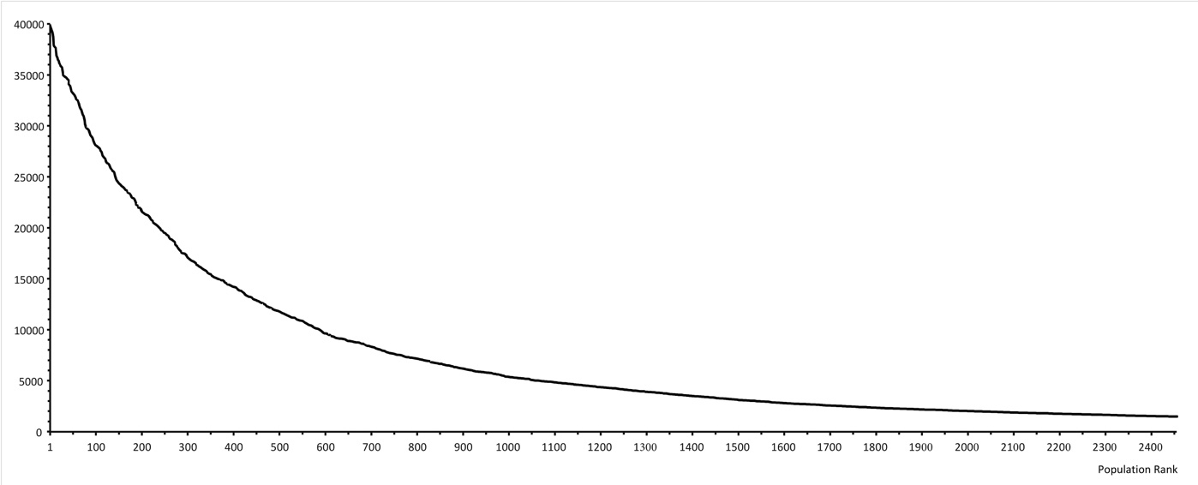

Table 1: Built-Up Areas Between 1,500 and 40,000 Residents, by Rural-Urban Classification*
Population | Urban major conurbation | Urban minor conurbation | Urban city & town | Rural town & fringe | Rural village | Total
30,000-40,000 | 1 |  | 24 |  |  | 36
20,000-29,999 | 6 | 2 | 66 |  |  | 85
10,000-19,999 | 6 | 5 | 160 | 16 |  | 183
5,000-9,999 | 8 | 6 | 66 | 282 | 2 | 290
2,500-4,999 | 8 | 1 | 61 | 452 | 5 | 471
1,500-2,499 | 2 | 2 | 49 | 495 | 22 | 533
Total | 31 | 16 | 426 | 1245 | 29 | 1598
Note: * In this table the sparsity distinction in the Rural-Urban Classification has not been used, because these constituted less than 3.5 % of the areas.

Table 1, and Figures 4 and 5, show the distribution of the small towns according to the 2011 Defra/ONS Urban Rural Classification. The results of this analysis included:
- that, as might be expected, the vast majority of the built-up areas with populations over 10,000 were classified under one of the urban categories, with over 87% of these falling in the Urban City and Town Category, although over 4.5% also fitted in the Urban Major Conurbation category, reflecting settlements in areas around the major conurbations of Greater London, Greater Manchester, Liverpool, Tyneside, West Yorkshire, the West Midlands and Bristol;
- these locations also figured in settlements with populations below the 10,000 threshold that appear in the Urban Major and Urban Minor Conurbation categories;

Figure 4: Small Towns in England 2021, by Rural Urban Classification
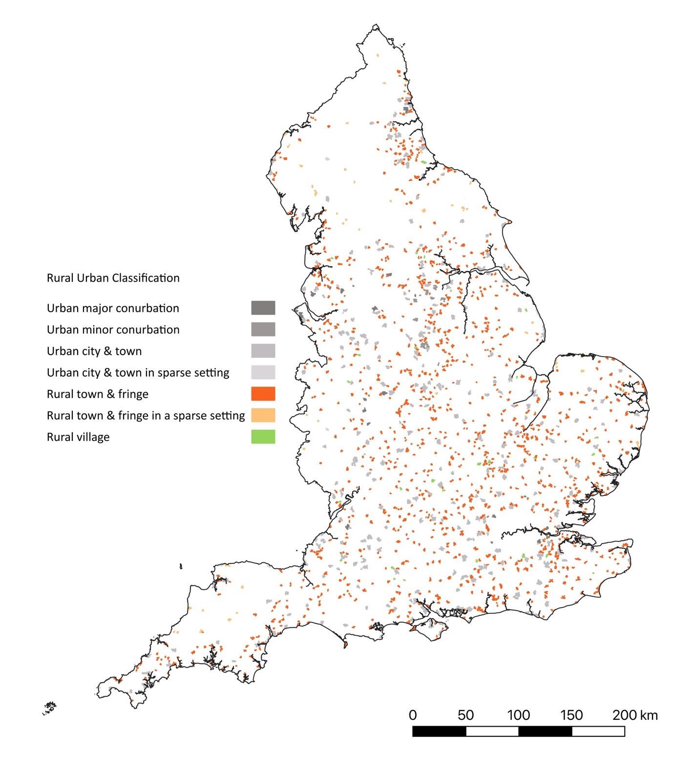

- the small-town settlements in the ‘Urban City and Town’ category were distributed much more widely across England, as were those classified as ‘Rural Town and Fringe’ (16 built-up areas with populations over 10,000, were classified in this last-named category, with 4 being settlements whose populations had reached this threshold only in the 2021 Census, and hence were unsurprisingly classified using in the non-urban category in 2011, while the 23 others all had population numbers of below 15,000. Given their proximity to the urban population threshold, it is likely that their non-urban classification reflected the inclusion of surrounding rural areas within either the spatial classification and/or the calculated population figures);
Figure 5: Population Distribution of Small Towns, 2021, by Rural -Urban Classification

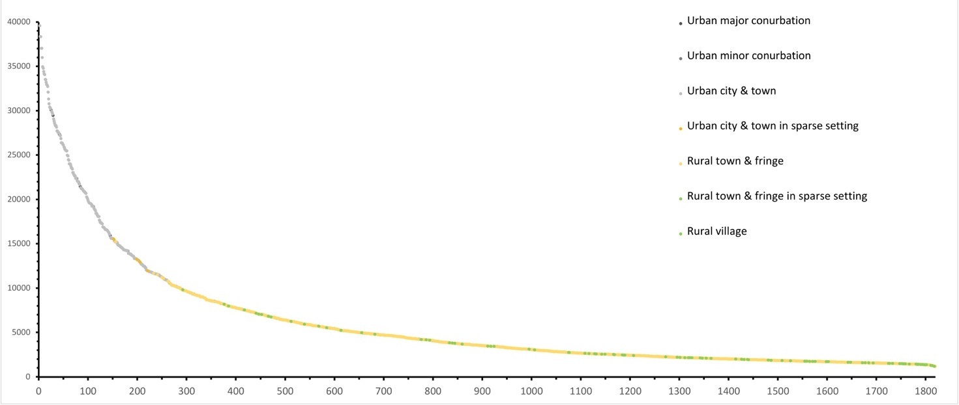

- below the 10,000 threshold, almost 84% of settlements were classified as Rural Town and Fringe, although in those with a population of below 2,500, this increased to almost 86%, even if there were still almost 4.5% Urban City and Town in this lowest population category;
- all of the settlements classified as Rural Village had a population of under 10,000, as would be expected, with over three-quarters of these settlements having a population in the smallest category.
Overall, the analysis suggests that the adopted approach provides a reasonable method of settlement classification. While the rural categorisations of Defra (2017b) figured only in settlements with populations of under 20,000, this is to be expected given the 'hub town' category was only employed in the locality classification and not the more spatially refined output area classification used in this analysis. The approach employed clearly identifies the large number of settlements in rural areas of England that have populations below the thresholds of town employed by Baker (2018 and ONS (2019), which is highly significant given the employment of the latter in the distribution of the Government’s Towns Fund, as issue explored in the next section.

Central Government Support: Analysis of Towns and Future High Streets Funds
As already mentioned, there has been some controversy surrounding the allocation processes employed in recent Government initiatives designed to provide support to towns in relation to both the impacts of the Covid-19 pandemic and longer-running transformations in the retail and service economies, including claims that schemes such as the Towns Fund, exclude many small rural towns. Table 2 shows the allocation of funding in this scheme to towns that fall within the criteria of small towns employed in this study, with only 19 of these settlements being allocated awards from this initiative, which overall distributed money to 101 towns.

Table 2: Towns Fund: Prioritisation and Awards

Assessment Level Given by Ministry Official | Number of Towns
 | Small Towns |  |  | Towns
 | Selected for Award | Assessed at Level | Success Rate (%) |  | Selected for Award | Assessed at Level | Success Rate (%)
Priority | 5 | 5 | 100.0 |  | 40 | 40 | 100.0
Medium | 9 | 109 | 8.3 |  | 49 | 380 | 12.9
Low | 5 | 109 | 4.2 |  | 12 | 181 | 6.6
Overall | 19 | 222 | 7.6 |  | 101 | 601 | 16.8
Source: National Audit Office (2020) Review of the Town Deals Selection Process, HS 576 (London: House of Commons).
Figure 6: LLSOA within Small Towns, by Rural-Urban Classification and Ranking of Indices of Multiple Deprivation 2019

As illustrated in Table 2, of the 19 small towns that received funding, five had received the highest priority ranking by officials in the Ministry of Housing, Communities and Local Government. This ranking was constructed using indices of income deprivation, as well as assessments of economic shocks and opportunities, a set of criteria that the Rural Services Network (2021b) argues acted to exclude small rural towns from Towns Fund selection. Figure 6 illustrates the distribution of the more general index of multiple deprivation for lower-level superoutput areas (hereafter LLSOAs) in small towns against the character of these as defined by the Defra/ONS Urban Rural Classification. It demonstrates the significance of the ‘Urban Major Conurbation’, 'Urban City and Town' and 'Rural Town and Fringe' categories within these settlements, although also highlights how the last group of places contained relatively low proportions of the most deprived areas, reinforcing the arguments of the Rural Services Network. By contrast, settlements classified as 'Urban Minor Conurbations' contained relatively high proportions of areas with high indices of deprivation: over 37% of the LLSOAs within this settlement group lay within the 30% most deprived areas within England. Conversely, only around 10% of the LLSOAS in built-up areas classified as Rural Town and Fringe across both sparse and non-sparse areas were classified in the 30% most deprived category. Furthermore, no areas classified as Rural Villages or Rural Hamlets and Isolated Villages were classified as lying within the 20% most deprived deciles. Given that all these settlements had populations of under 5,000, these settlements would have been excluded from consideration for the Towns Fund irrespective of their deprivation scores.
Figure 7 shows small towns that had LLSOAs in the most deprived decile, and clearly illustrates that many of these towns are located in South Yorkshire, Country Durham and Northumbria, all former coal mining areas, along with settlements in coastal areas of England, particularly along the east coast and in Cornwall. Many small towns in the former coalfield areas also had high proportions of residents employed in working-class (i.e. routine and semi-routine) occupations, or who had never been in employment or were long-term unemployed, or lived in rented accommodation (see Appendix 1), and it has been argued that these areas as a whole “lag behind” national averages across many socio-economic indices, including job density (ratio between jobs and resident population), number of businesses, average earnings, employment rate, number of people claiming benefits, life-expectancy and reported ill health (Beatty et al., 2019).
Figure 8 shows the location of small towns selected to receive funding from the Towns Fund. It illustrates that many of these were in the former coalfield areas, supporting arguments that this funding mechanism had an implicit focus on former industrialised towns with high levels of deprivation. All but 8 of the small towns allocated funding from the scheme had areas in the most deprived decile within the Index of Multiple Deprivation (Figure 7), with the exceptions being Clay Cross, Millom, Truro and Whitby, which were all given the medium priority ranking, and the towns of Newhaven, Todmorden, Stocksbridge and St Ives, which received a low priority ranking, but were still awarded funding.
As Table 2 indicates, all of the towns receiving the priority ranking were allocated funding under the funding procedures established by the Ministry, but small towns only contributed 10% of these settlements. A further 9 funded small towns had received a medium priority ranking, which represented just over 18% of towns in this priority group that were awarded funding, although only just over 8% of small towns received this ranking as a whole. This latter figure supports the Rural Services Network’ (2021b) claim that the enacted criteria for the priority rankings may have acted to disadvantaged small towns from funding selection.

Figure 7: Small Towns with LLSOAs in Highest Decile of Index of Multiple Deprivation 2019
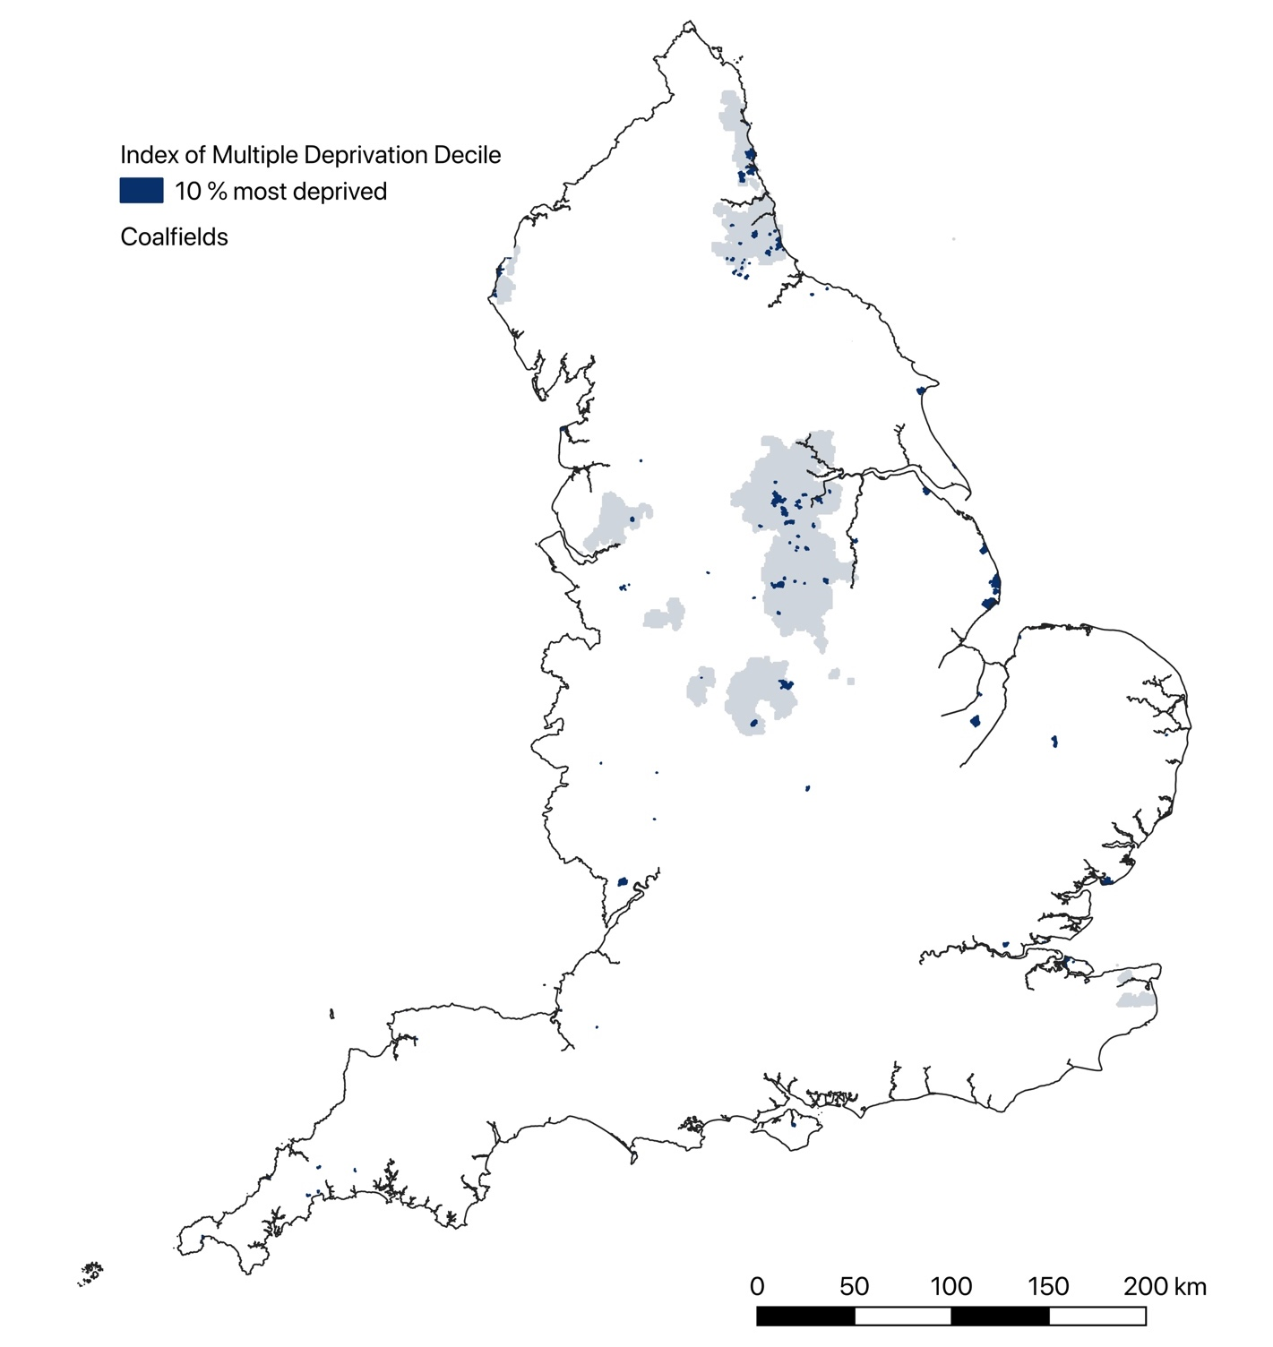
As noted earlier, four towns were allocated funding following being given a medium priority scoring by Ministry of Housing, Communities and Local Government officials, despite not having areas appearing in the above map of small towns with LLSOAs in the most deprived decile. In one of these cases, Clay Cross, it has been argued that it was funded on the grounds it was “in the 10% most deprived towns in England according to the ONS” (National Audit Office: 2020: 22), although the built-up area of this town does not actually contain any LLSOAs in the most deprived decile in either the indices of multiple deprivation or income deprivation for 2015 or 2019. No specific rationales for the selection of the two of the other medium priority towns, Millom or Truro, appear in the record of Minister rationales reported by the National Audit Office (2020), while the explanation recorded for the award to Whitby is just that it was a coastal town.
Figure 8: Small Towns Eligible and in Receipt of Support from the Towns Fund
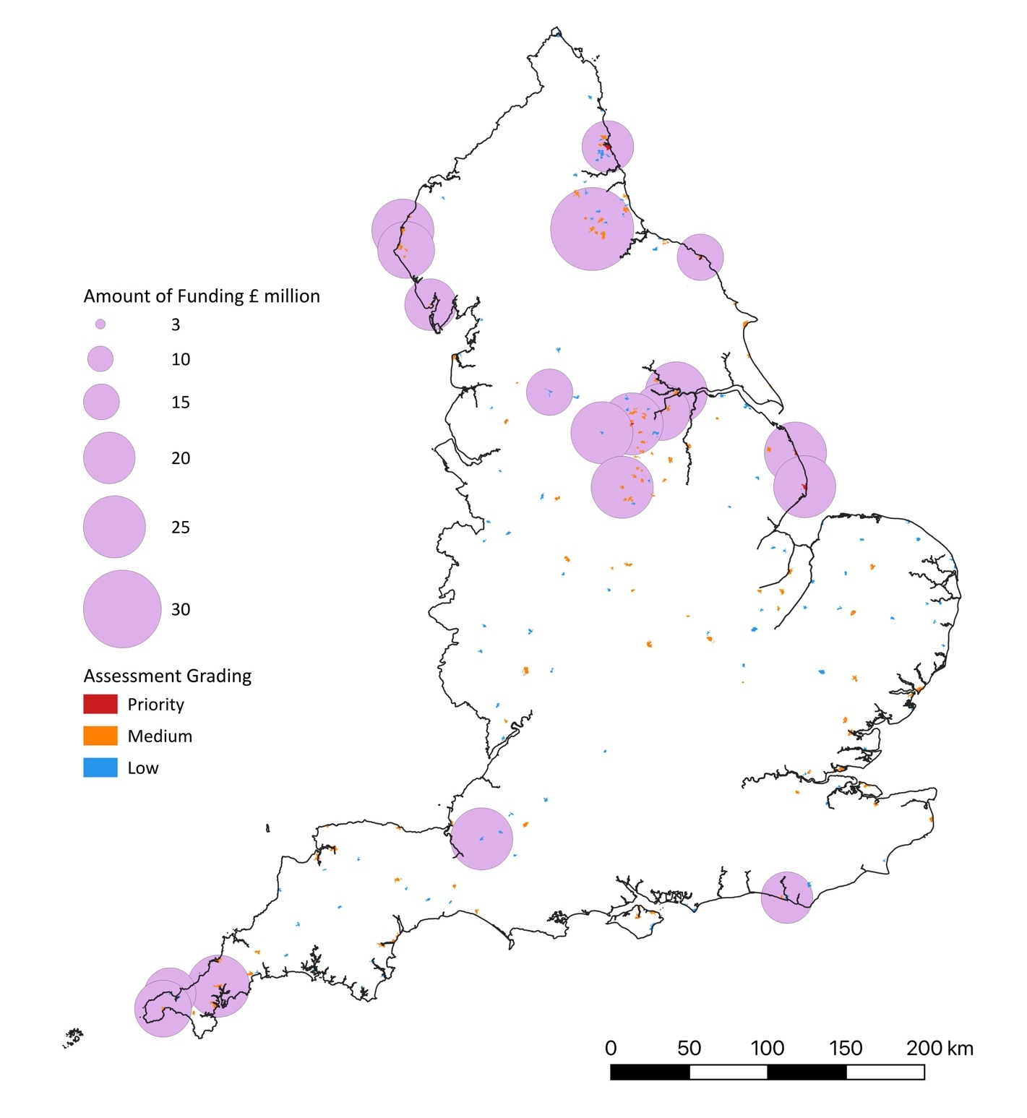

Studies such as Beatty et al. (2008: 9) have highlighted poor socio-economic conditions in English seaside resorts, noting that many had “levels of deprivation greater than the English average”. Their study included many settlements that were larger than the small towns identified in this study, as well as excluding ones with populations of less than 10,000. However, Bridlington, Ilfracombe, Penzance and Skegness, which all appear in Figure 5, were all identified as seaside towns with “weaker local economies” (ibid.: 9).
Beatty et al’s study focused on seaside resort towns, but Figure 5 also indicates that another type of coastal settlement has areas in the most deprived decile, namely cargo port towns, such as Immingham, Harwich and Goole. Other small towns with LLSOA in the most deprived decile category include South Ockendon, which was the site of a former Ford advanced vehicle plant, agricultural-food processing centres such as Wisbeach and Thetford, and settlements on the fringe of major metropolitan centres such as Winsfield, near Liverpool, which whilst originally a settlement linked to salt mining, became in the 1960s an area of overspill housing development.
The four towns of Clay Cross, Millom, Truro and Whitby all have areas with high deprivation scores, although in the second highest decile rather the most deprived decile. The lack of detail provided about their selection for Towns Fund awards, given the presence of many other towns with similar priority assessments and higher deprivation scores, support the arguments of the Public Accounts Committee (2020: 5) that the rationales given for the selection of towns from the medium-priority group were “scant” and potentially based on “sweeping assumptions”.
In relation to the towns that received awards despite an initial low priority assessment score, the Ministerial rationale for Stocksbridge outlined in the National Audit Office’s report focuses on the town’s economic vulnerability caused by uncertainties over its major employment area, steel making. This activity was particularly hit by the Covid-19 pandemic, because much of the steel manufactured in the town was used in the aerospace industry, where demand was dramatically reduced by the Covid-19 pandemic. Reference was also made to “low household income and high levels of deprivation”, although it was also noted that no areas of the town figured in the lowest decile although some lay “in second lowest” (National Audit Office, 2020: 27). In a sense, therefore, Stocksbridge’s deprivation indices were on a par with those of Clay Cross, Millom and Whitby, although those towns were assessed as being of medium priority, whilst Stocksbridge had been assessed prior to Ministerial review as being of low priority for funding.
The coastal settlements of Newhaven and St. Ives received a similar priority assessment score to Stocksbridge, and their built-up areas included zones that scored similarly in relation to income deprivation indices. Within the former town, the presence of deprivation is prominently referenced in the description of the Ministerial rationale, it being stated that “Newhaven has suffered from longstanding deprivation and is in the 25%-highest towns in terms of income deprivation” (ibid: 28). It was also argued that it is “an urban area but has significant rural pockets and is coastal”, and that development of the town “would help relieve pressure on Brighton’s housing and employment” (ibid.). A further stated rationale was that the town demonstrates “strong potential” due to it being a location for a designated enterprise zone and had “received investment from the High Streets Fund” (ibid.). Growth opportunities also figure prominently in the outlined rationale for St. Ives, it being claimed these arise “from investments related to the Tate Gallery” (ibid.: 28).
Two other small towns received awards despite being ranked low priority: Glastonbury and Todmorden. Both towns contained areas in the most deprived decile, a situation acknowledged in the Ministerial rationales for the awards. In relation to Todmorden, for example, there is reference to the town having “severe pockets of deprivation”, as well as the loss of industrial employment and a rise of a commuting population, with affordable housing having become “a

Table 3: Future High Street Fund, Successful and Unsuccessful Applications
Status of Application | Type of Town
 | Small Towns | All Towns | % Small Town
Selected to develop an application | 21 | 101 | 20.8
Successful application (selected to develop a business case) | 15 | 72 | 20.8
Unsuccessful application | 6 | 29 | 20.7
Source: DLUHC (2021a) Future High Streets Fund: successful and unsuccessful applications (London: Department for Levelling Up, Housing and Communities)
significant issue with limited land available for building” (ibid.: 27). In the summary of the justification for Glastonbury, there is reference to the town scoring “relatively poorly” (ibid.: 28) in metrics related not only to income deprivation but also productivity and EU Exit exposure. Use of the last measure was the subject of critical commentary by the National Audit, and no details were given as to why Glastonbury was seen to be particularly impacted by Brexit, although concerns have been expressed about its impact on its festival’s costs (Bugel, 2022).
As might be expected for a low priority ranking, the award rate for settlements of this rank was very low, with the five successful settlements representing just over 4% of the small towns categorised at this priority level, although almost 42% of the awarded towns with this low rank (Table 2). This last figure might suggest that small towns were relatively successful at this priority level, although these towns contributed to over 60% of the places assigned to this category, so their success rate in this lowest priority group was less than half of that for larger towns. It is also evident from Figure 6 that it was small towns in former coalfield areas in northern England, as well as coastal towns and remote areas, such as West Cumbria and Cornwall, that were gaining awards, despite the small towns figuring in the medium, as well as low priority, categories being distributed across many more areas of England, including the West Midlands and East Anglia, which received no funding from the Towns Fund.
Figure 7 indicates that a rather similar distribution of awards was evident in the ‘Future High Streets Fund’, which formed a second strand to the Towns Fund, even though its distribution procedures were set up as to be more competitive in character, with local authorities being invited to submit an expression of interest related to a town centre experiencing “significant” structural challenges (MHCLG, 2018: 12). These expressions of interest were then assessed, with selected applicants then being invited to develop and submit a full business case. Overall, 101 towns were initially short-listed, with 72 then being selected to develop full business cases. As illustrated in Table 3 and Figure 7, 15 of the successful applications at the second stage were made for settlements classified in this study as small towns, while a further 6 applications related to these settlements had been short-listed but not selected to develop a business case.

Figure 9: Small Towns in Receipt of or Applied for Support from the Future High Streets Fund
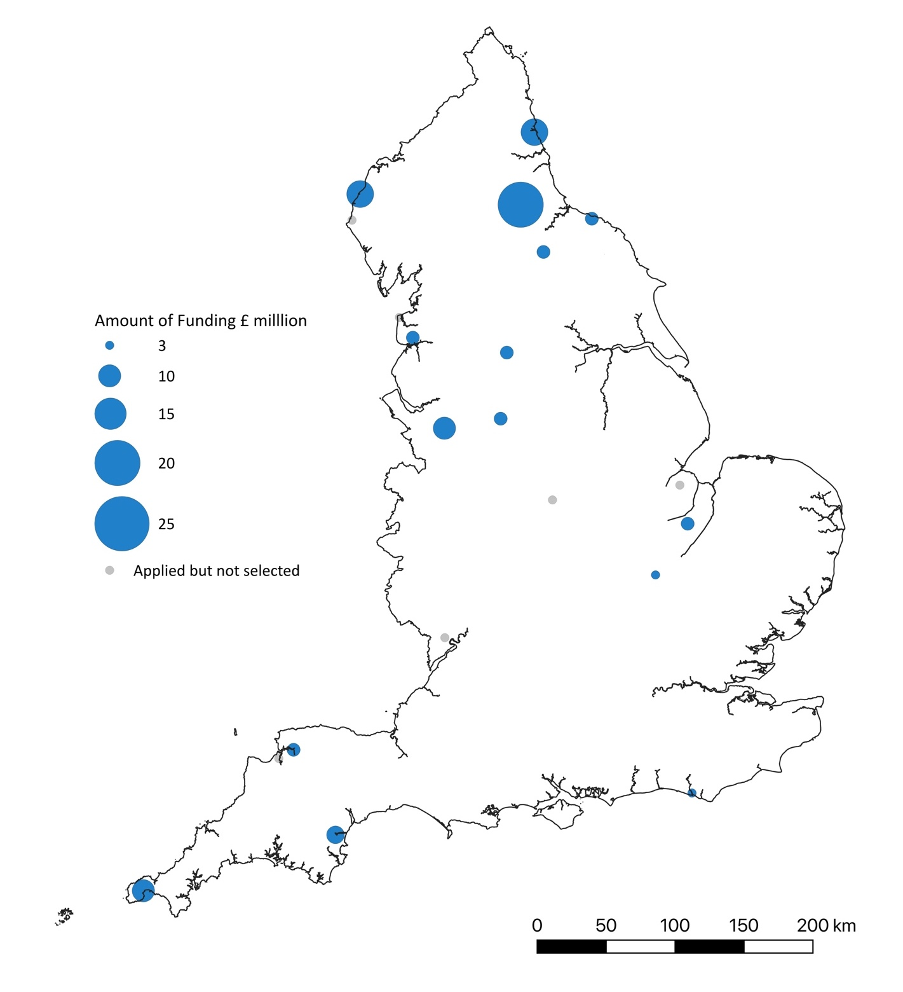

The success rate for small towns appears remarkably consistent throughout the application process, suggesting that small towns were treated in a similar manner to larger towns, although the small towns that reached the initial short-list represented only 1.2 % of this settlement type as identified in this study. As with the Towns Funds, coastal and former coalfied areas figured strongly amongst the small towns selected for support within the Future High Streets Fund.

Table 4: Engagement with Central Government Funding Scheme by Small Town Administrations
Funding Scheme | Successful | Applied | Success Rate of Applications (%) | Applications as % of responses
UK Shared Prosperity Fund | 5 | 7 | 71.4 | 23.3
Future High Streets Fund | 1 | 6 | 16.7 | 20.0
Rural England Prosperity Fund | 3 | 4 | 75.0 | 13.3
Towns Fund | 2 | NA | NA | NA
Reopening High Street Safely Fund |  | 1 | 0.0 | 3.3
Welcome Back Fund | 1 | 2 | 50.0 | 6.7
Levelling Up Fund | 0 | 1 | 0.0 | 3.3
Growth Corridor Initiative | 0 | 1 | 0.0 | 3.3

Table 4 illustrates the responses to the questionnaire sent to local government officials and representatives in relation to engagement with Government funding schemes. It confirms that engagement with central government funding schemes by representatives of small towns was often quite limited. As previously mentioned, Towns Fund eligibility was determined centrally by the Ministry of Housing, Communities and Local Government, rather than requiring applications by local authorities, although only two responses to the questionnaire survey were received from representatives of small towns who had received an allocation of funding from this scheme. Only one response was received from a representative of a small town awarded support from the Future High Streets Fund, although a further 6 responses were received related to locations that had made unsuccessful applications. This would suggest an application rate of 20% from small towns, a figure closely resembling that derived for the UK Shared Prosperity Fund. However, involvement in schemes such as the Reopening High Street Safely Fund, the Welcome Back Fund and the Levelling Up Fund were much lower, whilst applications for the Rural England Prosperity Fund lay at a moderate level. It was notable that no respondents referenced successful applications to the Levelling Up Fund, although there were small towns in receipt of support in all the other schemes listed in Table 4. However, overall the questionnaire survey suggests that generally relatively few of these settlements have received support from central government schemes created to address the challenges posed by the Covid-19 pandemic and longer-term structural challenges related to towns and their retail and service economies.
Feelings of a lack of central support to address significant challenges facing small towns were also very evident in responses to the questionnaire and interviews:
“In general, I think there is a lack of support for small market towns with a population of less than 25,000, from Government. Most schemes seem to be unfairly weighted towards bigger projects in larger towns and cities” (Economic Development Officer, East Midlands);
“Future High Street Fund useless, no account of small rural towns, aimed totally towards bigger and urban areas … need to appreciate how small towns work and stop just assuming that what applies to urban areas will work in rural areas. Sometimes wonder if people who set up these funds have ever visited a very rural area” (Town Council Clerk, South West England).
Some respondents drew attention to structural issues related to the organisation of government responsibilities and delivery:
“Current Government regulations prevent access direct to government funding by town/parish councils. This means local councils are wholly dependent on principal authorities to passport funds (often just not done) and prevents them from delivering or exercising responsibility on behalf of their communities” (Town Council Clerk, undisclosed location);
“There should be a duty on unitary authorities to engage town and parish councils (as the second tier of local government in their area) in significant policy and decision-making. Business rates should be channelled back into local communities more effectively. At present, the unitary Dorset Council receives business rates but is not equipped to address very local economic challenges. One solution would be for an element of business rates to be directed to town and parish councils - particularly at a town council level, where legislative freedoms granted by the Localism Act cannot be pursued due to a lack of access to funding” (Town Council Clerk, South West England).
There were also widespread concerns over the impacts of a lack of general funding to local government, while some respondents highlighted more technical issues in the allocation of funding and support, such as inadequacies in indices of deprivation with respect to small rural towns:
“more granular approach to analysing economic challenges and deprivation [is needed], so that localised place-based policies and initiatives can be developed. Levelling Up has so far passed Bridport by, despite some significant local needs” (Town Council Clerk, South West England);
“Due to our low population numbers even apparently affluent areas, such as Truro, Falmouth and Wadebridge, often experience pockets of significant deprivation which are often not captured with conventional measures of deprivation such as IMD. In other towns, such as Camborne and Penzance, we also have lower super output areas that rank in the bottom 10% IMD ranking for deprivation … The causes of this position vary and in part are similar to other towns in England in terms of industrial decline, the shift to out-of-town retail and online shopping … In addition, our economy as a whole and the majority of towns, are affected by the seasonal economy (due to heavy reliance on tourism and historic losses of what had previously been key industries e.g. mining) (Policy Officer, South West County Council).
“We are responsible for one town with a population of approx. 22,000. The town is typical of many towns which once relied upon mining. It has pockets of severe deprivation with some areas in the top 10% nationally. Wage levels are lower than the national average and educational achievement is low. Low house prices encourage the creation of hostels and homeless shelters which increase numbers of people with complex needs and asb [anti-social behaviour]” (Town Council Clerk, South West England).
These responses echo many detailed examinations of rural deprivation and poverty (e.g. Cloke et al., 2000; May et al., 2020; Milbourne, 2014; Shucksmith et al., 2023), which have highlighted their multi-dimensional character and intersectionality with both socio-demographic differences and the material, symbolic and experiential character of places; plus their invisibilities, both within statistical measures and in the perceptions of many rural residents, policymakers and practitioners. The next section will explore the presence of socio-demographic differences and inequalities in small Towns in England.

The Contemporary Socio-Economic Character of English Small Towns

Social inequalities, deprivation and social class differences
The invisibilities of poverty and deprivation in rural small towns in part relates to the presence of social inequalities in these localities, which means social disadvantage may be obscured by the co-presence of relative affluence, a point recognised in many policy documents related to small towns and comments from local government officials and representatives working in these settlements.
“Whilst the area is generally wealthy, the town includes two specific areas that appear in the bottom 20% and 30% in the Index of Multiple Deprivation. Recent analysis suggested that child poverty is higher than the national average … deprived areas are surrounded by very wealthy areas. Examples of where this applies are public transport (poor and reducing as most do not use it), housing (prices are significantly above the national average, putting huge pressure on very limited social housing), dentistry (it is in effect impossible to register with an NHS dentist - most dentists appear well-served by wealthier private patients and there is no incentive to accept NHS patients). Wages and job security are poor across significant parts of the economy (seasonal tourism, and hospitality, for example). Schools are satisfactory, but access to post-16 education opportunities is poor. Young people (particularly women) move away from the area post-18 for improved life chances" (Town Council Clerk, South West England);
"The population ranges from out-of-work, on benefits, to the just-about-managing, to the well-off and to wealthy landowners" (Town Council Clerk, Eastern England);
"Our town … attracts a lot of retired people who have relatively high incomes which effects the average income of our population and gives a false impression of that the residents are relatively well off” (Economic Development Officer, North West England).

Figure 10: Small Towns with LLSOAs in Lowest Decile of Index of Multiple Deprivation 2019
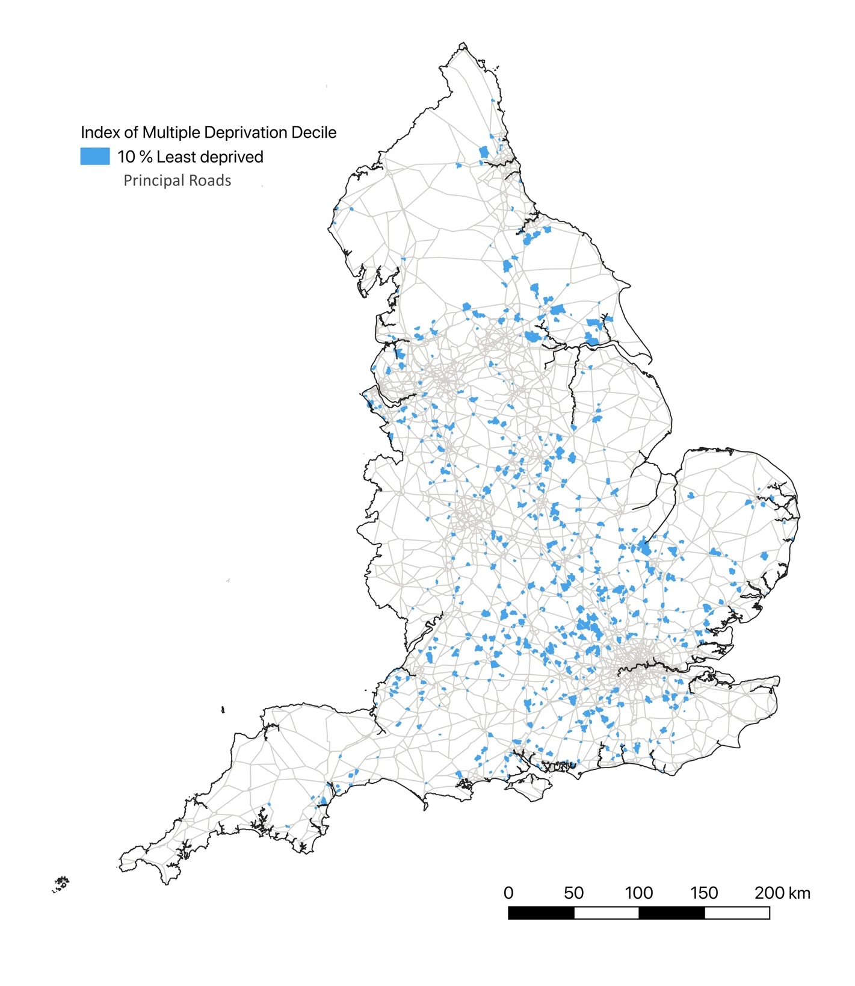
Figure 10 shows the distribution of small towns with areas of low levels of deprivation, and comparing the areas with the highest decile of deprivation (Figure 7), reveals that the former are more widespread across England, both numerically and in terms of their spatial distribution. They are also, as illustrated in Figure 4, commonly classified as 'Urban City and Town' and 'Rural Town and Fringe', and were also, as illustrated in Figure 10, often located on or close to major roads. This means these settlements had relatively good transport connections, even if they were spatially distant from other major settlements. Strong connective was indeed often dentified as an important contributor to the attractiveness of such towns to residents, businesses and visitors:
“Albrighton is well served with transport links. The only motorway directly serving Shropshire (the M54) is easily accessible, with J3 just 2 miles away. This provides easy access to the Black Country, the West Midlands conurbation and the M5 and M6 (13 miles to the M6). The I54 development, which is home to major manufacturers Jaguar Land Rover, Eurofins and Moog Aerospace, is within a 15 mile commute. The M54 westbound leads to Shrewsbury (24 miles). The nearby A41 provides direct links north to Newport (11 miles), Whitchurch (31 miles) and on to Cheshire. Southbound, the A41 links to Wolverhampton (8 miles). The A464 provides access to nearby Shifnal (5.5 miles)” (Shropshire Council, 2022a: 4);
“Leominster … is in a strategic location on crossroads of A49 and A44 with access to Wales and central location in the Marches. It has a railway station with good connectivity to Hereford and Shrewsbury and Cardiff and Manchester beyond” (RoseRegeneration, 2022b: 4);
“We’re 90 minutes from Birmingham, Bristol and Cardiff but a world away from the rat-race … The town is bisected by the A44 which provides an important cross regional route for long distance freight, commercial and tourist traffic. Unlike many towns in Herefordshire, it has few problems with accessibility, although public transport provision is weak” (RoseRegeneration, 2021b: 1-9).
The economic benefits of connectivity may foster low levels of deprivation through supporting businesses and local employment within small towns, and also attract people who wish to live within these settlements but commute to work in other locations. It has been argued, for instance, that counterurban migration to rural areas and small towns may be the outcome of people being willing to “tolerate a longer commute in return for a perceived enhancement of their quality of life” (Brown et al., 2015: 1190), and also that both rural in-migration and long-distance commuting are preferentially enacted by middle-class householders (Champion et al., 2009; Dargay and Clark, S. 2012; Fielding 1989; McQuaid, 2003). Figure 9 shows the proportion of residents in these settlements who can be classified as working in middle-class occupations according to National Statistics’ Socio-Economic Classification.
As might be expected, many of the small towns with areas of low deprivation level (Figure 10) also figured as areas with a high proportion of middle-class residents (Figure 11), a relationship further illustrated in Figure 12. However, the mapped distribution of middle-class residents also suggests some significant regional differentiation in the class composition of small towns, with there being a strong focus of settlements with high proportions of middle-class residents within South East England and near major urban areas in the Midlands and northern England. Conversely, there are many small towns in other areas of northern England, including many former coalfield areas, in more agricultural areas in eastern England, and in the South West, that have relatively low proportions of middle-class residents, a not unexpected distribution given that these regions figure in areas with relatively high proportions of working-class employment (see Appendix 1).
Figure 11: Proportion of Middle-Class Residents in Small Towns, 2021
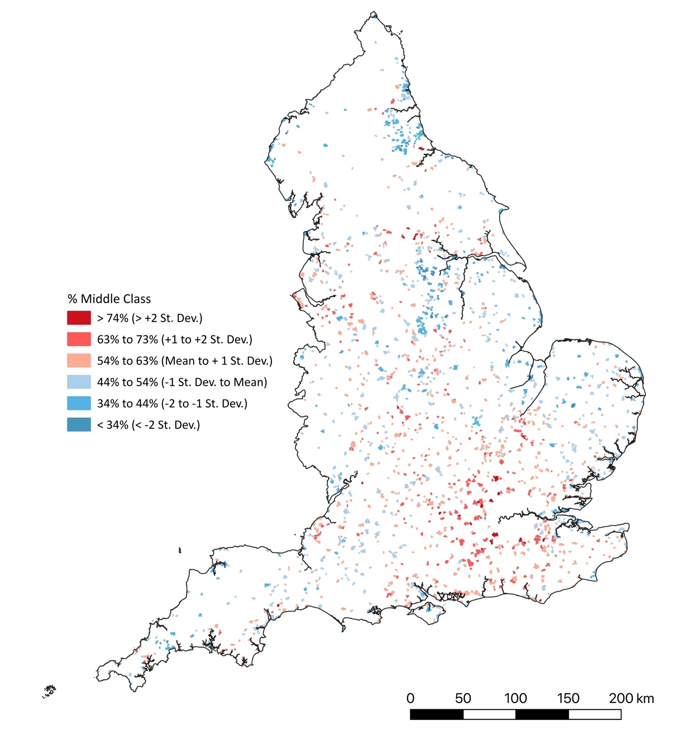

The presence of high levels of middle-class residents in a settlement does not signify that these were areas without socio-economic problems or deprivation. Reference has already been made to claims that there can be ‘pockets’ of deprivation even in areas that generally appeared to be quite affluent, and 6 of the settlements that appeared in Figure 7 also featured in Figure 10, which means that these small towns contained areas that appeared in the most and least
deprived deciles, and hence exhibited high levels of social inequality. More generally, as Table 5 demonstrates, many settlements had areas with divergent deprivation scores.

Figure 12: Proportion of Middle-Class Residents in Small Towns with areas in the Lowest Decile of the Index of Multiple Deprivation 2019

Table 5: Maximum and Minimum Indices of Multiple Deprivation 2019 within Small Towns
Decile of Most Deprived LLSOA in Built Up Area | Decile of Least Deprived LLSOA in Built Up Area
 | Most deprived | 2nd | 3rd | 4th | 5th | 6th | 7th | 8th | 9th | Least deprived
Most deprived | 1.3 | 2.3 | 3.6 | 3.8 | 2.5 | 3.4 | 2.8 | 2.1 | 2.1 | 6.6
2nd | 1.1 | 1.1 | 1.5 | 1.7 | 2.1 | 2.1 | 1.7 | 1.3 | 6.6
3rd | 1.5 | 1.9 | 0.8 | 0.8 | 1.5 | 1.1 | 1.5 | 5.7
4th | 1.1 | 0.8 | 0.8 | 0.6 | 0.4 | 1.1 | 5.5
5th | 1.1 | 0.4 | 0.2 | 0.8 | 0.6 | 5.5
6th | 0.8 | 0.6 | 0.8 | 1.3 | 4.7
7th | 0.0 | 0.2 | 0.0 | 2.3
8th | 1.5 | 0.2 | 2.1
99th | 0.4 | 0.6
Least Deprived | 0.8

Comments from local government officers and representatives provide supporting evidence about the significance, and complex causes, of social deprivation in many small towns:
“Areas in the town are amongst the 10% most deprived in the country. There is hardship across a number of areas including education and poverty … Also levels of crime are relatively high” (Town Councillor Leader, East Midlands);
"Approximately 10% of permanent residents are on some kind of benefit. Wages are not high enough to meet the cost of living" (Town Council Clerk, East Midlands);
"Low educational attainment. Large percentage in lower earnings bracket relying on seasonal work with uncertain income … Hidden population who live in caravans" (Town Council Clerk, East Midlands);
"Local people, particularly the young, find it very difficult to enter the housing market. The majority of local jobs are low-paid service industry jobs" (Economic Development Officer, North West England);
"lots of low paid jobs in the summer, very few jobs offering all year-round work. What exists is often below national average payscales" (Town Councillor, Eastern England);
These quotes not only provide further illustrations of the multiplicity of forms deprivation can take – child poverty, low incomes, and housing and service inaccessibility – but also highlight how a growing presence of affluent residents can itself foster some forms of deprivation, for instance, through stimulating housing price rises or reductions in public service provision and localised employment, as well as obscuring the presence of deprivation within a locality:
“In recent years, Bromyard has effectively become a dormitory town with many residents commuting to Worcester or Hereford for employment … real potential to become a desirable commuter settlement rather than a place with a significant ‘livework’ character” (RoseRegeneration, 2021a: 12);
“Cleobury Mortimer … supports a lower level of self-containment than most Shropshire market towns … The difference between the number of resident workers and the number of jobs is sizeable, with net out-commuting across the Cleobury plan border … with 2,332 people living in Cleobury Mortimer ... working elsewhere and 1,350 working in Cleobury Mortimer but living elsewhere” (Shropshire Council, 2021b: 27);
“There is an imbalance between housing and employment with some 40% of the working population commuting out of the town” (RoseRegeneration, 2022a: 22);
“disruptions to tourism, parking congestion, out-of-town shopping (large garden centre), pollution and congestion within the centre due to the high volume of vehicles travelling through” (Collective response from Council Officers, South East England).
Commuting was not the sole source of problems such as congestion and housing shortages, with tourist visitors often seen to cause similar issues in small towns:
“the challenge is to ensure that Ross will continue to be a favourite tourist destination but also enable development to ensure that our locally born young people have access to affordable housing” (RoseRegeneration, 2021b: 2);
“Although there is a supply of new homes on the open market, evidence shows that most households would need to triple their income to buy a modest house on a mortgage, and that to rent privately would take at least half their income … The community has raised concerns about the number and the impact of second homes (including holiday homes), particularly when there are local people in need of housing. Homes standing empty for much of the time have a depressing effect on a community’s economic and social well-being” (Bridport Town Council, 2020: 45);
“The tourism sector drives Whitby’s economy but also provides significant challenges in terms of traffic congestion, high house prices compared to incomes, lower value seasonal employment and in-work poverty, and the associated challenge of retaining or attracting young people” (Whitby Town Deal Board, 2020: 18);
“the prevalence of 'second homes' and properties used as short-term holiday lets has driven rising property prices and has led to shortages of long-term rental properties. Relatively low wages, combined with the high house prices, often mean that local people (particularly young people), are forced to move elsewhere” (County Council Policy Officer, Cornwall).
The last quote raises the age demographic of people impacted by in-migration, and there were numerous references to this issue, and related matters concerning the ageing character of settlements, in descriptions of small towns by local government officers and representatives, as well as commissioned reports:
“it is accepted that there is demand for housing in the area, which is popular with retirees and others from the rest of the country, with a 60% growth in the over 60s population predicted in the next five years … significant numbers of young people leave the area due to the lack of jobs and affordable housing, even if many do return in later years” (BAS Consultancy, 2020: 4);
"principal challenges … relate to scale and functionality, and a skewed demography in terms of economic workforce … Relatively low job density, a declining jobs market in the town (pre-covid) with comparatively high levels of out-commuting, combined with a high proportion of over 65s renders the town vulnerable to the persistence of this imbalance between scale, functionality and demographics" (RoseRegeneration 2022b, 5 10);
“An ageing population in most Cornish towns, coupled with the trend of outward migration from Cornwall of young people has led to labour market shortages in many towns and difficulties in servicing the ageing population. Our lower-than-average wages, higher than average house prices and popularity as a holiday destination and as a location for second homes also puts pressure on our local housing market” (Council Policy Officer, South West England);

Figure 13: Small Towns with High Proportions of Residents 65 and Over
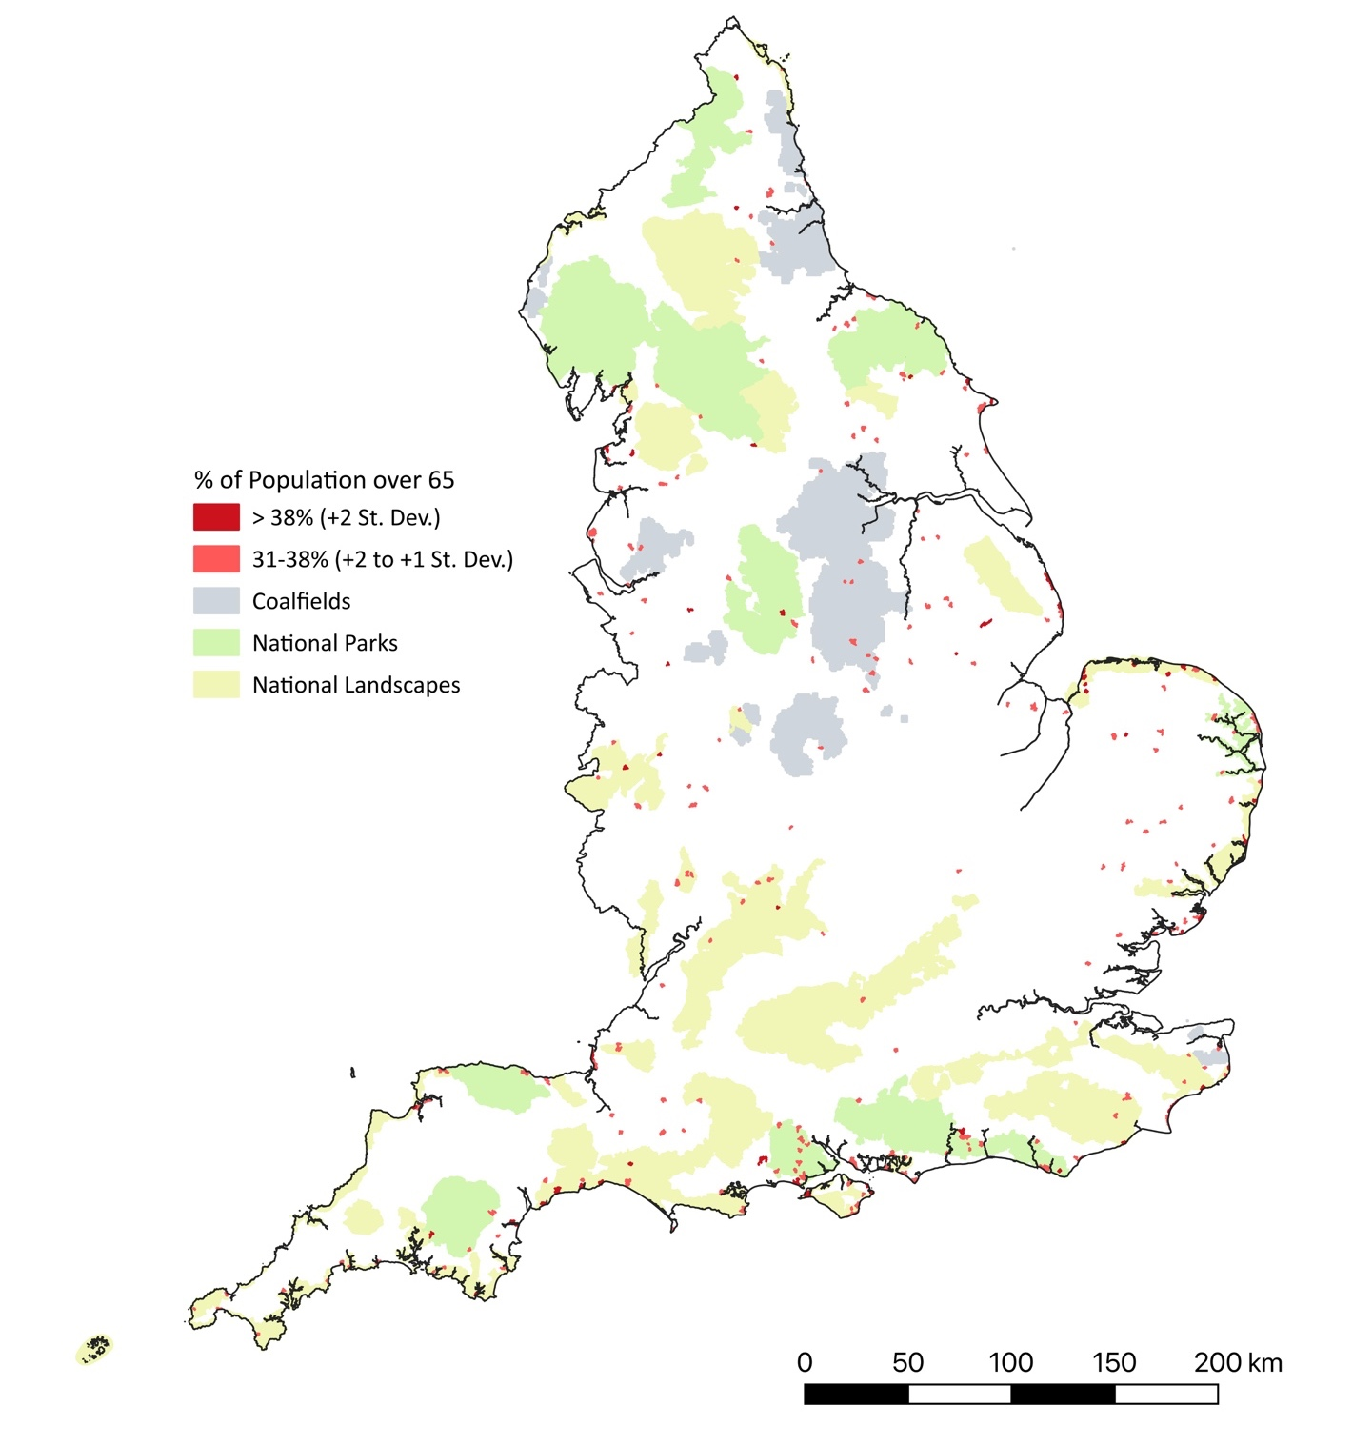
“The neighbourhood plan area is home to a higher than average population of older residents. Although many will prefer to live independently, some will seek some form of specialist home … The demand for specialist homes for the elderly will also influence the analysis of the optimal housing type and mix in the neighbourhood plan area. For example, elderly people who are reasonably independent and seeking to downsize will put pressure on the demand for 1-2 bedroom homes … new developments intended as specialist homes for the elderly ….must take into account the distance from the town centre and natural obstacles including the hilly terrain” (Bridport Town Council, 2020: 31).
“Ledbury has a population of 10,054 with a high proportion of over 65s (29% compared to the national average of 20%)” (RoseRegeneration: 2022a, 4);

These quotes not only highlight the presence of an aged demographic in the towns they are describing, but in some cases also point to dynamics accounting for this population profile, such as the in-migration of older populations and the out-migration of younger people, and in the last case, also to some of the resultant changes they may create in housing provisions, which can in turn, impact later migrations flows.
Figure 13 shows small towns with high proportions of residents over 65. It supports arguments that retirement-related migration, like tourist visits, is often focused in coastal and aesthetically valued landscape areas (e.g. Smith et al., 2019; Stockdale 2010), claims that resonated with one account of a small town’s contemporary development:
“The continuing relaxed and gentle attractiveness of Ross in its gateway setting and its unique status as the only Town in the Wye Valley Area of Outstanding Natural Beauty has fuelled its growth as a retirement and commuting centre" (Rose Regeneration, Appendix 1, p. 2).
Moreover, as illustrated in Figure 13, many of the inland towns with high proportions of residents aged over 65, are located within or close to National Parks and areas of National Landscapes, and many are also settlements that appeared in Figure 10 as settlements with areas of low deprivation. In relation to coastal settlements, however, towns with high proportions of residents over 65 included Ingoldthorpe, Mablethorpe and Jaywick, which are settlements with areas in the most deprived decile (see Figure 7), as well as many coastal locations that appeared in the map of areas of low deprivation (Figure 10).
Figure 13 also highlights the presence of small towns with high proportions of residents over 65 in former coalfield areas, which as previously discussed, also often have high deprivation levels. An aged demographic in these areas has been observed in other studies, including Beatty et al. (2019: 17), who argue it reflects both out-migration of younger, working-age people, who are moving away from the “difficult labour markets” of the former coalfield areas, and also the lack of international migrants into these areas.
Limited international migration is demonstrated by Figure 14, which shows the proportion of ‘non-White’ residents in small towns across England. People self-reporting their ethnicities as other than ‘white’ in the 2021 Census are indeed lower than average in many settlements located in former coalfield areas, although it should be noted that across many areas the figures were low (on average, non-white ethnicities constituted just under 4.4% of the population of the identified small towns in the 2021 Census). There were exceptions to this, with levels of over 13% being evident in many small towns in the South East of England around London. While many former coalfield towns exhibit an aged population profile in terms of the number of residents over 65, Beatty et al. (2019) argue that these regions are generally not experiencing high levels of retirement-related in-migration, such as those remarked upon by the local government officers, representatives and commissioned researchers quoted earlier.

Figure 14: Proportion of Self-Reported ‘Non White’ Ethnicities in Small Towns, 2021
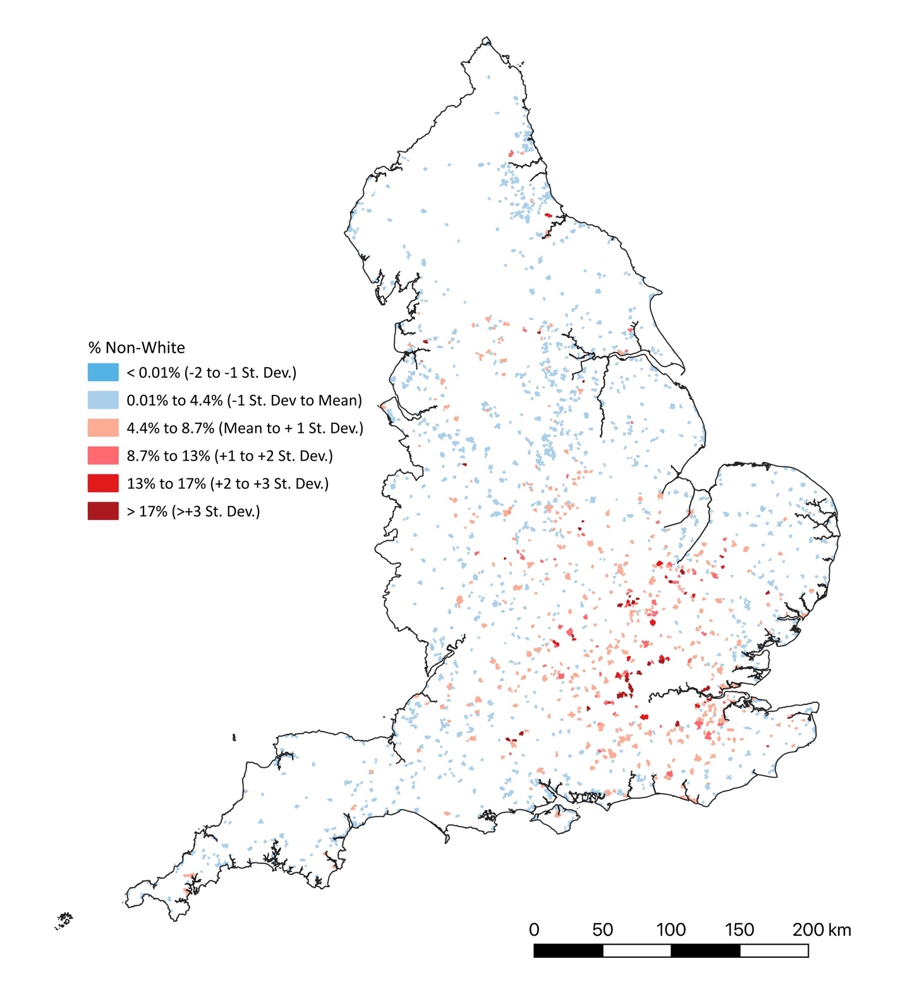
The significance of non-migrational demographic change is also highlighted by Figures 15 and 16, which show relative changes in the number of residents and households living in small towns between 2011 and 2021. The former map suggests a slight decline in population numbers across many small-town settlements in England, but the latter suggests that the majority of these settlements have seen household numbers increase over this period.
While the differences between the two maps are striking, it is not unexpected given that household size has been seen to be decreasing in the UK over many decades (Lewis, 1992),

Figure 15: Population Change in Small Towns, 2011 to 2021
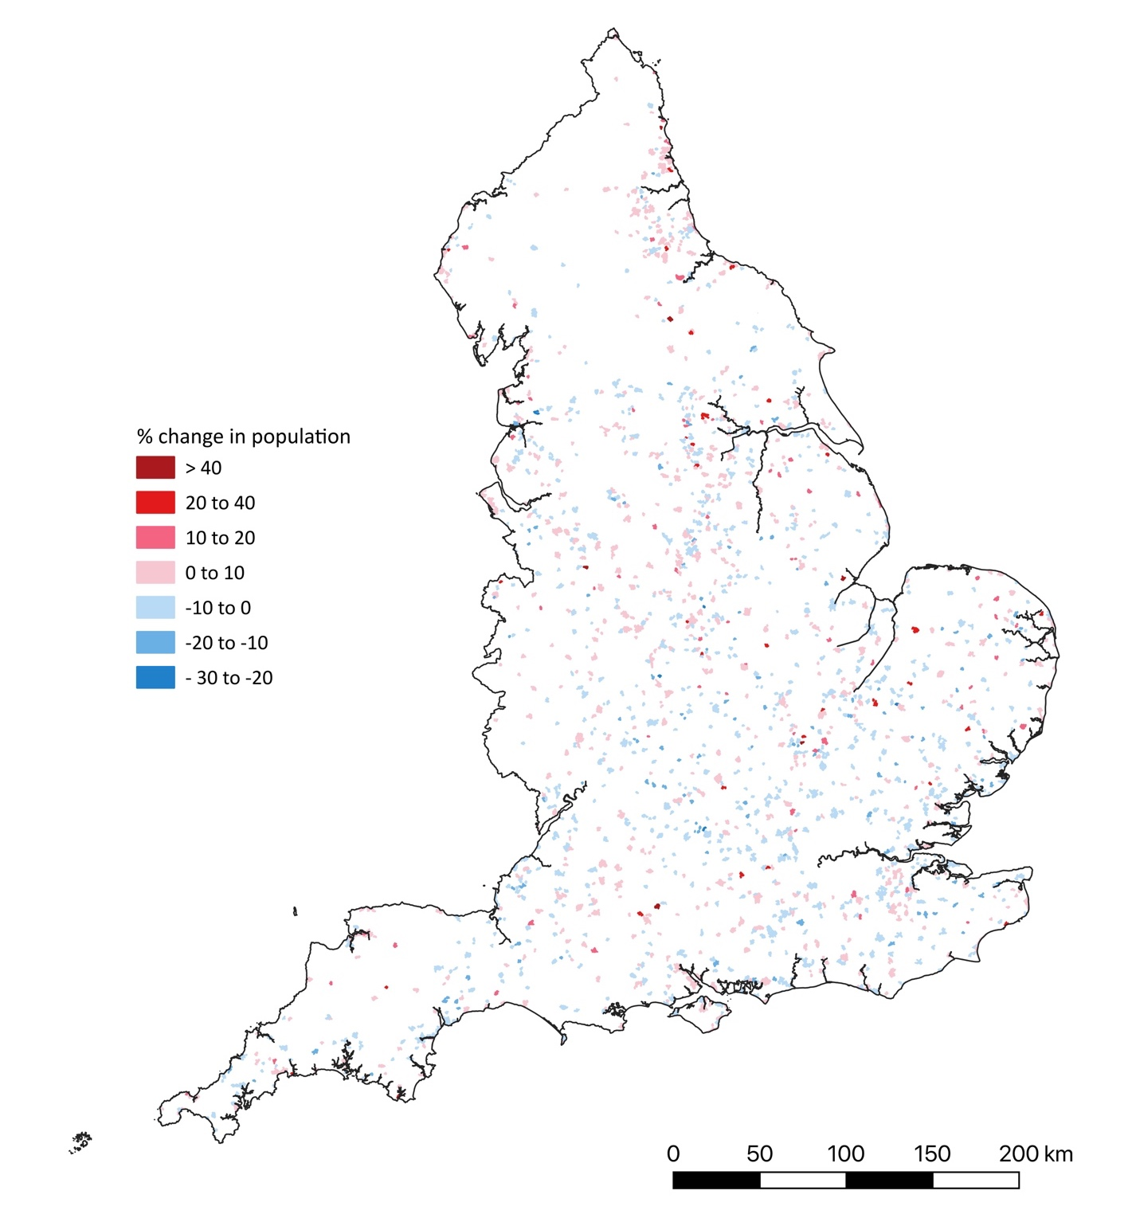
although this decline has been seen to have reversed since the 1990s (Bentley and MacAllum, 2019), and generally in the UK, household size remained largely unchanged between 2011 and 2021 (ONS 2022). However, many of the processes seen to drive falls in household size (e.g. an ageing population and an associated increase in single-person and ‘empty nester’ households, limitations in housing availability and an increase in the number of more affluent, middle-class households), may be of continuing significance in rural small towns, whilst new dynamics that might increase household size, such as heightened international in-migration by young adults, may be also of less significance in these settlements than they are in larger urban centres, as illustrated in part by Figure 12. It is also evident that many small rural towns have seen extensive house construction, which will enable increases in the number of resident households, although

Figure 16: Household Change in Small Towns, 2011 to 2021
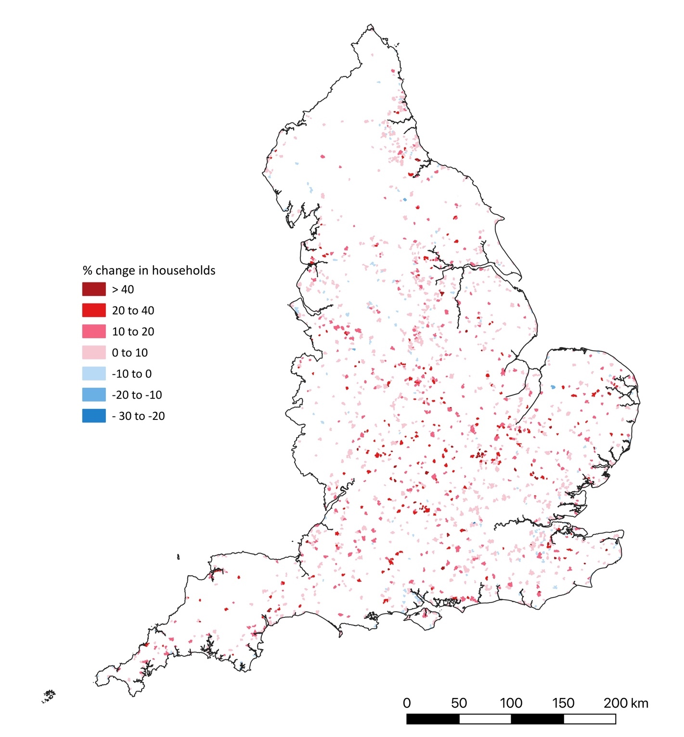
it is also clear that in many locations this increase is being accompanied by an overall reduction in the population size of these settlements.
Ageing demographic profiles and household-size reductions should not be taken to imply that small towns are devoid of families and young people. Figure 17, for example, shows small-town settlements with above average proportion of residents under the age of 20. There is a strong association between these settlements and National Landscape areas in the southern part of England, again suggestive that landscape amenity value may be of significance. However, there are fewer settlements with high concentrations of this age group within or near National Parks or National Landscapes in other areas of England, which suggests that proximity to London and
Figure 17: Small Towns with High Proportions of Residents Under 20
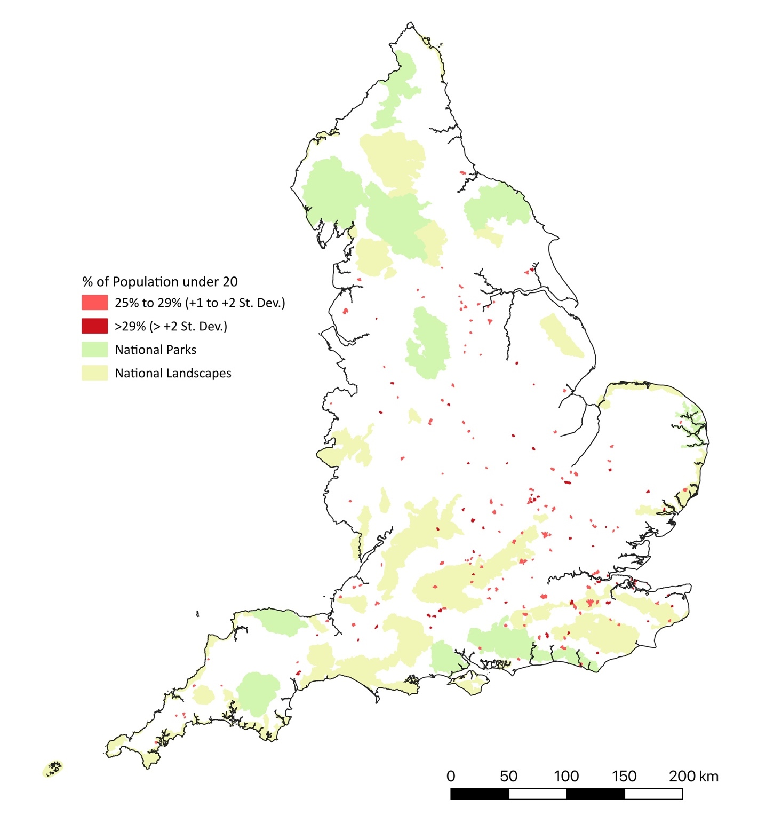
other urban employment centres in the South East and Midlands may also be a significant locational influence.
Also evident in Figure 17 are small towns with a major public school, such as Marlborough, Oundle and Uppingham, and there were also claims that educational establishments could act to attract people to live in certain small towns:
“the remote and high-quality environment along with its well-performing schools make Kington an attractive locale for new residents seeking the opportunity to live in a rural milieu. This is an asset for local employers and is attractive to those looking to move out of Cities to work from home and can support more local spend” (RoseRegeneration, 2021b: 13);
“The development site opens up the possibility of … some student accommodation … with close access to the station … The Skills Foundary project developed as part of Hereford’s Stronger Towns Funding bid, aims to include Herefordshire’s market towns in a hub and spoke delivery model and will actively engage with Ledbury” (RoseRegeneration, 2022a: 21);
“The opening of Exeter University's Tremough campus in Penryn in 2004 and investment in Falmouth University have contributed significantly to the economic growth of the area … Falmouth University (per Falmouth University's Economic Impact report) is estimated to currently contribute £1 in every £109 of GVA to Cornwall's economy” (County Council Policy Officer, Cornwall).
Overall, it is evident that small towns are home to a range of different populations, with there being both considerable social variations between these towns, but also often socially differentiated populations within them.

Change in Small Town Economies
As mentioned in the contextual discussion at the start of this report, small rural towns have been seen to have experienced major change in their economic structure, linked to declines in economic activities that historically provided economic rationales for these settlements, such as the sale of agricultural produce, the supply agriculture goods, and the provision of retail, financial and welfare services to not only their populations but also to those living in surrounding rural areas. This section will explore the extent to which small towns are still involved in the delivery of these activities or whether their economies have become linked to others, including the producer-service, creative and green economies.

Small Towns and the Agricultural Economy
Historically English rural towns have been viewed as locations for the marketing of agricultural produce, but Table 6 indicates that agriculture, energy and water collectively contribute less than 3% of the employment in these settlements. This employment level, not unexpectedly, declines to less than 2% in settlements classified as part of urban major conurbations, although is higher in both urban cities and towns and rural towns and fringe settlements in sparse settings, suggesting that remoteness may play a role in increasing slightly the relative importance of these sectors of employment.
Figure 18 provides more insights on the spatial distribution of employment levels in this sector, highlighting that within eastern England, the South-West and the West Midlands, there are many small towns with above average employment of people in agriculture, energy and water. These areas are associated with sparsity in the rural-urban classification (Defra, 2017b), as well as arable farming in the first case and pastoral agriculture in the latter two cases, although even in areas appearing to have high levels of relative employment in these three activities, employment levels were generally low, with only 1% of these settlements across England having 10% or more employment in this sector. Furthermore, many of the small towns with the highest proportion of employment in agriculture, energy and water were located in

Table 6: Employment in Built-Up Areas of Between 1,500 and 40,000 Residents in 2021, by Economic Activities and Rural-Urban Classification*
Economic Sector | % of employed residents in Built Up Areas with Population 1,500 to 40,000, 2021 Census
 | Urban major conurbation | Urban minor conurbation | Urban city & town | Urban city & town in sparse setting | Rural town & fringe | Rural town & fringe in sparse setting | Rural village | Overall
Agriculture energy & water | 1.9 | 2.0 | 2.6 | 3.8 | 3.3 | 5.2 | 3.4 | 3.1
Manufacturing | 7.2 | 11.6 | 8.8 | 8.7 | 8.0 | 7.9 | 6.3 | 8.2
Construction | 9.8 | 11.8 | 9.5 | 10.2 | 10.1 | 10.9 | 9.0 | 10.0
Distribution, hotels & restaurants | 17.9 | 22.3 | 20.1 | 30.0 | 18.9 | 26.8 | 16.7 | 19.4
Transport & communication | 8.5 | 9.0 | 8.5 | 5.1 | 8.1 | 5.7 | 7.8 | 8.1
Financial, real estate, professional & administrative | 17.7 | 11.4 | 15.6 | 10.5 | 16.0 | 12.2 | 17.5 | 15.8
Public administration, education & health | 32.7 | 28.4 | 30.2 | 26.2 | 31.0 | 26.1 | 34.9 | 30.7
Other | 4.4 | 3.5 | 4.7 | 5.5 | 4.7 | 5.2 | 4.4 | 4.7

Figure 18: Percentage Employed in Agriculture, Water and Energy in Small Towns, 2021
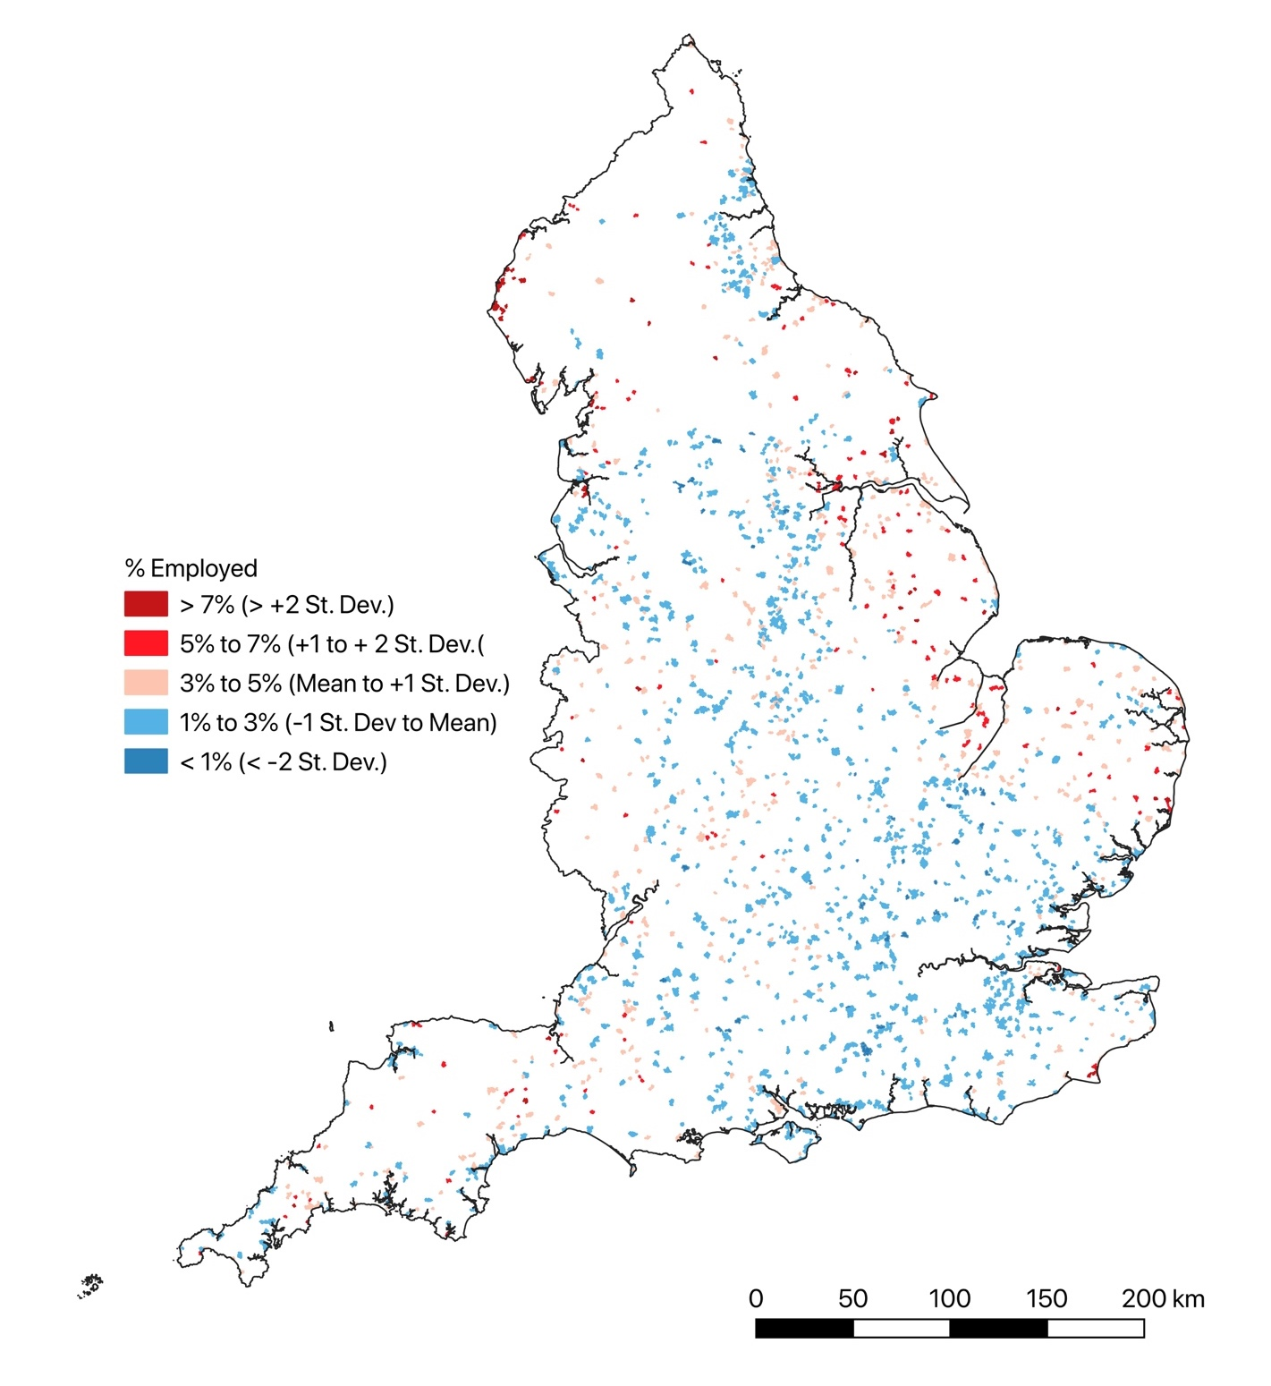

northwest Cumbria. Whilst this is a further area of sparse settlement and generally pastoral agriculture, it is also an area of employment in the energy sector, particularly in the nuclear industry at Sellafield, and more recently in wind power. Remoteness and settlement sparsity have been seen to play a significant influence in locational decision-making in relation to both forms of energy production (Hanley and Nevin, 1999; Phillips, 2019; Phillips and Dickie, 2019; Stevenson and Richardson, 2003), and it may well be that the apparent significance of sparsity observed in relation to Table 6 may reflect the significance of this rather than agricultural influences. Having said this, it is clear that some small towns have very strong, and continuing to be developed, connections to agriculture and the processing of agricultural produce:

“Holsworthy is a small rural market town … the majority of the businesses linked to agriculture in some way … The opening of a new AgriBusiness/Livestock Market has aided the town” (Town Council Clerk, South West England);
“Town has historically provided major employment through food and drink/manufacturing – accounts for 24% of all employment … Food Enterprise Zone … will … improve integration within the food chain, linking the farmers at the beginning of the food chain, manufacturers who add value to the food, distribution partners who deliver it, businesses/establishments who sell it and customers who benefit from the high-quality food products” (Melton Borough Council, 2015: 5-7)

Small Towns as Retail and Service Centres
Small towns have historically also been seen as centres of retail and service provision, and Table 6 indicates these functions are still a major focus of employment within these settlements, with ‘Distribution, hotels and restaurants’ accounting for over 19% of the employed population resident in these settlements in 2021, while ‘Public administration, education and health’ accounted for over 30%. Levels of employment in the former set of occupations were particularly high in areas classified as ‘Urban city and Town’ and ‘Rural town and fringe’ in sparse areas, potentially reflecting how these activities may become more concentrated in settlements located in more remote areas of the country: Powe and Hart (2007: 18), for instance, remark that towns “remote from other towns” tend to be “comparatively well serviced for, their size”.
Table 7, however, which shows the distribution of retail centres identified by the Consumer Data Research Centre (CDRC) within the settlements identified as English small towns, along with the spatial size of these centres, presents a rather different image. In the CDRC data, which relates to areas with at least 50 retail units, and differentiates these on the basis of the number and density of shops, plus their relative significance in relation to surrounding centres, it is non-sparse ‘Urban City and Town’ and ‘Rural Town and Fringe’ areas that figure most strongly.
Table 7 also suggests that over 71% of the retail centres in small rural towns, took the form of ‘small local centres’, with a further just under 10% being larger ‘local centres’. It further indicates that in the small towns classified as forming part of urban major or minor conurbations these forms of retail centres were not only predominant, but there was only one larger retail centre: the ‘District Retail Centre’ of Yate, near Bristol. Larger-scale retail provision only became significant in areas classified as ‘Urban City and Town’ in non-sparse areas. These areas contained all but one of the identified Large Retail Park, 94% of retail ‘Town Centres’ and four of the five ‘Large Shopping Centres’, all of which were ‘Outlet Centres’. Conversely, only one District Retail Centre (Looe in Cornwall), one Large Shopping Centre (Dalton Park Outlet Centre, in County Durham) and one Large Retail Park (Morris Central Shopping Park, in Shropshire) were identified within ‘Rural Town and Fringe Areas’, along with only four retail ‘Town Centres’ (Ashbourne, Cromer, Richmond and Totnes). The single ‘Rural Village’ area identified as containing a retail centre in the CDRC dataset related to student-focused provision, and it is

Table 7: Type and Size of Retail Centres in Small Towns, by Rural-Urban Classification*

Rural Urban Category |  | Count of Retail Centre Type in Built-Up Areas (Overall size in km²)
 | District Centre | Large Shopping Centre | Major Town Centre | Large Retail Park | Small Shopping Centre | Town Centre | Small Retail Park | District Centre | Market Town | Local Centre | Small Local Centre | Total
Urban major conurbation | 1  (0.04) |  |  |  |  |  | 2 | 1 | 2 | 4 | 25 | 34
 |  |  |  |  |  |  | (0.06) | (0.04) | (0.25) | (0.41) | (0.61) | (1.37)
Urban minor conurbation |  |  |  |  |  |  |  |  | 1  (0.15) |  | 16  (0.51) | 17  (0.66)
Urban city & town | 1  (0.06) | 4  (0.53) | 1  (0.16) | 10  (1.39) | 1  (0.10) | 64  (9.67) | 21  (2.47) | 1  (0.06) | 63  (6.97) | 61  (4.49) | 265  (7.03) | 491  (32.87)
Urban city & town in sparse setting | 2 |  |  |  |  | 2 |  | 2 | 3 | 1 | 3 | 11
 | (0.16) |  |  |  |  | (0.33) |  | (0.16) | (0.26) | (0.04) | (0.07) | (0.87)
Rural town & fringe | 1 | 1 |  | 1 |  | 4 |  | 1 | 13 | 30 | 430 | 480
 | (0.04) | (0.16) |  | (0.04) |  | (0.32) |  | (0.04) | (1.02) | (1.84) | (10.07) | (13.50)
Rural town & fringe in sparse setting | 1 |  |  |  |  |  |  | 1 | 3 | 8 | 33 | 45
 | (0.05) |  |  |  |  |  |  | (0.05) | (0.25) | (0.57) | (1.03) | (1.89)
Rural village |  |  |  |  |  |  |  |  |  |  | 1 | 1
 |  |  |  |  |  |  |  |  |  |  | (0.01) | (0.01)
Total | 6 | 5 | 1 | 11 | 1 | 70 | 23 | 6 | 85 | 104 | 773 | 1079
 | (0.35) | (0.69) | (0.16) | (1.43) | (0.10) | (10.32) | (2.53) | (0.35) | (8.89) | (7.35) | (19.33) | (51.16)
Source: Derived from data provided by the Consumer Data Research Centre, an ESRC data investment, under project ID CDRC 498-01, ES/L011840/1; ES/L011891/1.

important to recognise that whilst the retail sites described in this dataset encompassed 811 of the built-up areas identified in this research, this means that 936 built up-areas are not represented. Many of these will be settlements with less than 50 retail units, further accentuating the evidence in Table 3 that the bulk of retailing in English small rural towns comes through provisions that lie towards the smaller and localised end of a retail spectrum, although as highlighted by several studies of rural retailing, many rural settlements have no or only a single retail outlets (e.g. Association of Convenience Stores, 2023).
CDRC have developed a further classification of retail centres, which is shown in Table 8. This is a multi-dimensional classification based on 46 variables relating to the composition, diversity, size, function and economic vitality of retail provision, which through cluster analysis are used to differentiate 4 supergroups and 8 groups, although only 7 of the latter were found to be applicable to the small towns identified within this study. This classification suggests that just over 67% of the retail centres in small towns take the form of so-called ‘indie high streets’, which are taken to reflect areas with high proportions of independent retailers, offering a range of products and services, although potentially with high turnover rates and small retail catchment areas, plus often located in “more affluent neighbourhoods” (Ballantyne et al., 2022: 11). A further 19% of the retail centres were classified as ‘Mass and value high streets’, with these in all but 3 cases being in settlements classified as ‘Urban city and town’ in character. This characterisation of small-town retailing as having a significant proportion of independent retailing was echoed in descriptions of these towns in commissioned policy reports and comments from local authority officers and people involved in local town and parish councils:
“a historic post-industrial, market town … with a mix of independent shops and businesses” (Economic Development Office, East Midlands);
“Affluent residents like to support local independent traders rather than going to 'clone towns'. The mix of an attractive town setting and a good range of shops has made the town successful” (Economic Development Officer, Eastern England);
“The town is identified as one of the five market towns in the Herefordshire Local Plan Core Strategy to have a good provision of independent retailers. Kington is a primary location for food shopping for residents, but its historic environment and niche retail offer also makes it an attractive destination for visitors” (RoseRegeneration, 2021b: 9);
“22 stores with just under 2,700m² of floor space. This proportion is higher than is typical for a town the size of Bishop’s Castle, and perhaps reflects its rurality and relative self-containment … Within the town there are four clothing/shoe shops, five stores selling antiques, four selling gifts and two bookstores. One of the gift shops is also a florist, while one of the bookstores incorporates a café. There are also two galleries which sell art in the town … The majority of stores are independent … There are three convenience stores within the main shopping … These account for 4% of all units and for 12% of gross floor space. As well as a supermarket (the Co-op), there is a Spar convenience store attached to the petrol station and a butcher” (Shropshire Council, 2022b: 19-20)
Table 8: Extent of Retail Centres in Small Towns in England, by Rural-Urban Classification*
Rural Urban Category | Retail Supergroups and Groups
 | Leading comparison & leisure destinations | Retail & shopping parks |  | Local 'everyday' goods & service centres |  | Traditional high streets and market towns |  | Total
 | Sub-regional retail & leisure destinations | Primary shopping centres & premium destinations | Secondary retail parks & shopping centres | District urban service centres | Local urban convenience centres | Mass & value high streets | Indie high streets | Retail Centres
Urban major conurbation |  |  |  |  |  | 4 | 3 | 7
Urban minor conurbation |  |  |  |  |  | 1 |  | 1
Urban city & town | 13 | 1 | 4 | 14 | 2 | 45 | 125 | 204
Urban city & town in sparse setting | 1 |  |  |  | 1 |  | 6 | 8
Rural town & fringe |  | 1 |  | 2 |  | 3 | 42 | 48
Rural town & fringe in sparse setting |  |  |  |  |  |  | 12 | 12
Rural village |  |  |  |  |  |  |  | 0
Total | 14 | 2 | 4 | 16 | 3 | 53 | 188 | 280
Source: Derived from data provided by the Consumer Data Research Centre, an ESRC data investment, under project ID CDRC 498-01, ES/L011840/1; ES/L011891/1.
“The retail sector assists in attracting visitors to the town by offering a mix of independent and national stores” (Shropshire Council, 2021a: 29).
Whilst all these quotes present independent stores as a key component of the retail offer of small towns, a range of distinct customer groups and shop types are highlighted: there are, for instance, references to the significance of affluent residents and visitors, as well as niche retail and everyday convenience stores. It is therefore important to recognise variations within the independent retail sector, which are not being captured in classifications such as that developed by the CDRC, although have been recognised within in some localised studies. Pendle Borough Council, for example, commissioned a study of retail provisions and capacity across settlements in their district (Pendle Borough Council, 2023). Although this study encompassed examinations of larger settlements than is the focus of this report, it also included two built-up areas that fit within the delimitation of small towns employed here, namely Barnoldswick and Earby.
As Figure 19 demonstrates, the retail offer in these two towns differ significantly, with the former, which is classified in the CDRC datasets as a ‘Local centre’ and an ‘Indie High Street’, having not only a significantly larger number of shops, but also a wider range of so-called ‘comparison goods’ being sold. These are products seen to be generally high cost, less frequent purchases, where consumers tend to compare products before purchasing them, and for which they may be prepared to travel greater distances. Within Earby, classified by CDRC as a ‘Small Local Centre’, there appears to be a smaller range of stores selling such products, and they tend to be rather more focused around utilitarian products, such as DIY, hardware, furniture and healthcare. There also appear to be a significant number of charity and second-hand shops. The Pendle Borough Council commissioned study also recorded that Earby had lowest level of non-retail service provision and combined retail turnover (of £9.27 million) amongst the settlements studied, as well as a shop vacancy rate of 19.5%, which was the second highest in the Pendle District and “significantly above the UK average” (Pendle Borough Council, 2023: 119). It also outlined that in a household survey in the town, “only 8% of respondents … had visited shops or leisure services in Earby in the last 12 months”, even though this local retail centre attracted the majority of its customers “from the local area” (Pendle Borough Council, 2023: 120). This compared with 25% of respondents to a similar survey in Barnoldswick, which was calculated to have a combined retail turnover that, at £44.52 million, was over four times that of Earby, despite having only two and a half times more retail units. However, even in Barnoldswick there was a shop vacancy rate of 11.6%, and the survey indicated that only 1.5% of residents did the majority of their household shopping within the town (Pendle Borough Council, 2023: 108). This highlights that even in settlements where classificatory terms such as ‘Indie High Street’ may be applied, this is not necessarily indicative that independent retail stores are offering a large range of products or services to affluent residents or visitors.
Moving to consider public sector service provision, Table 6 indicates that employment on ‘Public administration, education and health’ is, on average, highest in settlements with between 1,500 and 40,000 residents that were characterised as ‘Rural Village’. That is, in settlements towards the lower end of this settlement range (Table 1 and Figure 4). Given the small number
Figure 19: Retail Provision in 2022 in Two Small Towns in the Borough of Pendle
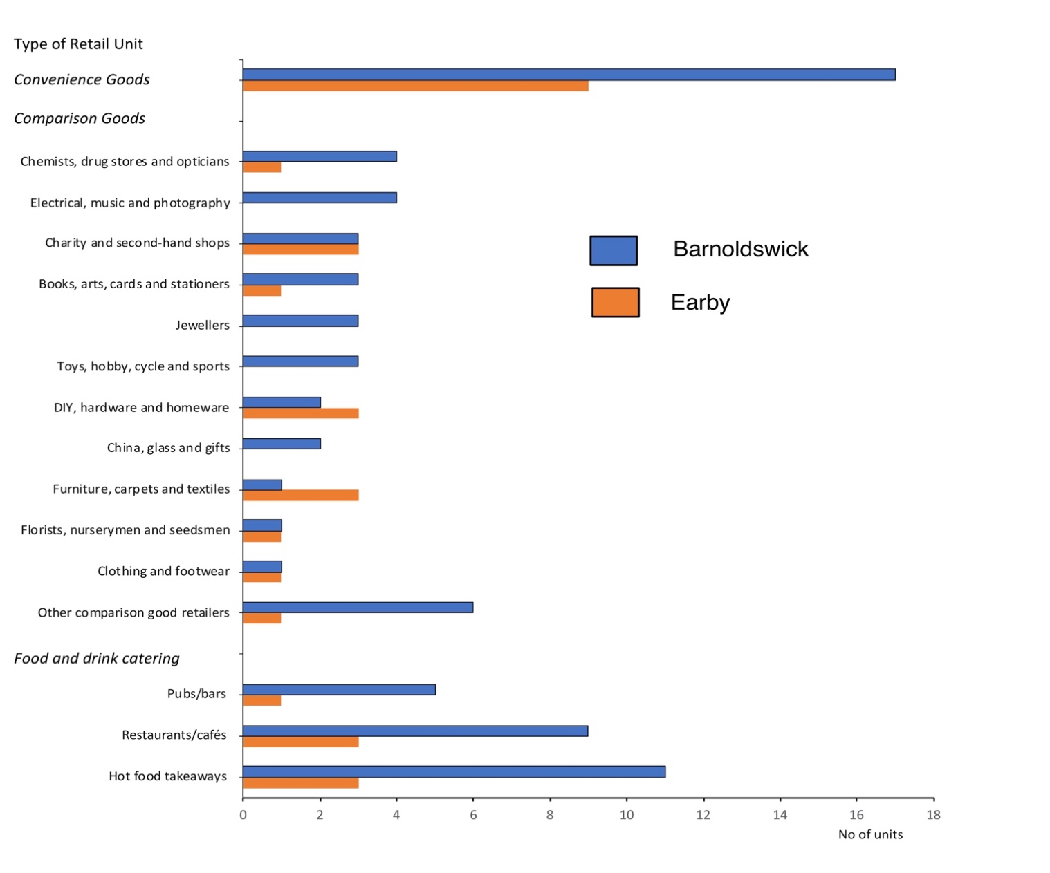
Source: produced from data contained in Pendle Borough Council (2023) Pendle Retail and Leisure Capacity Study: Final Report (Nelson: Borough Council and Nathaniel Lichfields and Partners Ltd.), Appendix 5: Town and local centre analysis

of these settlements, care needs to be exercised in interpreting this figure, particularly as there are significant variations across all the settlement categories in the proportion of people employed in this economic sector. In relation to Rural Village settlements included in this study, for example, significantly higher proportions of residents were employed in this sector in Old Sarum (42%), Wymott (43%), Great Bricett (65%) and Larkhill (80%). Such cases reflect the presence of major public sector institutions in or close to these settlements, such as prisons in Wymott, military bases in Larkhill and Great Bricett, and museums and heritage organisations in Old Sarum. However, across all the small-town settlements in England, it was clear that employment in ‘Public administration, education and health’ generally contributes significantly more to employment within small towns than does ‘Agriculture, energy and water’, with no settlements having less than 14% of people employed within the public sector. Furthermore, although there are some localised high concentrations of employment in this sector linked to
Figure 20: Percentage Employed in Public Administration, Education and Health in Small Towns, 2021
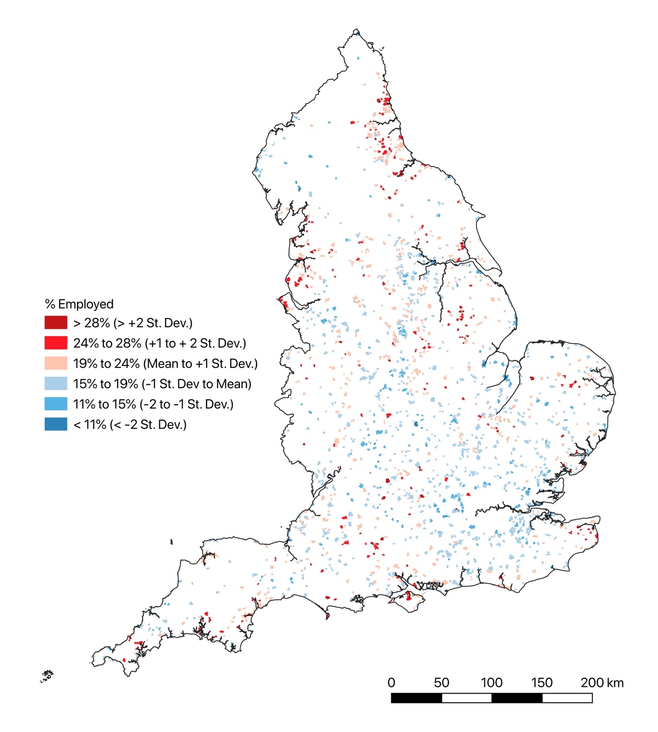
specific institutions, as illustrated in Figure 20, this area of employment was significant in small towns across all regions of England, although it was also evident that many of the small towns in eastern England with higher levels of employment in ‘Agriculture, energy and water’, also had relatively high levels of employment in ‘Public administration, education and health’, and that this sector also figured highly within settlements in the North-East and North-West England, many in the southern Pennines and in coastal centres in Cornwall, south Devon and Hampshire, Sussex and Kent.

Figure 21: Percentage Employed in Distribution, Hotels and Restaurants in Small Towns, 2021

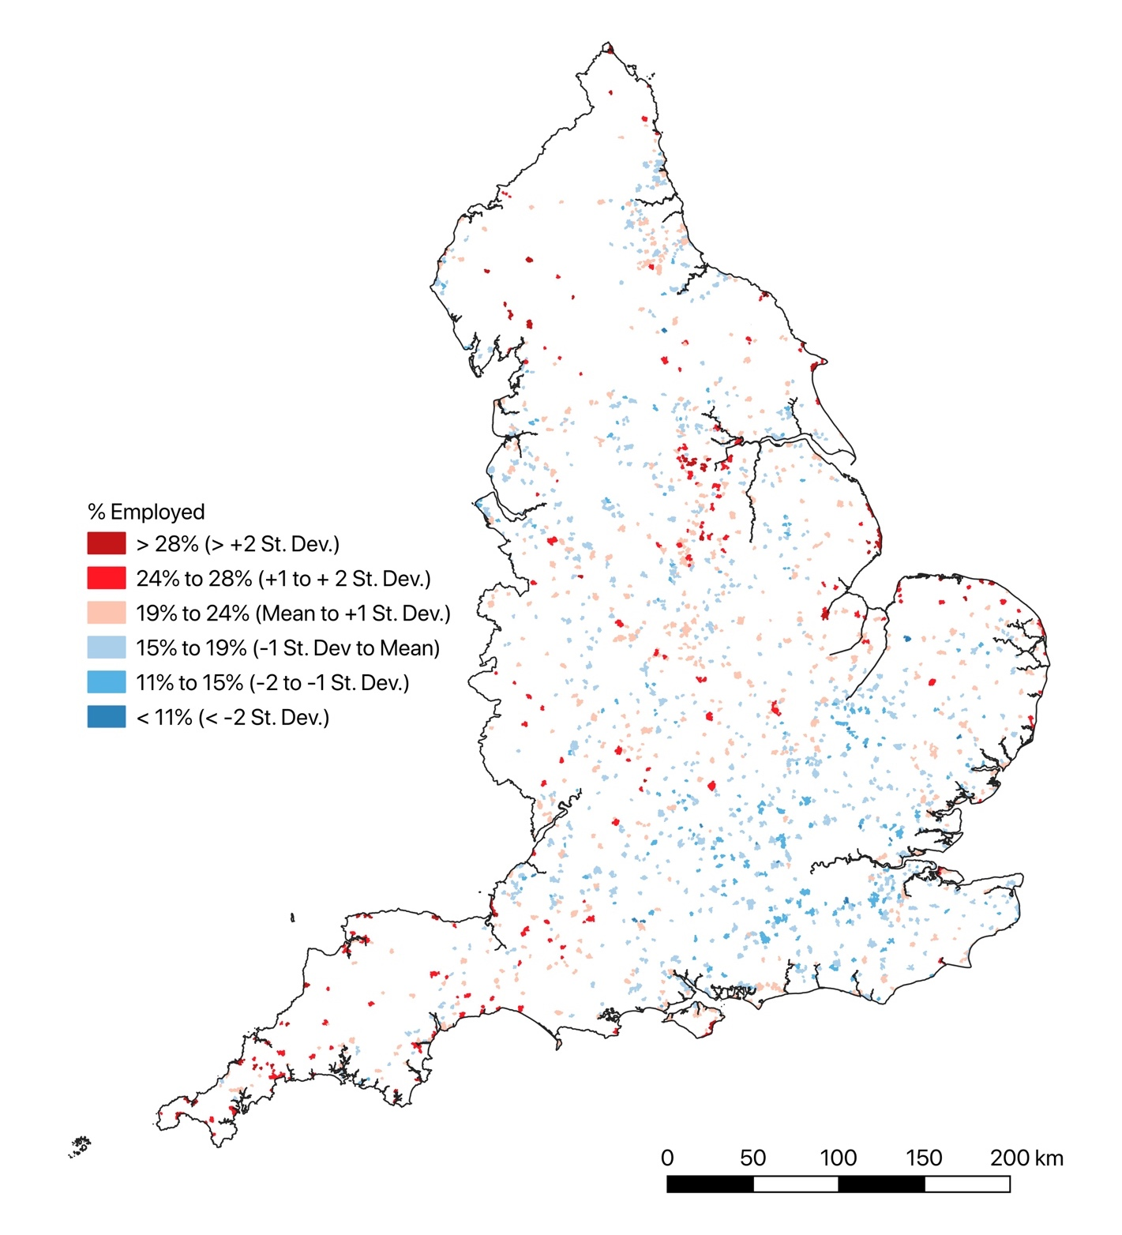
The last group of areas also contain small towns with above average proportions of people working in ‘Distribution, hotels and restaurants’ (Figure 21). This occupational grouping includes retailing and wholesaling, as well as the provision of accommodation and catering, and can be seen to encompass the retailing and trade activities often presented as a key function performed historically by small rural towns (e.g. Powe and Hart, 2008; Powe and Short, 2004). Reference, for example, has already been made to the significance of visitors to the retail sector in some towns with a so-called ‘Indie high street’. There were, however, some variations in the location of concentrations of the accommodation and public sectors within the above-named regions.
Cornwall, for instance, had more settlements with relatively high proportions of people working in ‘Distribution, hotels and accommodation’ than had high relative employment in ‘Public administration, education and health’, while north as well as south Devon also had settlements with high concentrations in the former sector. There also appeared to be fewer areas of high relative concentration in ‘Distribution, hotels and accommodation’ within settlements along the South Coast of England, while a larger number of small towns with high relative employment in this sector appear within southern Pennines. The pattern of concentrations may well reflect the influence of tourism within the sector, and it is notable that Table 6 indicates that settlements classified as lying in ‘Urban City’ and ‘Rural Town and Fringe’ areas in ‘Sparse Settings’, had, on average, higher proportions of residents working in ‘Distribution, hotels and accommodation’. Such settlements may well act as accommodation, catering and retail centres within the rural recreation and tourism visitor economies, which have been identified as having a focus around aesthetically pleasing, sparsely populated landscapes (Walford, 2001; Smith et al., 2018), as well as acting as commercial centres to serve surrounding rural areas with lower population densities.
Small Towns as Places of Industry and an Emerging Green Economy
Manufacturing employment is often viewed as highly urban-focused in its distribution, although studies have highlighted its presence within rural areas (e.g. Day, 1986; Healey and Ilbery, 1985; Jarvis et al., 2000; Keeble and Tyler 1995). Table 6 indicates that employment in manufacturing is indeed on average well over double the employment in ‘Agriculture, energy and water’, although is almost half the level of employment in ‘Distribution, hotels and restaurants’ and under a third of employment in ‘Public administration, education and health’. It also suggests that manufacturing employment tends to be lower in ‘Rural villages’ than in other settlements categories in the Urban Rural Classification.
Figure 22 indicates that there are also strong spatial differences, with small towns in the South East of England tending to have relatively low levels of employment in manufacturing, whilst settlements in the Midlands, northern and eastern England generally had higher concentrations, which in 30 cases extended to over 15% of the employed population. The settlements in eastern England included many large food processing centres, such as Wisbech and Thetford, whilst settlements in northern England and the Midlands tended to be located in or close to coalfield areas or large urban centres of industry like Birmingham and Manchester. In this latter group of settlements, new businesses could clearly draw upon legacies of earlier and wider industrialisation, including access to nearby industrial and residential consumers, labour availability and, in some instances, the presence of properties or brownfield sites released by industrial decline:
“Newton Aycliffe has established itself as a key employment centre and an attractive place to live close to work and with commuting opportunities. The location of Hitachi Rail in the town and opportunities to feed into both Nissan’s supply chain and Tees Valley process and offshore industries underpin an already strong and regionally significant employment base” (Durham County Council, 2013: 4);
Figure 22: Percentage Employed in Manufacturing in Small Towns, 2021
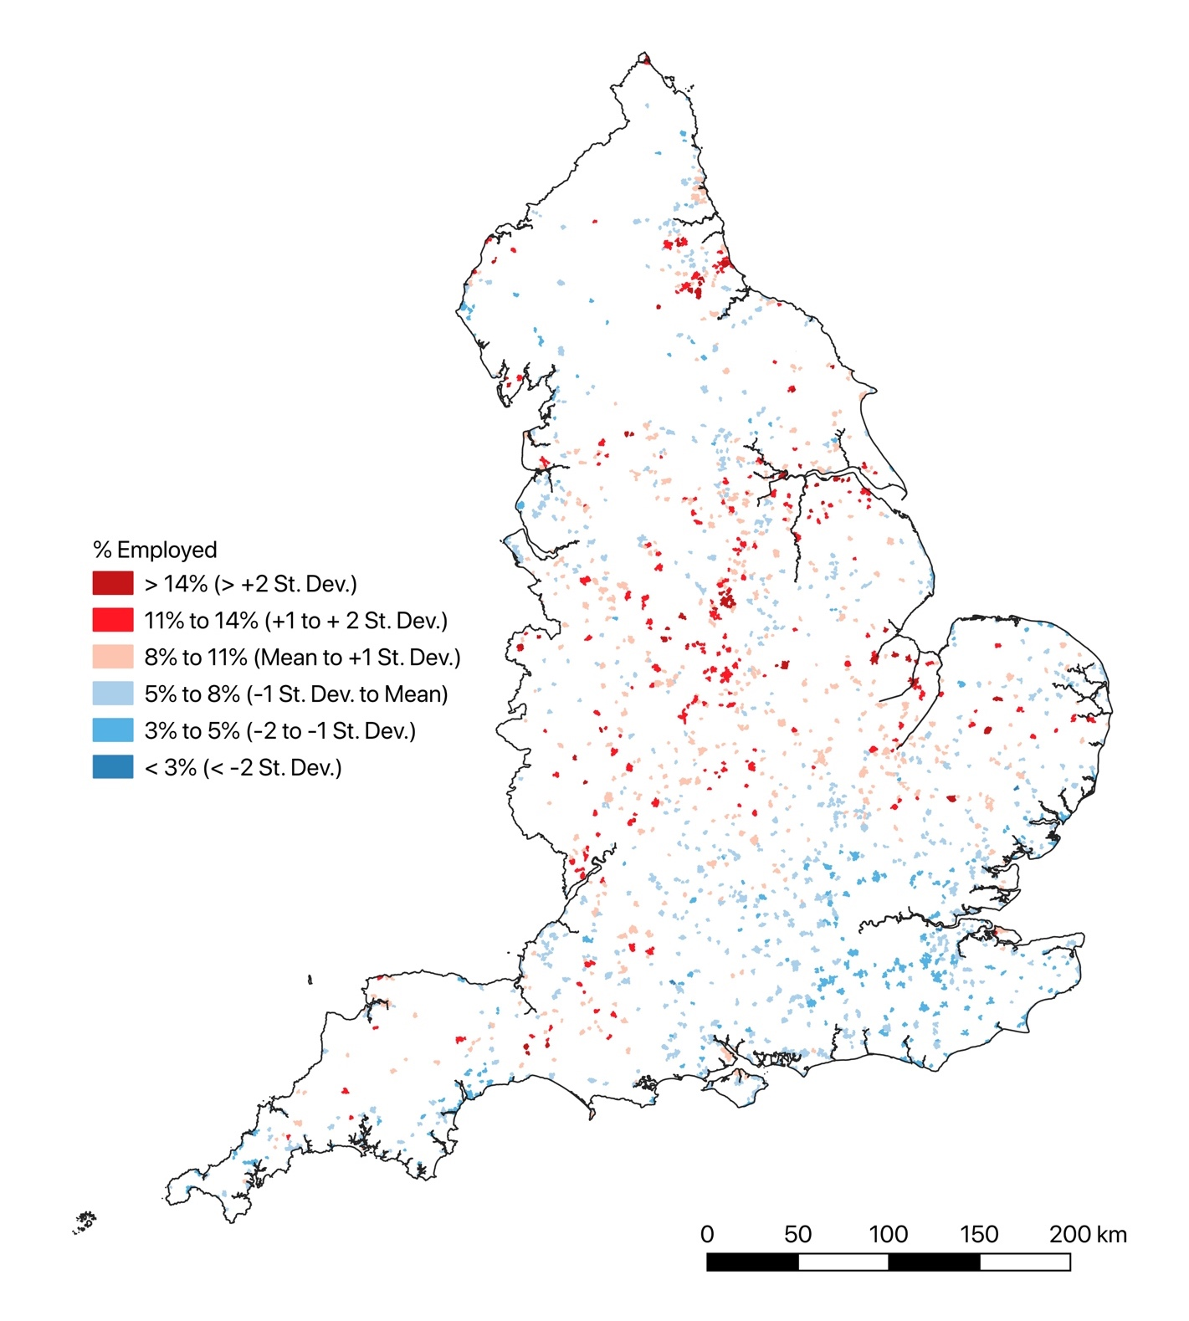
“South Normanton and Pinxton contrast with many other former mining settlements as they have amassed a large employment area and opportunities around their communities. This is primarily due to the high accessibility of the locations, triggered by the M1 and A38 interchange. As well as encouraging businesses to locate nearby, this has also made the area more attractive to live in, both in terms of local jobs and the opportunity to commute to other urban areas … Pinxton’s Kirkstead Road Industrial Estate is sited on the former pit head site … with lower rental values catering for a number of older manufacturing activities rather than business or distribution centres” (Broadway Malyan et al., 2009: 5-6).
There were, however, also cases of light industrial development in other settlements, often centred in small industrial estates or the presence of specific businesses:
“Pennygillam Industrial estate includes some additional retail, leisure provision as well as light and heavy industrial and is an important part of the town’s employment provision. Scarne Industrial Estate is located in the heart of the southern centre of Launceston. Whilst the employment provision is very important, the location and character of the estate is poor in terms of its relationship with the ‘future’ centre of Launceston” (Launceston Town Council and Cornwall Council, 2020: 32);
“The Dobles Lane Industrial Estate …is the main employment area in Holsworthy. The industrial estate provides the base for a range of manufacturing and service-based industries. Further expansion of employment opportunities is being provided through a 2.6 hectare/ five plot extension to the estate … There is very little remaining capacity within the industrial estates”(Torridge District Council, 2011: 5);
“Ledbury has a thriving light industrial base, with companies such as Amcor, Galebreaker, Ornua, Helping Hand, ABE, Heineken and Bevisol … Heineken is offering 19 acres of greenfield land adjacent to its Ledbury site to the market for commercial development” (RoseRegeneration, 2022a: 11-20).
The last quote, whilst highlighting the presence of a series of particular firms in the town and their influence on the local economy (see Powe, 2004), also reveals how decisions by such companies can have major implications for these settlements. In the case of Ledbury, a decision by Heineken to restructure its cider production, turning its site in the town from a cidery into a location for fruit milling, rather than a brewing location, not only led to local job losses (Addy, 2014) but also land release. While described in the extract above as ‘greenfield land’, it is also argued that the site is actually not commercially “attractive to the market to bring forward” for development because of “potential extraordinary costs associated with site remediation” (RoseRegeneration, 2022a: 22). There were other cases where land within light industrial estates in small towns was being released for redevelopment, including Cleator Moor, where Copeland District Council had successfully sought support from the Government’s Towns Fund to assist in the redevelopment of “underused or dilapidated sites” in two industrial estates. Planned redevelopments include the establishment of an ‘Innovation Quarter’ in one of the estates, focused on attracting businesses in the “nuclear and clean energy sectors” (Cumberland Council, 2024). This focus links to the existing significance of these activities in this area, which has already been highlighted. Supporting business growth in existing areas of industrial activity is also clearly evident in local authority redevelopment plans in Ledbury, where there is reference to supporting business growth in “food supply chain/agri-tech innovation” (RoseRegeneration, 2022a: 31). However, there are also clear expressions of interest in diversifying the industrial base, including into, again, “green energy”, but also into the digital and creative sectors.

Small Towns and the Producer-Services Economy
The significance of non-manufacturing business in the economy of small towns is highlighted by Figure 23, which shows the relative distribution of people in these settlements working in finance, real estate, and professional and administrative services. It indicates that this employment tends to be located in quite different area of the country than manufacturing, it being highest in small towns located in the South-East of England, particularly in areas around London, although there are relatively high numbers of these workers in south Yorkshire, south Lancashire and Cheshire, the West Midlands and north Somerset. This population is focused in areas adjacent to conurbations such as Greater London, Greater Manchester, Liverpool, Bristol, West Yorkshire and the West Midlands, and areas connecting them, such as along the M4, M5 and M62. Consequently, there is a strongly regionalised pattern to the distribution of this private-sector service economy, a pattern that has been remarked upon in other studies.
Thrift (1987:242), for example, argued that employment in ‘producer services’ such as banking, finance, business services and real estate has expanded in the UK since the 1970s, particularly in South East England, where it has also decentralised from major urban cities to encompass suburban and rural settlements, becoming particularly “prominent in towns outside London which have a small town residential environment but are still within commuting distance of London”, as well as in larger “freestanding” cities and towns like Norwich and Canterbury, and many rural areas with good transport links to London (see also Hoggart, 1997; Hendersen 2005; SERRL 2004).
Taylor et al. (2009) more recently have argued that producer services have expanded within and beyond London to such an extent that it is possible to identify a ‘London mega-city region’ related to these services, which not only extends beyond the boundaries of London but also beyond the South-East region of England. They argue, for instance, that the cities of York and Chester are producer-service centres with strong connections to London, and have a ‘pre-industrial character’ that may set them apart from many other cities in the north. As already noted, Cheshire has a noticeable number of small towns with high proportions of people working in what may be described as producer services, and there are also a significant number of towns with similar employment levels in areas to the south-west and west of York. Many of these settlements have also experienced limited industrialisation in their historical development, which has both contributed to many of these being toward the lower end of the settlement size range employed in this study, and is presented in some local council documentation as contributing to their current social character:
“Originally … an agricultural village but with the advent of the railway in 1877 linking the surrounding villages and subsequent road links the Village took on a mixed role of farming and residential base for commuters, formerly to Leeds, but more recently to Harrogate, York and beyond” (Bardsey Parish Council, 2016: 3);

Figure 23: Percentage Employed in Finance, Real Estate, and Professional and Administrative Activities in Small Towns, 2021
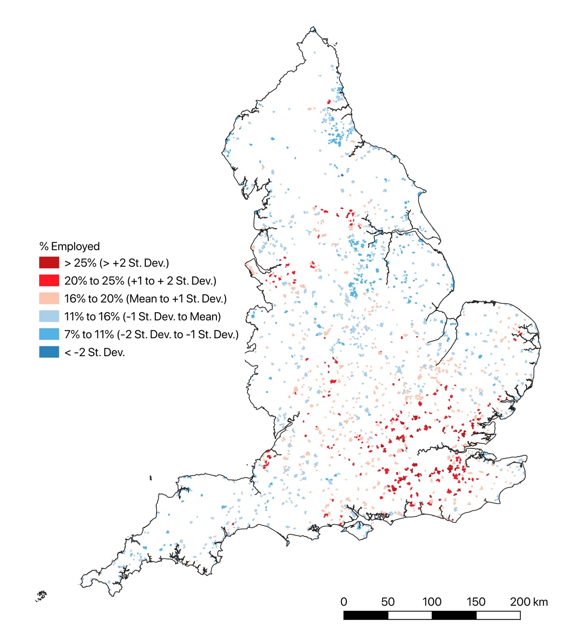
“The town has prospered, but has never become industrialised, and remains a desirable location for the fairly affluent” (Knutsford Town Plan Steering Group, 2010: 5);
“the village only sprang to life in the mid 19 Century with the discovery of spa mineral waters in 1744 … There then follows rapid growth until the 1830s, with the elegance of Georgian architecture …. at the heart of its sense of place …. Much later, mid and late 20 Century developments, suburban in style, expanded the village to its present shape” (Boston Spa Parish Council, 2020: 3).
The location of the northern settlements with high proportions of producer-service employment corresponds closely to Cunningham and Savage’s (2015: 328) identification of ‘islands of affluence’ in northern England as lying “in Cheshire and in … North Yorkshire approximating to the so-called ‘Golden Triangle with vertices in York, Harrogate and plush north-east Leeds”. These settlements, and the much larger number of small towns with high proportions of residents working within producer services in the South East of England around London, and also around Bristol, Norwich and south of Birmingham, illustrate how many small rural towns have become important sites within the service and finance economies of England.

Small Towns and the Visitor and Creative Economies
While engagement in producer services may be important in some small rural towns, much more widely recognised has been the significance of the visitor or tourist economy. Powe (2018), for example, remarks that leisure-orientated visits are widely viewed as important contributors to the economy of many rural small towns, and it was clear that the visitor economy was seen by many local authorities as major elements in current and future rural small-town economies:
“Approximately 900 people are employed in the tourism sector in Bridgnorth, of which 650 are employed in accommodation and food services and 250 in arts, entertainment, recreation and other services. This is equivalent to 19.7% of the total Bridgnorth workforce” (Shropshire Council, 2021a: 22);
“Tourism and the visitors it brings is extremely important for the economy, employment opportunities and vitality of the neighbourhood plan area. The South West Research Company in 2013 put the value of tourism to Bridport at nearly £57 million per annum and estimated that it supports over 1300 full-time equivalent jobs. Visitors to the area not only benefit those providing accommodation, but also pubs, restaurants, shops, taxi firms, and garages” (Bridport Town Council, 2020: 5);
“The town has the potential to be a key tourist destination with a history dating back to the seventh century … Our key strategic objectives include making Leominster a place … with a thriving and diverse tourism economy rooted in its unique heritage and nationally-renowned antiques trade … [and] a gateway for walking, cycling and holidays based on a range of rural activities” (RoseRegeneration, 2022b: 11-14);
“Our aim is to make Bishop Auckland’s future even more vibrant than its past … We have a bold but deliverable vision to tackle historic under-investment especially in infrastructure, to enable the town to flourish … Three ideas embody our Vision for this future. 1. Development of Bishop Auckland into a Visitor Destination of Choice with international prominence. 2. Strengthening its established position as a 21st Century market town and service centre for the whole of South West Durham. 3. Opening up the town’s potential as the gateway to County Durham’s hidden gem that is the Durham Dales” (Durham County Council, 2021: 7).
These quotes highlight how small towns can attract visitors into their built environment, both to view its buildings and consume both heritage and a range of goods and services, and/or act as a site from which visits are undertaken to a wider rural hinterland. Powe (2018: 125), whilst highlighting the widespread perception of the significance of an amenity-focused visitor economy, argues that only a “small proportion of rural towns” have the assets to attract such flows of people. It unfortunately is not possible to map the overall distribution of tourist business or employment across the small towns identified in this study, because occupational/industrial/ business classifications fail to clearly differentiate tourist-related activities at sufficient small spatial units to connect to specific built-up areas. Figure 21 did show the distribution of employment in ‘Distribution, hotels and restaurants’ and it was noted that this may reflect, in part, the influence of tourist and recreational visits to small towns, including to ones in or close to aesthetically pleasing landscapes. However, it was also noted that the distribution of such employment is reflective of other influences, not least linked to servicing the residential populations of these towns surrounding rural areas. However, given the arguments of Powe (2018: 125) and the difficulties of developing a more systematic assessment of the specific role of the visitor economy in small towns across England, it is worth highlighting that some accounts of such settlements do include references to a weakly developed visitor economy or phrase it as a desired, but not currently realised, development:
“The town has a limited leisure and tourism offer beyond its retail role. There is little marketing of the town. There are only a few restaurants and hospitality venues in the town centre. Bideford has the potential to attract more visitors as part of the tourism and leisure offer across northern Devon i.e. providing a town/retail/wet weather component alongside the beaches and rural environment of the wider area” (Hardisty Jones Associates, 2022: 11);
“the visitor economy is weak compared to the UK average … The town has a wealth of heritage buildings which has been recognised by Historic England in awarding the town Heritage Action Zone Status with a substantial funding allocation. The town’s heritage and strong antiques sector have the potential to attract a substantial number of tourists” (RoseRegeneration, 2022a: 4);
“Holsworthy is not particularly reliant on tourism, but could attempt to further cultivate the market, with a ‘rainy day offer’ or a series of events over the tourist season to attract Bude-based vacationers. This would boost spend in local shops and market. However, there is no entity with a specific remit to promote the town” (BAS Consultancy, 2020: 4).
The creative sector has also been highlighted as a potentially significant new influence on rural economies (Bell and Jayne, 2010; Bunting and Mitchell, 2001; Hunter, 2006; Verditch, 2010). Bell and Jayne (2010) argue that the counties of Cornwall, Devon, Herefordshire, Shropshire and Staffordshire have all seen active promotion of a rural creative economy, although also remark on its promotion across many other regions of England. Creativity and the creative sector were indeed highlighted as significant in contemporary rural small economies in some local authority reports related to these counties:
“Northern Devon is alive with culture. It is a dynamic ecosystem of organisations, traditions, physical and environmental heritage, creative businesses, freelancers, volunteers, hobbyists and audiences local and national. Together they create a diverse but distinctive cultural identity … There are an estimated 345 creative and cultural industries businesses operating in the region employing around 1,250 people or 1.81% of total employment in northern Devon” (North Devon Council and Torridge District Council, 2021)
“Together the place and the people have created ways of making money from their creative work. And this work has led to more jobs. And today, Cornwall has more of these people and these jobs, than any other rural area of the UK. The creativity is attracting more people, of all ages, to come and study and also live in Cornwall. So more modern-day jobs, like computer game designers, are available in Cornwall. These are some of the key reasons why Cornwall is now known as the UK’s leading rural creative economy” (Cornwall Council, 2021: 2);
“The cultural sector is important to Shropshire not just because it enriches the quality of life for its residents and visitors, it is also a vital contributor to the County’s economy … Official statistics, though useful, underplay the size of the sector as small organisations tend not to be captured … Notwithstanding this, the sector supports 15,000 jobs which are captured by official data (15,750 when sole proprietors are included), 1,380 organisations and generates a value in gross value added (GVA) terms of an estimated £432 million. This means that at least 12% of employment in Shropshire can be classed as cultural, with the sector contributing around 7% to the overall economy” (Shropshire Council, 2021c: 1).
“Falmouth has embraced the Tourism and Creative industries which now makes up a significant proportion of its local economy” (County Council Policy Officer, Cornwall);
These reports generally presented quite undifferentiated accounts of rurality, although in the case of north Devon, the small towns of Barnstaple, Bideford, Ilfracombe, Holsworthy, Great Torrington and South Moulton were all identified as “culture towns” (North Devon Council and Torridge District Council, 2021: 75), with existing or potential creative assets (see Table 9).
The accounts presented suggest there is considerable variation in the creative activity and assets of these north Devon towns, ranging from the presence of artists, galleries, museums, theatres, and other explicitly culture-focused organisations in Ilfracombe, through to a few, quite scattered organisations and, in the case of Bideford, an apparently quite disinterested population. Such accounts highlight the need to recognise localised variability in engagement with the creative economy, rather than assume regionalised promotions of a rural creative economy are reflective of its development geography. Figure 24, which shows the proportion of people recorded in the 2021 Census as working in ‘Arts, Entertainment, Recreation and Other Services’, which might be seen to loosely correspond with creative employment, presents, for example, a slightly different geography to the regional foci identified by Bell and Jayne (2010). First, it is clear that across small towns, relatively low proportions of the population are employed in the creative economy. Second, even though the counties of Cornwall, Devon, Staffordshire and Shropshire have towns which have above average employment in the sector, the numbers are still relatively low, while most of the small towns in Herefordshire have below average levels of employment. There are also many more settlements with above average levels of employment in these activities in South East England, clustered around London, as well as in the southern Midlands, around Greater Manchester, in coastal areas and in or close to National

Table 9: Small ‘Culture Towns’ Identified in the ‘North Devon Culture Strategy, 2022-2027
Towns | Description of cultural assets in the Cultural Strategy
Barnstaple | “Barnstaple has a layered and fascinating history of over 1000 years, It retains its Saxon street pattern and important heritage sites like Barnstaple castle mound and the Long Bridge and 375 listed buildings. Foregrounding this heritage in the identity of Barnstaple and making it visible in the public realm through trails, interpretation and public art can help Barnstaple build a more defined identity … that can then be reinforced by the broader cultural offer”.
Bideford | “current cultural offer of the town is fractured and sporadic. For example, there is a strong craft offer highlighted by The Burton at Bideford and independent craft businesses at the Pannier Market. However these are split either side of the town centre with little connection. Finding ways of clustering strengths such as these and encouraging them into the town centre, such as through meanwhile and pop-up activities, can help give stronger critical mass to the overall offer … Bideford has some of the highest proportions of people least likely to engage in arts and culture in northern Devon … Most arts and culture offers in the town close in the evening, … with little to draw people in after 5pm. Facilitating evening activity is a key area where the cultural sector can work together with business, retail and town centre commercial whether through meanwhile activations, evening events or cultural venues … Bideford has got some great small creative businesses, particularly in areas like PR and marketing. However, the sector is small, lacks critical mass and suffers from an absence of supportive infrastructure. Creative workspace and target creative sector business support can help give a centre of gravity to the town’s creative industries”.
Ilfracombe | “a fantastic array of independent galleries, a statement theatre at the Landmark and cultural organisations with strong links in the community like Ilfracombe Museum and the Space. However, no single partner has the capacity to leverage cultural change in the area on its own and established organisations have a responsibility to bring smaller independents into the conversation about collectively supporting change in the town … With iconic venues like the Landmark, stunning setting and tourism heritage, Ilfracombe is ideally suited to festival approaches to culture … The number of artists both within Ilfracombe and in surrounding places like Braunton and Combe Martin alongside the beautiful but decaying architecture of the town lends itself well to public art and street art programmes … The recent success of the new watersports facility along with Ilfracombe’s associations with sailing, surfing and maritime heritage make a strong thread for the cultural sector to celebrate and amplify”.
Holsworthy | “currently underserved in terms of cultural infrastructure … Addressing this either through increased activity by other northern Devon organisations in the town, enhancement of existing infrastructure such as Holsworthy Amateur Theatrical Society or the development of new programmes is needed”.
Great Torrington | “a distinctive Civil War story and the benefits of the Plough Arts Centre and nearby RHS Rosemoor. Ensuring that cultural activity is well publicised, accessible and integrates a strong youth offer will help to grow from this strong foundation”.
South Moulton | “a strong community-led cultural offer, an active One Northern Devon group, vibrant Pannier Market and important assets like Arts Destination South Molton and Quince Honey Farm. Supporting the development of this and spreading learning of best practice to other communities should be prioritised”.
Source: North Devon Council &Torridge District Council (2022) Flourishing Culture (Pitsea: Things Made Public CIC): 79-80.

Figure 24: Percentage of People Employed in Small Towns within the Arts, Entertainment, Recreation and Other Services,2021

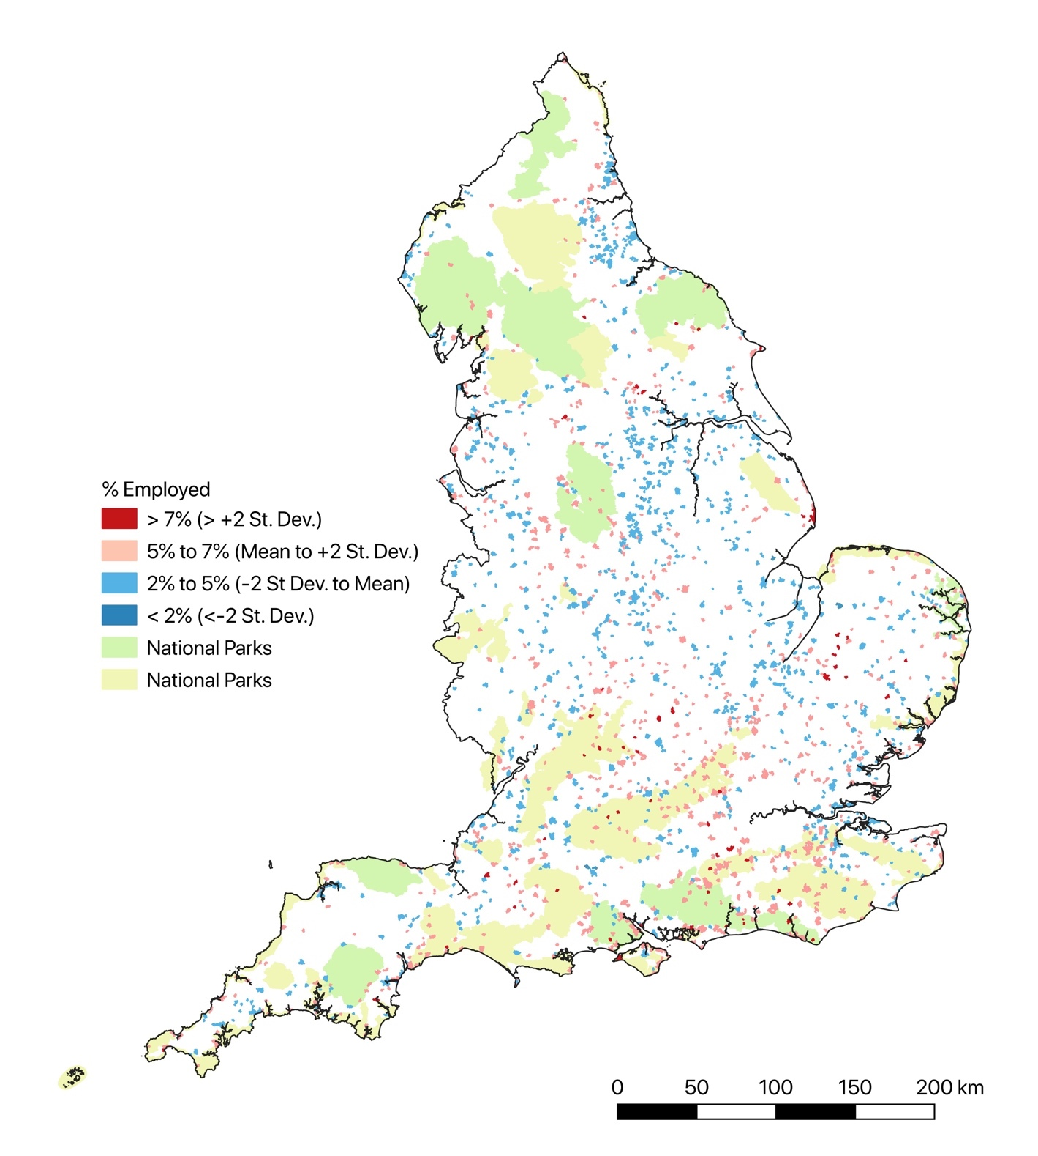 Parks or areas of National Landscapes. Such distributions may be seen to reflect arguments that the location of creative employment in rural areas may reflect counterurban, amenity focused, migration (Bell and Jayne, 2010), both by those seeking an ‘escape’ to a distant rurality and those seeking areas with connectivity to urban cultural centres (Bunting and Mitchell, 2000). Support for such arguments can be gleaned from local reports. In Bridport, for example, a study by the town council remarks on the role of in-migration in fostering a local arts scene:
“In the 21st Century, Bridport’s arts scene has expanded with an arts centre, theatre, cinema, and museum. Many artists have settled locally. Working in studios scattered around the Bridport area artists exhibit their work during Dorset Art Weeks and Bridport open studios” (Bridport Town Council, 2020: 10).
In Market Harborough, Leicestershire, connections are also made to in-migration fostering the emergence of a creative sector, it being claimed that the town has one of the “largest concentrations” of people working in the creative industries in Leicestershire, outside of the city of Leicester (ERS Consulting, 2016: 4), although many people moving into the town commute to this nearby city or to London. Such examples indicate that there may actually be quite different strands of counterurban migration exerting an influence on the distribution of creative sector workers in small towns, with these migrational streams potentially connected to different practices of creative working, such as Bell and Jayne’s (2010: 2014) differentiation of “high-end or contemporary designer-makers” and “hobbyists and traditionalists”.

Socio-Economic Change and Challenge in Rural Small Town Centres
The previous section provided a general snapshot of the character of small towns in England, and also at times pointed to some changes that have occurred in these settlements. This section of the report will further explore changes that have occurred in these settlements and the challenges these might create, focusing particularly on those that impact their central areas. In addition, it will discuss actions undertaken to address these challenges, and the opportunities that change may create.

Marketplaces and Public Spaces in Small Towns
As discussed earlier in this report, small rural towns have historically been viewed as settlements for the marketing of agricultural produce, with centres of these towns often being marked by the presence of a marketplace and/or market hall. Whilst it was also noted that many small rural towns did not have a market, and many that historically had some form of market or fair have seen these cease to exist, it is also evident that in many small towns, markets still form a central feature within the townscape, even if they have become less important economically:
“Bromyard will build on its proud market town heritage to attract people to live, to work, to invest, to visit and to play” (RoseRegeneration (2021a: 4);
“Kington Market Hall is the most prominent public building in the town serving as the town's market hall and as a key hub/ focus for the town centre” (RoseRegeneration, 2021b: 14);
“The Town Centre boasts characterful buildings, including its historic Market Square …, with a thriving café culture” (Wychavon District Council, 2022b: 22-30);
“Pershore has a vibrant independent retail and food and beverage offer, with 93% of businesses being independents, compared to 64% in comparator towns nationally. Footfall is heavily concentrated on the central section of the High Street, anchored by the Indoor Retail Market to the north and ASDA supermarket in the centre” (Wychavon District Council, 2022c: 32).
There were also a few instances where plans were expressed about expanding existing or creating new market facilities, or intensifying their use, either materially or symbolically as a constituent of an historic and/or aesthetically pleasing townscape:
“a strategic approach to curating the town centre is possible … The Town Council can support this initiative with longer market hours and promotion … Greater links can be formed between the cattle market and town-centre economy. Market research should be undertaken with the customers of the market on what can be provided in the town centre to patrons and their families. Additionally, the cattle market can be developed to act as an attraction for Holsworthy, with tours of the cattle auctions. When not in use, it could host an information centre to act as a focal point for the Ruby Country initiative” (BAS Consultancy, 2020: 6-7);
“Bromyard town centre is home to a variety of independent retail businesses and has the potential capacity to host a regular weekly market in the market square … Market square improvements to encourage a sustainable street culture and evening economy, supporting a market, festivals, and arts' projects and including a performance space” (RoseRegeneration, 2021a: 9-18);
“the masterplan proposes a number of developments to reinforce the north and centre of the town. This cluster of projects takes advantage of the high-quality townscape (at Market Place, the arcades, the river and Moneys Yard) to create a leisure, cafe and independent retail focus. Market Place and its town market needs to be reinstated as a destination” (Lincolnshire County Council et al., 2011: 61).
It was, however, also evident that in many small towns, marketplaces and halls were facilities that had declined economically and physically, in many instances to such an extent that their future had become a focus of concern and deliberation:
“the refurbishment and repurposing of the Market Hall would reclaim one of the most attractive and important spaces in Kington, underpinning footfall and creating a visible anchor for the town’s visitor economy … The proposal is to renovate/refurbish Kington Market Hall and surrounding area and to utilise the market hall as a focus for crafts and associated activities … The core building is a Victorian red brick market hall dating back to 1885. A refurbished building could provide a real focal point for the town centre and could be used to hold a wider range of regular markets as well as other events and activities including craft fairs, events and festivals. The primary focus should be more regular and wide-ranging markets etc. There is also an opportunity to include interpretive material about the Town” (RoseRegeneration, 2021b: 14-32);
“The redevelopment of Pershore Market and surrounding light industrial uses provides an opportunity to regenerate a significant gateway site and build upon the success of Pershore Market by expanding and diversifying its offer … Part of this site is allocated for up to 20 new homes alongside retail and office uses, however, there is significant mixed use redevelopment potential beyond this allocation. The site presents a residential-led redevelopment opportunity, including two-storey dwellings (two and three bed), Extra Care or later living accommodation or other residential, alongside a small proportion of apartments … A mixed-use and leisure-led development creates a contemporary produce and makers market, flexible work and incubator space as well as Extra Care and food retail, set within a high-quality public realm that reconnects the historic core of the town with its riverside and landscape” (Wychavon District Council, 2022c: 81-82);
“Market House & Market Apron Revitalisation … a potentially transformative project for Ross High Street and the wider town when considered in the context of the pedestrianisation of the High Street and investments in the routes linking the town and the river. This combined package of investments would deliver significant benefits in terms of the community and tourism offer, and support a stronger, more diverse and resilient High Street retail offering. RTC is already committing funds and seeking grants to renovate the 17th Century Market House and has commissioned an Architect to prepare the tender documentation set. Two options are being considered, one is to ‘glass in’ the ground floor of the Market House, and the second is to seek Herefordshire County Council’s permission to terrace the Market Apron and create a central focus to the Town Centre. E.g. on non-market days extending the popular ‘tables under the market house’ service. It will also create opportunities to hire out the ground floor of the Market House ... Ross Town Council would seek to contribute £200k. Other sources of funding include Historic England and National Lottery with £1M - £1.5M and the RTC could contribute £200k … It will attract greater footfall within the Town Centre, supporting 6+ independent coffee/tea rooms” (RoseRegeneration, 2021b: 35).
These quotes highlight how a range of different futures were being envisaged for marketplaces and halls in these small towns, including renovation, refurbishment, repurposing and redevelopment. In some cases, the envisaged changes seemed to involve effective cessation of use of these locations as a place of market trading, although in other instances this continues, albeit potentially refocused or diversified into the selling of crafts and food, in part related to the hosting of events and festivals.
Such changes can be seen to support the arguments of Gonzalez and Waley (2013: 965) that attempts to ‘revitalise’ indoor and outdoor markers have often involved their "redevelopment along gentrified lines" (see also Coles and Crang, 2011; Coles, 2014; Gonzalez, 2019; Watson and Wells, 2005), although, conversely, they note that many others have experienced accelerated decline and closure. It is unfortunate that there are no contemporary official listings of town markets in the UK, although the National Association of British Markets and the National Market Traders Federation have calculated from surveys of their members that there were 1,150 markets in the UK in 2022, 84% of which were run by local authorities in 2022 (National Association of British Markets, 2022). The surveys indicated that the number of markets and market stall occupancy had declined, respectively falling by 574 and 5% between 2018 and 2022, with the latter lying at 72% in 2022 (National Mission for Markets, 2018; National Association of British Markets, 2022). Furthermore, it was recorded that only 8% of traders were under 40 and only 40% of markets made an annual financial surplus (National Association of British Markets, 2022). An account of the market in the Devon town of Holsworthy certainly painted a similar picture of declining use, even if it also argued for the continuing significance of the market to this town:
“The Wednesday market is now taking a quarter of the space it filled a few years ago, but it has been picking up slightly since lockdown. It is reported anecdotally that where the market day used to be the busiest shopping day for Holsworthy, it is now the quietest. Although the market has been declining, there is much support for it, and Holsworthy promotes itself as a historic market town, suggesting that it goes some ways to defining local identity” (BAS Consultancy, 2020: 4).
Gonzales and Watson (2015) argue that reasons for marketplace decline identified in policy and trade literatures include: competition from alternative retail outlets, particularly supermarkets; changing consumer expectations about retail facilities and experiences; lack of investment in market facilities; decline in the number of people wishing to become market traders; and producer by-passing of retail markets through selling to wholesalers, supermarkets and direct to consumer, including via so-called ‘farmers markets’, as well as via farm shops, product outlets and box schemes (Kirwan, 2004; Seyfang, 2007). Gonzales and Watson (2015: 968), however, argue that the apparent decline in markets needed to be understood in wider contexts, including not only transformations in the wider retail sector, but also changing state dynamics, which have often led to retail markets being viewed principally as sources of revenue to help support pressurised “public budgets”, with there being “little reinvestment, resulting in … physical decline”. They also argue that changes created through retail market redevelopments often adversely impact previous users of these markets, both because developments frequently foster price rises as rents are increased to help generate income for the authorities undertaking the development, and because there is frequently an ‘up-market’ shift in the products being sold, with there often being “a particular emphasis on arts and crafts produce and ‘quality’ food” (Gonzales and Watson, 2015: 976). The first two products were indeed promoted as outcomes of market redevelopment schemes discussed earlier.
Gonzales and Watson (2015) also suggest that farmer’s markets may attract more affluent consumers than general retail markets, and it was evident that many small towns had, or planned to, become a site for such markets, and also for craft and maker markets:
“Fore Street is at the civic heart of the changing Callington community as it has been for centuries. Following its greening and pedestrianisation in the early 2020s the street became an improved focus for the town – a great place to visit local shops; cafés; pubs; a place to live and to work; to sit out when the weather is good and to visit the local farmers and produce market which now spreads throughout the centre of town” (Callington Town Council, 2021: 39);
“Temporary street closures to allow for Makers Market and Cultural Event” (Wychavon District Council, 2022a: 87).
“It will provide the setting for great farmers’ markets and be a hive of activity on market days, both within the Town Centre and providing a wider leisure offer alongside the River Avon” (Wychavon District Council (2022b: 53).
As these quotes illustrate, some of these new markets were located in the infrastructures employed for more general retail markets - i.e. they were conducted in pre-existing marketplaces or halls – whilst others were held in other locations, such as in streets temporarily closed from use by vehicles.
The use of streets and pre-existing market infrastructures could often be implemented without substantial financial costs, but many of the major refurbishments and redevelopments of marketplaces and halls could involve substantial expenditures, and it was clear that this often acted as a major barrier to effecting change:
“it is unlikely that normal development equations would lead to this level of key high street investment. This is particularly true in view of the need to think about long-term re-visioning of the High Street. Many of the approaches proposed to redeveloping commercial space, which supports commercial development do not fit traditional investment models. A local authority is equipped to borrow at lower commercial rates and take a very long view in the way it approaches regeneration, having regard to social value alongside commercial returns” (RoseRegeneration, 2021b: 24).
It was also evident that marketplaces and halls were not the only infrastructures in small towns experiencing change and challenging futures, as clearly illustrated in the quotes below:
“There is an opportunity to relocate the Police and Fire Stations from their current location in Churchill Road. This will also allow the existing site to be redeveloped as a mixed retail/housing scheme. It should also improve operational efficiency, make revenue savings and deliver an improved service to the public. Herefordshire Council could acquire the existing sites for redevelopment to deliver new homes for the Town. Alternatively, the sites could be sold to a private developer” (RoseRegeneration, 2021b: 22);
“leisure centre is the primary indoor sports facility in the town and is well-used by all age groups, but it requires improvements to cater for the growing needs of the town and surrounding villages, especially considering the large housing development planned at Vearse Farm and the pressures that this is likely to place on several local services. In addition, indications suggest that financial support from the local authority for the management of the swimming pool could be under threat” (Bridport Town Council, 2020: 48);
“relocation of the Town Council to the Master’s House to allow repurposing of the existing building for holiday let and wider tourism/local facilities to generate revenue and add to the Towns Heritage Tourism offering. Provisional Cost - £500,000 … The relocation of the Town Council could be effected through space provision within the Master’s House leased from Herefordshire Council” (RoseRegeneration, 2022a: 20-27);
“This iconic listed building is in a key location near to the hub of the town centre. The building is in disrepair and needs significant investment it has potential for a range of uses … The building has been derelict for a number of years and has been in a number of different ownerships but no viable scheme has yet come forward. The building and associated site have the potential to be converted into a number of commercial, office, residential or other uses” (RoseRegeneration, 2021b: 33);
“Wychavon District Council has freehold ownership of the Public Hall, a proud Grade II listed building which comprises the western part of the current Riverside Centre. Wychavon District Council has committed £3.9 million to refurbish the building to create a new events venue and home for Evesham Arts Centre Association” (Wychavon District Council, 2022b: 73).
In some towns, it was evident that a series of buildings used for the provision of welfare and other public services to residents in and around these settlements, had been left unused for many years, in some instances becoming dilapidated, and would require significant investments to refurbish and/or repurpose.
Council and other bodies with plans to address perceived declines in town centre areas appeared to often focus their actions on lower cost ‘improvements’ to 'the public realm' rather than on refurbishing or repurposing public buildings. Public realm concerns and actions often focused on the visual appearance of streets and public spaces, including open marketplaces, town squares and retail spaces such as shopping centres:
“The street scene of the centre has been classed as poor, with very little street furniture, apart from a few benches and some bins. Derwent Parade in particular, looks very dated, untidy and has no real character or sense of place, despite it being a large, spacious area” (Thurrock District Council, 2018: 35);
“it is widely accepted that improving the town’s public realm and making it a more attractive destination for both residents and visitors will benefit the local economy and promote future growth within the town … Public realm improvement … by delivering new street furniture, signage, planters etc, in keeping with the town’s heritage” (RoseRegeneration, 2021a: 9-18)
“The proposal is to purchase and install multi-purpose brackets, light fittings and seasonal decorations in key locations in and around Kington High Street. Once installed the brackets/fittings can be used to light and decorate the Town as appropriate during key activities and events throughout the year. The fittings will be multi-purpose to allow bunting, flags, banners and Christmas lighting to be added to the streetscape to make the Town more attractive as well as to help promote key events and other activities” (RoseRegeneration, 2021b: 34).
The degree to which activities such as adding street furniture, signage, plants and lighting can address the disinvestment and functional transformations that many rural small towns have experienced is questionable, although there was, in some instances, a recognition that they needed to be accompanied by increased economic support and investment:
“Investment in the public realm needs to be complemented by investment in the frontages of shops and other town centre buildings to make the town a place to visit and spend time in. A grant scheme is required to encourage property owners to invest in town centre properties. It is suggested that any grant from the scheme would need to be 50% matched by the private property owners making the application” (RoseRegeneration, 2021b: 25).
Lack of use of marketplaces, halls and other public buildings not only often raised investment and redevelopment questions, but also raised questions concerning the delivery of their associated services, and it was clear that declining service provision was a focus of concern within many small towns:
“10 years ago the local Borough Council was open to the public 5 days per week. Now it only opens 1 day per week on a limited basis” Town Council Clerk, undisclosed location);
“The police are less responsive, less present in the area and therefore less respected by the community” (Town Council Clerk, Eastern England);
“Lack of dentists, increasing waits for doctors, school classrooms expanding … More funding [needed] for public toilets, footpaths and cemeteries, as councils are cash strapped and these services really suffering” (Town Councillor, West Midlands);
“It has 540 under 16 year olds who have limited access to activities and opportunities” (RoseRegeneration, 2021b: 4);
“economic challenges … [include the] loss of good quality public sector jobs as it withdraws from communities, impacting spend and loss of public services, with particular adverse impacts on digitally excluded and vulnerable cohorts” (Town Council Clerk, undisclosed location).
As illustrated in some of these quotes, expressions of concern about access to services connected to a series of economic and social issues, including employment, social inclusion and the welfare of specific social groups, and also often spanned private and third sector, as well as public service provisions, as illustrated in the next section.

Changing Retail and Service Provision
Retailing and service provisions have been seen to have undergone significant change in small towns since at least the 1990s (e.g. Guy 1990; Bromley and Thomas, 1995; Thomas and Bromley 2003), with concerns raised about the impacts on high street provisions of service rationalisation by retailers, banks and public-service providers, as well as the price competitiveness of their shops in the context of increasing personal mobility which may encourage travel to other retail locations (Findlay et al., 2001; Guy, 1990; Lumpkin et al., 1986; Marjanen, 2000). These may include ‘out of town’ shopping centres and retail parks and outlet stores, which expanded rapidly in number from the 1980s (Thomas and Bromley, 2003), or retail centres in other nearby town or city centres. Findlay et al. (2001: 2) have observed that processes of retail rationalisation and concentration can be “at odds with” populations trends such as counterurban migration which have fostered population dispersal, and concerns have been expressed about the formation of both ‘spirals of decline’ in existing town centres in “middle order settlements” (Thomas et al, 2003: 48) and the emergence of ‘food deserts’ because of a lack of retail establishments to purchase fresh food (Furey et al. 2001), which may stem variously from such processes of decline or from the construction of new housing areas without any accompanying retail provision. The latter issue was highlighted by one respondent to the questionnaire, who commented that the small town where they lived was “rapidly expanding faster than amenities can keep up”, through the construction of “large housing developments” that exhibited a “lack of amenities” (Town Councillor, West Midlands). Courtney et al. (2007: 1219), however, have suggested that heightened personal mobilities may encourage a "diverse range of firms and individuals to re-locate to these rural settlements", or at least to some of these, such as those that exhibit the features associated with the ‘Indie high street’ of the CDRC classification. However, concerns have also been raised about declines in the number of independent retailers in the face of competition from multi-store retail chains (Furey et al. 2001).
Many of the changes identified as impacting retailing in rural small towns can be seen to reflect wider changes in the retail sector, and it has been argued that this sector has experienced significant further change since those identified in studies of the 1990s and 2000s. Hubbard (2017), for example, has argued that there has been a profound shift in how the 'high street' in towns and cities of the UK have been represented. Up until the financial crisis of 2007-2008, the high street, or the principal shopping area of a town or city, was, he claims, largely viewed as an indicator of economic vibrancy and success, as it was where retailers competed to be located and land values within settlement tended to be highest. Hubbard argues, however, that in the years following the global financial crisis, high streets became increasingly portrayed as areas in crisis, with a series of major retailers either closing stores in many places, including many small rural towns, or going out of business (e.g. Woolworths, British Home Stores, Comet, Blockbusters). The reasons for this were not simply financial, but also included competition from other retail locations, such as out of town retail parks and shopping and outlet centres, plus the rise of on-line shopping. As illustrated by the quote below, the significance of these general changes to retail provision was recognised as being of considerable significance to economic life within rural small towns:
“Ever-changing consumer shopping preferences are causing uncertainty for the future viability of small-scale, retail activity in Bridport. The move to internet-based shopping is having wide ranging impacts on high streets across the country, driving shop closures and reducing the range of the retail offer” (Bridport Town Council: 71).
Hubbard (2017) argues that the consequences of these changes in retailing and consumer behaviour included a growing presence of empty retail premises within many city and town centres, which resulted in the UK Government commissioning the ‘Portas Review’ to examine the state of high streets and town centres in the UK. This argued that a “downward spiral of decline” (Portas 2011: 9) was evident in many town centres, in which retail closures not only meant that people may have less reason to visit a shopping area, but that the presence of empty shops itself acted as a deterrent to people through reducing the “attractiveness and desirability” (ibid.: 35) of an area. The report argued that:
“The problems associated with empty properties are considerable. They attract vandalism and increase insecurity and fear. And this all reduces the value of surrounding businesses and homes. So the decision to leave a property empty is not just a private matter for the landlord. It affects us all. Innovative solutions could add value to not just the individual properties but to the surrounding area” (Portas 2011: 9).

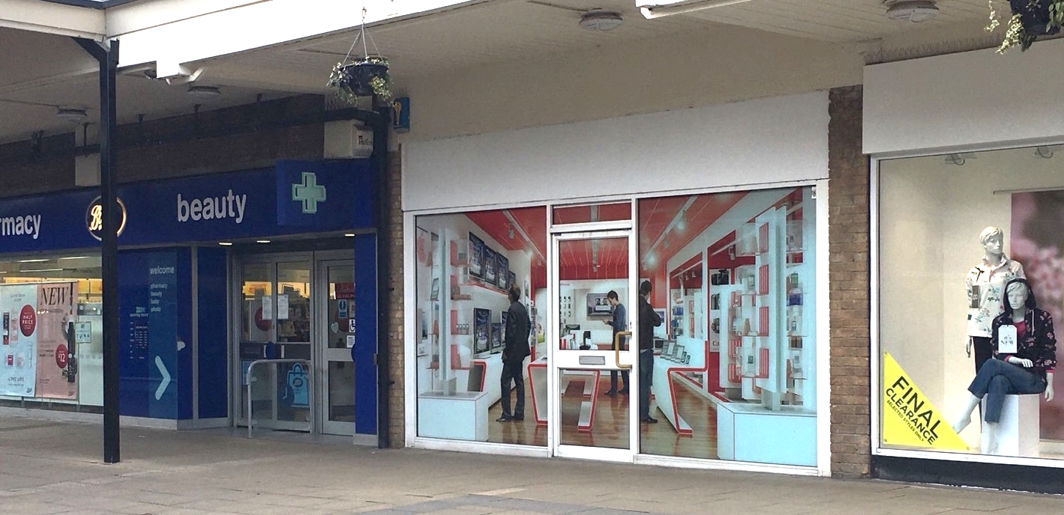
Figure 25: Use of Mock Shop Fronts
Source: The author
The report proposed a series of actions that might be taken to address the formation of such spirals of decline, including the removal of empty property tax relief from owners of retail properties who fail to invest in them; the use of financial penalties for landlords with a large proportion of vacant properties; greater use of Compulsory Purchase Orders by local authorities; and the establishment of ‘Empty Shop Management Orders’ that would allow local authorities to “enter and upgrade strategic properties that have been left empty”. As Dobson (2012-13: 115) records, initial responses to the report were “striking”, and 12 “Portas pilot” towns were allocated funding to address issues in their retail high streets and town centres, plus its analysis of the challenges facing high street retailing was supported in subsequent reports (e.g. Distressed Town Centre Property Taskforce, 2013; High Streets Expert Panel, 2018). However, Wrigley and Lambiri (2015: 3) note that a year after its publication “vacancy rates in British town centres and high streets has risen to … peak levels”, and arguably one of its most widespread impacts has been to provide legitimacy to schemes to improve the appearance of shopfront and to disguise the presence of empty retail units through the use of mock shop fronts for unlet retail properties (see Figure 25).
The presence of vacant retail properties in town centres was clearly an issue of concern for many people involved in the planning and management of small towns:
“The town does not always present itself at its best, with the condition of some of the heritage buildings and shop fronts in disrepair” (BAS Consultancy, 2020: 4);
“12% of all commercial premises were vacant in 2022 - the rate has increased since 2021 with two additional vacant units … The number of vacant premises … has fluctuated slightly in recent years. In 2019 there were five vacant premises. This number had fallen to three by 2020 and crept back up to four in 2021. By 2022 the number had risen still further to six, which is the equivalent of almost 500m² floor space … The vacancy rate is high compared to many Shropshire towns but is also lower than the national average, which stood at 13.9% in the third quarter of 2022 according to BRC (data relating to high streets only). There are five vacant premises on the High Street and one on Station Road. (11%)” (Shropshire Council, 2022a: 1-16);
“The night time economy of the local centre is poor, with approximately 25% of units open after 7pm … A large proportion of units within the centre are vacant” (Thurrock District Council, 2018: 35)
“10% of Bishop’s Castle town centre outlets are vacant (10% of gross floor space), which is the equivalent of 7 units covering around 850m² floor space. This is around average in comparison with similar-sized market towns in Shropshire (11% vacancy rate across the Shropshire towns surveyed). The 2022 vacancy rate was lower than the national average … Two vacant premises are on Church Street, two are on the High Street, two in Market Square and one in New Street. The number of vacancies remained the same in 2022 compared with the previous year, but remains one higher than the number recorded in 2019 … Five premises which were vacant in 2021 remained so in 2022. Two new vacant properties were recorded in 2022, but these were cancelled out by two previously vacant premises becoming filled” (Shropshire Council (2022b: 22).
Such comments were also often accompanied by reference to policies and initiatives focused on improving the visual appearance of shops:
“To protect the attractive characteristics of areas main shopping areas it is necessary to conserve the vitality and interest of the historic street scene. This is achieved by protecting the collective and individual qualities of shopfronts, whilst recognising modern retail needs … Using sensitive design and careful attention to detail, a shop can promote its image through its unique quality … By describing the character of the retail heritage of the neighbourhood plan area the intention is to provide businesses, retailers, landowners and developers with the starting point for developments that will respect and add to the special character of the Plan area” (Bridport Town Council, 2020: 58);
“A public sector grant scheme is proposed to encourage investment in the frontages of shops and other town centre buildings to make the town a place to visit and spend time in. Elsewhere in the country grant schemes have been successfully used to encourage property owners to invest in town centre properties. Provisional budget - £75,000 … It is suggested that any grant from the scheme would need to be 50% matched by the private property owners making the application. It is recommended that grants should be dependent on the property condition and private sector match would need to be between £1000 and £5000 per property” (RoseRegeneration, 2021b: 20-25).
Although there is reference to finance grants to businesses in the second account, the focus on the visual appearance of retail premises has been subject to similar lines of critique as levelled at aesthetically focused public realm interventions, including that they tend to reinforce rather than mitigate existing economic and social inequalities. Hubbard (2017: 22), for example, argues that aesthetic focused retail schemes often implicitly enact a retail gentrification logic, whereby ‘improvement’ of visual appearance is seen as a mechanism to “reverse images of decline” via “attracting new visitors” that act to widen,
“the client base of the High Street through an overt targeting of the middle classes … New Business, preferably independent and locally owned, are courted, sometimes offered vacant properties, at heavily discounted rentals. Art galleries, vintage boutiques and cafés are privileged, alongside other ‘healthy facilities that can bestow users with some form of educational, cultural or social capital”.
In relation to this study, there were, as has been previously discussed, frequent references to the value of independent retailers to the economy of many small towns, and claims that these shops provided not only a source of local economic resilience, but also desired liveability:
“Existing units are small and reﬂect the presence of smaller and independent occupiers. Whilst national multiples are present in the town centre there is also a notable absence of other multiples that might be expected to have a presence in the town” (Lincolnshire County Council, et al., 2011: 38).
“Bridport town centre is vibrant and faring well. It compares well with other similar sized market towns in the south west. It appears to have built a distinctive offer based upon a good range of shops, many of which are independents … The character and vitality of the Centre of Bridport owes a lot to the locally-owned and largely independent businesses that bring financial benefit and security to those living and working in the area” (Bridport Town Council, 2020: 70-71);
“Saffron Walden has boomed in recent years. Affluent residents like to support local independent traders rather than going to 'clone towns'. The mix of an attractive town setting and a good range of shops has made the town successful” (Economic Development Office, Eastern England).
However, there were also expressions of concern about the strength and resilience of independent retailing in small towns:
“As with many small locations, its retail and wider service catchment is threatened by a lack of financial capacity amongst many of its businesses” (RoseRegeneration, 2021a: 12)
“Three premises in the town have been converted from a commercial entity into residential accommodation since 2019, with a possibility that two more will follow suit …The retail centre of Cleobury Mortimer is amongst the smallest in Shropshire, with just 36 commercial enterprises in operation” (Shropshire Council, 2021b: 1-3);
“some of the independently run businesses … have little embedded value and as shopkeepers retire, there will be few buyers for the business as a going concern. … a concern at the numbers of town centre businesses run as ‘hobbies’ - closing early to provide the business owner with a balanced lifestyle" (BAS Consultancy 2020).
Expressions of concerns over retailing futures did not simply relate to the independent retail sector, but encompassed many other agencies and processes in this sector identified in previous studies of small town retailing. Powe (2012), for example, highlighted the contradictory pressures surrounding the establishment of ‘large format’ stores in small rural towns. On the one hand, the establishment of such stores is often welcomed by the residents of such towns as they may be able to offer a wider, and cheaper, range of products than available within smaller scale units. However, as Powe details, they can be difficult to accommodate physically, aesthetically and economically within a small-town context, which has often led to attempts to restrict their development, although this has been seen to potentially foster further retail decline as consumers simply resort to increased ‘out-of-town shopping’. This complex combination of concerns was evident within many accounts of the retail structure of rural towns:
“The centre of Evesham is dominated by a failed shopping centre which has a debilitating impact on investor confidence across the town centre” (Economic Development Officer, South West England);
“residents … are frequent visitors to other nearby shopping centres which offer a greater choice of comparison retail and more leisure and hospitality opportunities.” (Shropshire County Council, 2022a: 8);
“Retail continues to be an important sector for the town. The growth of the town requires a strong retail offer in order to retain and attract expenditure from the residents in the local catchment … Leominster has some convenience and comparison retail floor space need … In terms of convenience retail, this could create the opportunity for an additional food store development in the town centre, which would draw more shoppers into the centre and complement the existing independent convenience shops. Small scale convenience retail will be provided within the urban extension to meet the day to day needs of the residents of the new development … priority should be to steer any new floorspace to the town centre as far as this is practical, and only to permit out of centre facilities if they would materially enhance the retail offer of the town” (RoseRegeneration, 2022b: 10).
There were also expressions of concern about the impact of online shopping, and the impacts this could have on town centre retailing:
“Like towns across the country, our small towns have been impacted by changing consumer habits such as online shopping and increased home-working” (Economic Development Officer, West Midlands);
“Increase of online trading has negatively impacted on town centre occupancy“ (Local Economic Partnership Officer, West Midlands);
“the rise of online shopping has affected the town centre and the weekly market” (Town Council Clerk, South West England);
“economic challenges … [include] sustaining the high street offer … [given the] impact of on-line and out of town providers, and inflationary pressure on spend. Hospitality and discretionary spend especially badly hit” (Town Council Clerk, undisclosed location).
There was also evidence of local business and policy responses and wishes related to the rise of online shopping:
“Virtual high street – consolidated online town shopping offer, enabling people to order online from a range of shops to click and collect or arrange home delivery. ShopAppy is an example of this and has been used by towns to help during the Covid recovery period” (BAS Consultancy, 2020: 7);
“Ledbury has a range of independent … specialist shops which attract visitors from further afield and have also created online businesses” (RoseRegeneration, 2022a: 14);
“Change in business rates [needed] to make the distinction between physical shops and online sales fairer” (Economic Development Officer, Eastern England).
Concerns over retail decline have, as Hubbard (2017) records, led to a growing discourse that presents retail high streets as being potentially in a terminal crisis, with the phrase the ‘Death of the High Street’ appearing crisis appearing in both popular and policy discourses (e.g. Osborne and Butler, 2019). A series of policy initiatives emerged in response, including the Our Plan for the High Street (HM Treasure, 2018) and the associated Future High Streets Fund (MHCLG, 2018) and the Towns Fund (MHCLG, 2019), focused in part on supporting retail businesses to remain in town centre premises, for instance through providing business rate reductions, but also facilitating transitions to alternative uses of these spaces, including for housing, leisure, culture, education and as a social and experiential space. Within these policy discourses and initiatives there have also been calls to reduce the size of retail areas, accepting that there may be less need for physical retailing space, but also seeking to maximise the benefits that physical proximity may bring when people do visit such retail spaces. Powe and Oswell (2022) suggest that a series of concepts have emerged reflecting this idea, including ‘smart-decline’, ‘rightsizing’ and ‘town centre shrinkage’, although it has also been called ‘retail shrinkage’ (Talen, 2022).
The local policy documents examined and the questionnaire responses received primarily focused on the provision of support to retain, and if possible, expand retail provision within small towns, and there were no direct references to concepts such as ‘smart-decline’, ‘right-sizing or ‘shrinking’ the town centre or high street. There were, however, comments referring to conversions/repurposing of retail spaces to other uses:
“There would be a demand from residents from in and outside Bromyard for more friendly, up to date exercise options (particularly focused on modern trends like yoga pilates spinning etc)” (RoseRegeneration, 2021a: 20);
“Residents and visitors are seeking a broader offer than solely retail within town centres. This development provides the opportunity to create a more experiential retail offer coupling retail outlets alongside food and beverage, appealing to new independent-retailers and eateries, as well as extending opening hours beyond 9-5. As is the case with many regional towns, there is scope to rationalise the quantum of retail floorspace and repurpose elements to bring in community uses as well as residential provision in the heart of the Town Centre” (Wychavon District Council, 2022a: 82).
It is also important, given the evidence presented earlier in this report about the economic and social diversity evident across rural small towns, to note that the specific, and changing character, of specific settlements may create very particular service needs, and indeed opportunities. Reference was made earlier to the aged population demographic in many small rural towns, particularly those in coastal locations or in or close to aesthetically valued landscapes, and it was evident that servicing the health needs of these populations was an issue of concern in many locations, as well as also seen in some cases to provide valuable economic opportunities:
"The care sector is important to the town with many jobs in health and social care and there is a need to recognise the skills needs in this sector as demand continues to increase linked to an ageing population" (Rose Regeneration 2021a, 10);
“Greater consideration is needed to address the ageing demographic, particularly related to healthcare, and the specific needs of people with disabilities” (Bridport Town Council, 2019: 9)
“There are seven health care providers in Bridgnorth town centre, which are allocated approximately 480m² gross floor space. Included within this number are a dentist, a denture repairer, an osteopath, alternative health provision and a therapist” (Shropshire Council; 2021a: 25).
There were also comments about the difficulties that responding to such changes could entail and how addressing them often fell to third-sector, volunteer-based organisations, because of limitations facing public sector providers:
“in Sleaford, key challenge is for the town centre, which is the main retail and service centre for the District, to respond to the changing retail habits of the wider population and maintain its role as a key service centre for the District. This means adapting its historic, traditional town centre role, enhancing its services to keep pace with rapid population growth e.g. health, leisure etc. But to deliver this, we need funding, which up to now, because of our wider District demographics, we struggle to compete with areas that have far worse deprivation statistics. On the face of it, we are seen as prosperous, when that in reality we have underlying issues that need to be tackled” (Economic Development Officer, East Midlands);
“More support for the voluntary sector to carry on the great work they do filling in gaps in service provision” (Town Council Clerk, Eastern England).
Overall it is clear that retail and public service provisions in small towns have faced a series of significant challenges in recent years, reflective of both wider dynamics in state activity, retailing and consumer behaviours and more localised dynamics such as patterns of in- and out-migration by particular socio-demographic groups, the material structuring of townscapes, and responses by people working in local businesses, governmental bodies and third sector organisations. Whilst the focus of many responses was on seeking to protect and support retailing, or particular sectors of this, such as independent stores, there was also widespread recognition that the central areas of towns might need to become much more than spaces focused around the retailing of commodities and services.

Small-Town Festival Economies
In part a diversification of the central areas of many small towns had emerged prior to discourses related to a crisis in retailing, the death of high streets or smart-decline/rightsizing/shrinkage, in that, as discussed earlier, many rural small towns had become significantly influenced by the tourist/visitor economy. Indeed, it has already been noted that in such locations, many retailers may be highly dependent on serving customers who are visitors, and also that visitors may be attracted into town centres by not only their retail provisions, but also by heritage and cultural attractions and experiences, features that were also stressed in the earlier discussions of the creative economy. As illustrated by the quote below, rural towns are often now presented simultaneously as sites for purchasing and consuming an ensemble of commodities, cultures and embodied experiences:
“a place which is recognised regionally, nationally and globally for its artisan food and drink culture and experiential tourism offer, operates as a gateway for walking and cycling and has a national profile in terms of its festivals and events” (RoseRegeneration, 2021a: 4).
This quote refers to the holding of festivals and other events, and a striking feature emerging through the research was the presence of festivals, or a desire to hold them, in many of the small towns being studied, as illustrated in the quotes below:
“often referred to as the ‘Town of Festivals’; its festivals and events calendar is an example of what could be developed across the county and includes: an annual Speed Festival and Foodie Tour; a Town Crier Festival which involves representatives from across the UK; a highly successful rock music festival, Nozstock; a Folk Festival which includes music, crafts and workshops; and a Christmas tree festival … The development of a permanent festival site will underpin the success of a key county visitor attraction” (RoseRegeneration, 2021a: 9-13)
“Kington could also benefit from a county-wide strategy to integrate festivals and events while the regeneration of the High Street would directly address the aspiration to position the town as a gateway for walking and cycling holidays and other rural activities. The main opportunity for the Town is to develop itself as a walking centre” (RoseRegeneration, 2021b: 31);
“the town celebrates the charters each year at the annual charter fair. Other events are held in Bridport including the ropewalk fair, carnival, and the torchlight procession which trails its way down to West Bay (originally called Bridport harbour). The town also holds music festivals, The Melplash Show, a hat festival, and ‘Christmas Cheer’” (Bridport Town Council, 2020: 10);
“Scope to … increase the Town Market and other attractions including festivals … support local producers through expanded market and increased visitor numbers through expanded Market and other activities – festivals etc.” (RoseRegeneration; 2022a: 5-17).

These quotes indicate that the promotion of festivals was often conjoined with claims that this would act to stimulate the towns’ visitor economies, both by attracting people to directly visit the festival but also, whilst there, go to, and spend money, within other areas of the town and surrounding areas. As well as having spatial economic impacts, festivals were also seen to have temporal ones, being a means to extend the visitor season, with, as the quotes above demonstrate, there in many cases being a series of festivals or other events spread out across the year. Festivals were also seen to provide a means to showcase local producers, particularly artisanal and craft-focused ones. Festivals were often themed around local historical events and activities, and were hence often viewed as supportive of heritage tourism and the conservation of historical built environments and buildings, including marketplaces and halls. Indeed, the development of festivals in several instances was connected into planned investments in refurbishing or repurposing historic public buildings and public realm improvement. It has also been argued that festival development can be productive of more indirect benefits, including the building of local organisational and social capital and building both external and internal awareness of local heritage, culture and place identifies (Gibson et al., 2010; Mahon and Hyyryläinen, 2019; O'Sullivan and Jackson, 2002).

Public and Private Transport
While festivals were often presented in positive ways in reports related to rural small towns, the same could not be said with respect to transport, and particularly public transport, which as illustrated below, was frequently described in very negative terms, both in terms of the quality and impacts of this service, including those relating to retailing and public service delivery:
"the town itself has few shops, … but there is no more affordable supermarket. Most people living in the town travel to shops. … It has a limited bus service" (Town Council Clerk, South West England);
“public transport provision from the parishes into the town centre has been in decline for some years, particularly recently with declining subsidies, and public transport for out-of-town journeys is currently too infrequent or too expensive to provide a viable alternative to the car for many people … the bus station in Bridport has seen a decline in use by local bus companies and a lack of investment in its maintenance. The site is well used by visiting coaches, however, due to the suitability of the coach bay parking and easy access to the toilets and centre of Bridport. There is a concern that without a re-focus on the use of the site, its further decline will threaten the future of the site” (Bridport Town Council, 2020: 32-3);
“As a rural town, Belper has suffered from recent county-level cuts in bus services to parts of the town. This coupled with reduced East Midlands Railways (EMR) services, caused significant hardship to residents and travellers; consequently, an integrated Public Transport Plan is needed” (Economic Development Office, East Midlands).
A lack or decline in public transport provision, along with population expansion or a buoyant visitor economy, were often presented as causing significant traffic and parking problems in a small town:
“For many people, the car is the principal mode of travel for journeys into town from the surrounding parishes. In the summer months, and especially on market days and for town events, traffic can be particularly heavy leading to major congestion, increased pollution, and extended journey times” (Bridport Town Council, 2020: 31);
“Parking is a key issue in the town with opinion divided on the question of pedestrianisation or part pedestrianisation … with strong opposition to reducing car parking in particular from traders, who state that customers need to be able to stop immediately outside their shop to ‘grab and go’” (BAS Consultancy, 2020: 4-6);
“Earlier this year the County Council introduced a parking permit and paid for on-street parking in Woodstock. We are aware that this has caused difficulties for the farmers’ market that attend twice a month” (Collective response from Council Officers, South East England).
The second and third quotes mention debates over a strategy to respond to traffic and parking problems, using pedestrianisation. This was a widely adopted strategy, but as the quotes below illustrate, there were a range of others being employed or considered, including dial-a-bus and community bus schemes, efforts to encourage better integration of car parking with public transport options; and efforts to encourage greater use of bicycles and walking:
“Holsworthy is trialling Demand Responsive Transport (which uses an algorithm to calculate the optimal route for those passengers that have called a bus through an app), such services seem to be effective only when supplementing existing public bus networks … There have been attempts to supplement public bus services with community transport, with limited take-up. A Demand Responsive Transport system will be trialled in Holsworthy if a Devon County Council application to DfT’s Rural Mobility Fund is successful” (BAS Consultancy, 2020: 3-5);
“additional car parking at Ledbury Station as well as opening up pedestrian access (including disabled access) to the East bound platform. Current parking facilities and pedestrian access are severely constrained, creating disruptive on-street parking and significantly restricting access to public transport. These constraints act as a major drag on delivering the wider economic and social connectivity benefits and advantages of this significant transport asset. The car parking element has clear revenue potential. The potential to include small business units and a local farm shop equally present revenue options for the scheme that could form the basis for debt financing and other sources of commercial finance” (RoseRegeneration, 2022a: 20);
“The Council car parks are free to use which helps to attract visitors to our Town Centres but parking capacity has been an issue in many of the towns including Burford and Chipping Norton for some years resulting in congestion. There are a number of District and County Council led initiatives looking at how the pressure on the existing car parks can be reduced, i.e. Active Travel schemes … to make it easier to access the town centre on foot or cycle and also the reduction in car parking times to increase turnover” (Collective response from Council Officers, South East England);
“Our overarching mobility strategy is focused around living locally, supported by active travel. A 20-minute town is all about living locally, giving people the ability to meet most of their daily needs within a 20-minute walk from home, with safe cycling and local transport options supplementing this” (Wychavon, 2022: 42).
“Currently the infrastructure for cycling is patchy and poorly marked and many pavements are uneven and in poor repair. Investment in improving walking and cycling routes in the town centre and out to the industrial and main housing estates have economic benefits by making the town more attractive to remote workers, professionals and businesses looking for good quality of life and reliable fast internet” (RoseRegeneration, 2022b; 11).
It was not just central town retailing that was seen to be impacted by inadequate public transport provision, with significant impacts on employment and public services such as healthcare also being identified:
"hopeless public transport means that many people wanting work cannot get work" (Town Councillor, Eastern England);
"The general nationwide decline in public services is mirrored … but exacerbated by its rural nature, and it is likely that deprivation is amplified by this rurality, and by the fact that the deprived areas are surrounded by very wealthy areas. Examples of where this applies are public transport (poor and reducing as most do not use it) … [and] dentistry (it is in effect impossible to register with an NHS dentist - most dentists appear well-served by wealthier private patients and there is no incentive to accept NHS patients) (Town Council Clerk, South West England).
There was also recognition in some cases of the environmental dimensions of transport decisions, as illustrated in the quotes below, which also highlights the challenges that addressing a long-term objective of reducing dependence on hydrocarbon-consuming private vehicles can face given there may be many immediate problems in the current transport system within small towns:
“Over the medium to longer term, move towards a town centre less dependent private vehicle movements … The preferred policy response is to define a long-term ambition for a more sustainable transport future for the town centre whilst responding in the short to medium term to the current challenges of a primarily car-based transport system. The long-term aspiration is to make it easier to walk, cycle and use public transport in and around the neighbourhood plan area, with the aim of reducing reliance on the car … Proposals for new development which are likely to generate increased pedestrian and/or vehicular traffic movement should: a) Provide for pedestrian movement as a priority. b) Make appropriate connections to existing footpaths, cycle paths, rights of way and bridleways to improve connectivity in and between settlements … Make possible, or not hinder, the provision of improvements to public transport and of facilities for car sharing and electric vehicles … Transport Development proposals should, where achievable, include provisions to enable access to public and community transport and provide easy connections to the social, community and retail facilities of the neighbourhood plan area” (Bridport Town Council, 2020: 31).
Overall, it is clear that public transport is widely perceived as having declined in its provision within many small towns, with this being viewed as contributing to many other issues of concern within these settlements, including access to employment, retailing and public health and welfare services, traffic and parking congestion, and environmental pollution and car parking. While various strategies have been proposed to reduce the impacts of public transport decline, including dial-a-bus, community buses, pedestrianization and promotion of cycling and walking, there are often localized challenges to their implementation as well as tensions between longer-term ambitions to reduce dependence on private vehicles and short term needs to address current problems with the transport provisions in and to small towns.

Environmental Change, Sustainable Small Town Living and the Green, Hi-Tech Economy
Environmental change is clearly not just a transport-related issue, and a striking feature in many of the local, neighbourhood and town plans of small towns is the significance given in many of them to issues of environmental sustainability and climate change. The market town investment plans commissioned by Herefordshire Council (RoseRegeneration, 2021a,b,c; 2022a,2022b), for example, all make reference to this council’s declaration of a climate emergency in March 2019, and in the cases of those published in 2022, also highlight the Council’s target of becoming “zero carbon and nature rich by 2030” (RoseRegeneration, 2022b: 7).
The significance given to climate change within small-town plans might be seen as unsurprising given that there have been high-profile cases of such settlements being heavily impacted by flood events, and in some documents and questionnaire responses there was direct reference to the risks of flooding:
“Extensive areas of Leominster are at risk of flooding, (in order to address this active flood protection works are currently underway to the north of the town – a considerable investment by the Environment Agency) particularly to the north of the town, and therefore the effects of any new developments must be mitigated through adequate control measures and additional capacity in water treatment infrastructure and surface water management” (RoseRegeneration: 2022b: 16)
“[Need] long-term clarity over impact of sea level rises and sea defences” (Town Council Clerk, East Midlands).
Much more widespread, however, were references to ambitions about pursuing a green economy and sustainable living and housing within small towns:
"Leominster aspires to be a model 21st century market town, building on its unique heritage, pivotal location and innate potential to create an ambitious and sustainable future … At the heart of our vision is an inclusive and prosperous mixed economy which supports its residents and welcomes inward investment and new business creation in a stunning and affordable rural environment. We will collaborate with others to develop lifelong analogue and digital skills, to create a thriving visitor economy and to realise our full potential as a cohesive and dynamic community" (RoseRegeneration, 2022b: 1);
“projects not only deliver … post coronavirus growth they have been carefully chosen to respond to the principles of clean growth. In choosing them we have had regard to: promoting better design and sustainable construction approaches, increasing energy efficiency (particularly in terms of housing), promoting low carbon transport and enhance the effective use of natural resources (Connected Coast, 2020: 22);
“Developing Ledbury as a forward thinking, self-reliant and sustainable lifestyle community to reflect increasing climate change challenges. For example, through self-build zero carbon based housing developments, growing its own food, generating renewable energy and recycling waste and water” (RoseRegeneration, 2022a: 13);
“In consultation with the local community the Neighbourhood Plan Steering Group has concluded that the focus for improvement and regeneration should be around delivering a beautiful town centre, green transport, a stronger community, quality homes and better job opportunities, within a healthy and sustainable place” (Callington Town Council, 2021:37);
"Our vision is rooted in our location in some of Britain’s most beautiful countryside and in our ambitions to connect to the advanced industries and services in engineering, green technology, agri food, digital and circular economies which are emerging on our doorstep and to lead the way in artisan food and drink tourism” (RoseRegeneration, 2021a: 2).
Such accounts often place considerable emphasis on bringing together long-recognised aspects of small-town living (such as historical connections with a marketplace or hall; economic connections with agriculture and food production; and geographical proximities to rural landscapes), with new arenas of activity, including green technologies such as renewable enegy production and the bio and digital economies.
This last emphasis stands in some contrast to expressions of concern about the impacts of online retailing on small towns, and also to expressions of concern about the actual level of digital connectivity available in these settlements. Baker (2018), for example, has suggested that small-town ultrafast broadband connectivity (300 Mbps or above) levels were significantly lower than those available in cities, even if superfast broadband availability was relatively comparable, and levels of service below universal service obligation were actually higher (see Figure 26).
While there was a clear technological emphasis in many references to a green economy and sustainable living and housing, in many cases there were also discussions of more practice and low-tech modes of transition, particularly in relation to transport and recycling:
“Sustainable transport projects to make walking and cycling safer in and around towns” (Local Economic Development Officer, South East England);
“make it easier to walk, cycle and use public transport, with the aims of shifting to less polluting forms of transport and improving safety and well-being” (Bridport Town Council, 2020: 23);

Figure 26: Levels of Broadband Connectivity in Small Towns* and Other Settlement Types

Source: derived from figures presented in Baker C. (2018) City and Town Classification of Constituencies & Local Authorities. House of Common Library Briefing Paper 8322 (London: Housing of Common Library). Notes: * definition of small towns in this classification is settlements with populations of between 7,500 and 24,999, which is a narrower range than employed in this study.

“The Public Rights of Way and cycle network will have been similarly enhanced, thereby further promoting local sustainable travel. Meanwhile, a local rural road network, in keeping with a rural parish, will survive, no longer over-burdened by unwanted commuter and ‘rat-running’ traffic” (Pannal and Burn Bridge Parish Council, 2022).
Small towns have been identified as important spaces of ‘transition culture’ (Neal 2013), with “English market towns” presented as “ideal sites for situating a transition town” (Connors, 2010: 235), with the founder of the ‘Transition Towns’ movement proposing that a population of around 5,000 people might be an optimal settlement size (Hopkins 2008). Such settlements lie, as discussed previously, at the lower threshold of ONS’ (2019) delimitation of towns, although many places with smaller populations were included in this study’s delimitation of small towns (see Table 1). An analysis of ‘Transition Groups’ listed by the Transition Network revealed that 98 could be viewed as being centred on small towns located across England (Figure 27), with the majority of these being settlements with populations of over 5,000 people (see Table 10). While Table 10 might suggest a fall off of groups in the most populated towns, it should be noted that transition groups were also located in 62 settlements with over 40,000 residents.

Figure 27: The Distribution of Small-Town Transition Groups in England, by Population 2021
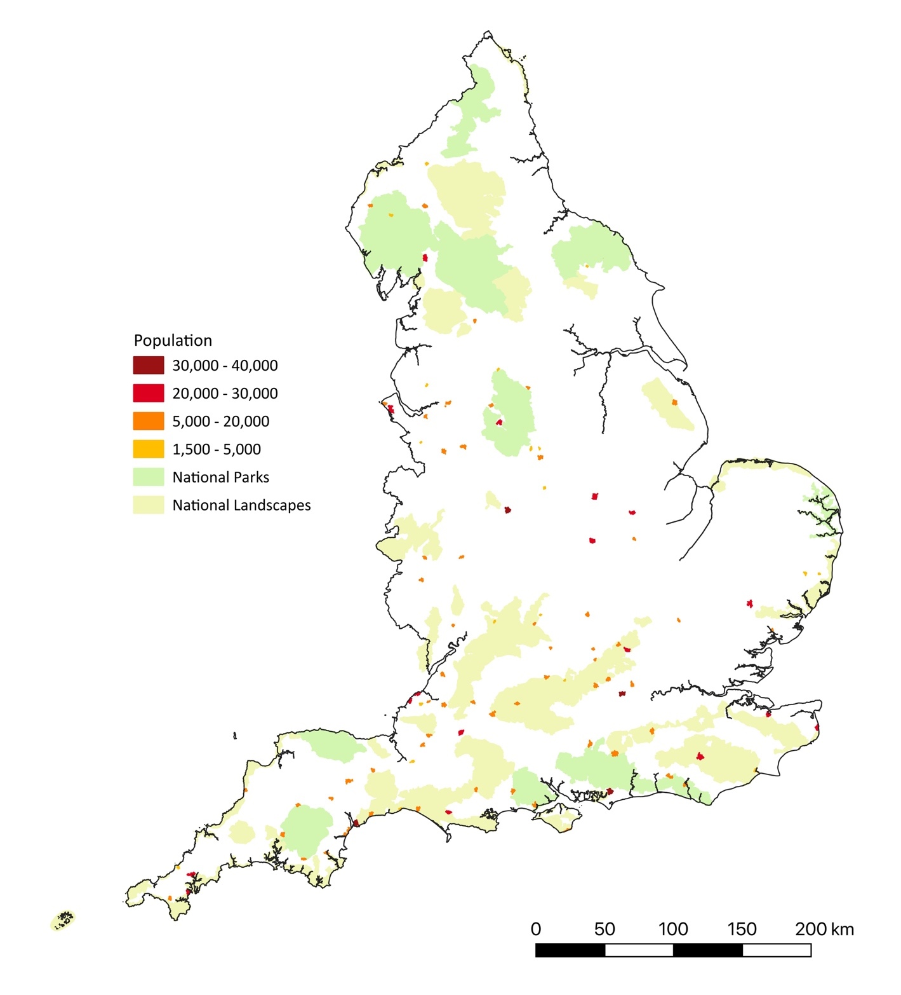

Table 10: Transition Groups in Small Towns, by Population 2021
Small Transition Towns |  | Population
 |  | 30,000-40,000 |  | 20,000 -29,999 |  | 10,000 -19,999 |  | 5,000 -9,999 |  | 1,500 -4,999 |  | Total
 | Number |  | 4 |  | 17 |  | 37 |  | 22 |  | 18 |  | 98
 | % of Small Towns |  | 11.1 |  | 20.0 |  | 20.2 |  | 7.6 |  | 3.8 |  | 4.9
Source: figures derived from The Transition Network (https://transitiongroups.org; last accessed 12/6/24).
While Figure 27 highlights the wide spread of transition groups in small towns within England, some geographical concentrations can be identified, including within and close to National parks and, particularly, National Landscape areas. This would support claims that there has been a strong aesthetic dimension to environmentalism in rural locations, with actions often being strongly associated with the promotion and protection of visually attractive landscapes (e..g. Batel et al., 2015; Muir et al., 2000; van der Horst, 2007)), although research has also highlighted how these are often intertwined with a complex series of other concerns (e.g. Holmes et al., 2022; Mason and Milbourne, 2014; Woods, 2003, 2005).

The impact of the Covd-19 Pandemic
While many of the challenges and changes discussed in this report can be seen to have long-standing roots, the Covid-19 global pandemic provided a major new challenge. An earlier study by Rural England (2022) highlighted some of the immediate impacts of the pandemic, and associated measures to respond to it, such as spatial lockdowns, particularly in relation to service provision. One of the objectives of this research was to consider whether the impacts of the pandemic had changed since when that earlier report was conducted, and it was certainly evident that many respondents recognised both a series of immediate and also longer-term impacts. Regarding the former, for example, as illustrated below, local government officials and representatives identified a series of negative impacts associated with the lockdown periods:
“during the pandemic … we saw a lot of people moving away from big cities and into more rural areas – house prices in the district increased exponentially, and the increase in population has put extra pressure on local services. The tendency to work from home: again, a trend that increased during the pandemic, … has impacted footfall and spend in the High Street … During the pandemic fewer people wanted to use the bus to get into the towns due to social distancing worries and since then we have seen a reduction in services … Government measures to prevent the spread of the virus may have led to the closure of businesses. Increased numbers of empty units have a detrimental effect on the appearance and atmosphere of the towns. Consumer confidence – perceived health risks reduced footfall in towns and at events in the towns. The impact of illness created temporary shortages in the workforce … The tendency to shop online increased and consequently we’ve seen reductions in footfall to physical stores. People working from home reduced footfall in the towns. The towns that relied heavily on tourism were not as resilient as the other towns; the tourism industry shut down during the pandemic and whilst we have seen signs of recovery the number of international visitors are unlikely to reach pre-pandemic levels until next year … The pandemic highlighted the uncertainty of job security in retail and hospitality and many businesses are still struggling to recruit. Smaller businesses were impacted to a greater extent than larger multinational stores particularly supermarkets which could continue to trade and were also able to continue the sale of comparison goods within their stores. Reduction in bus travel which affected those on lower incomes and the elderly” (Collective response from Council Officers, South East England);
“between 2015 and 2018 Ross-on-Wye saw a small reduction of 65 jobs (1.3% of the total). And more recently during the early part of the pandemic, between April and September 2020, experienced an increase in benefit claimants from 300 to 350 (17%)” (RoseRegeneration 2021b: 4);
“towns have seen a decline in footfall in high streets/main streets, which has been exacerbated by the Covid-19 Pandemic … The pandemic exacerbated a pre-existing trend of High Street and Main Street decline (largely attributed to reduced footfall and online shopping outcompeting the traditional retail offering) … Cornwall Council launched a 'Resident Impact Survey' in late May 2020, gathering responses from 500 residents, 65% of which were aged between 35-64 years old. From the responses, it was clear just under half of respondents (42%) felt their wellbeing had been adversely impacted by the pandemic whilst 45% were worried about the future. Furthermore, 25% of business owners had to close, compared to only 7% nationally” (County Council Policy Officer, Cornwall).
Several of the extracts quoted above make some references to longer-term impacts, and also to how the pandemic may have exacerbated some already existing processes viewed as having negative impacts on small towns, such as increasing use of online retailing, declining use of public transport and services, and counterurban population impacts. When discussing longer-term impacts, it was often argued that the acceleration in these processes observed during the pandemic may have slowed after it, but there had generally not been any reversal of these processes. Further arguments made were that the pandemic may have impacted the tourist and hospitality sectors particularly hard, and indeed may have instigated some new dynamics, including changes in visitor numbers and the reduction or closure of some visitor services:
“many small Cornish towns are heavily reliant on the hospitality industry and the visitor economy, both of which were badly disrupted by the social distancing and lockdown measures in response to the Covid-19 pandemic. The impact at the time was seen in analysis undertaken by Tortoise Media of consumer spending as a wider economic barometer during the pandemic. In the week 14 April 2020 during the national lockdown, a number of Cornish towns particularly tourist towns saw large falls in consumer spending in comparison to previous years … Penzance being a prime example, ranking 2 out of the 172 towns studied for highest impact. Newquay was also identified as the most exposed town in England and Wales to the impacts of the pandemic and lockdown by the Centre for Towns in 2020, due to its high combined employment in at-risk sectors such as accommodation and food. St. Ives, Penzance and Falmouth were also included in the top 20” (County Council Policy Officer, Cornwall);
“We have previously seen many overseas visitors to our towns, this has reduced since the pandemic, this is especially notable in towns such as Burford which relies heavily on tourism. … Due to a lack of funding, the visitor information centres in Witney, Burford and Chipping Norton were closed during the last few years. This has presented a challenge for our tourism team whose services are now online. It has been reported that many of the businesses in the town feel that a physical visitor information point is crucial for the tourists that visit. We are currently commissioning a report that will recommend how visitor information can be provided in the future and what this might look like” (Collective response from Council Officers, South East England).
“During Covid, it was very quiet, however, post-Covid there has been a large increase in tourists, which has put enormous pressure on infrastructure. There is now a lack of people to fill jobs, meaning that businesses are having to shut at least part of the week during the height of the season due to staffing issues” (Town Clerk, North West England).
A few respondents, whilst identifying problems emerging or being accelerated during the pandemic, also identified some more positive outcomes as well:
“Many businesses had to adapt in order to survive i.e. takeaway services and it should be noted that some businesses experienced rapid growth during this period … Increase in community spirit and ‘togetherness’ in some towns/ villages which is a positive element that we should attempt to harness through community events and engagement” (Collective response from Council Officers, South East England);
“Community support was exemplary in a town with a strong community spirit” (Town Council Clerk, South West England).
Moreover, in general, there appeared to be a view that whilst short-term impacts of the pandemic had been considerable, in many instances its longer-term impacts had been relatively minor or had largely taken the form of accentuating already significant processes:
“Reduced footfall, increased vacant premises and lower town centre spend. In the main, Shropshire's high streets have been reasonably quick to bounce back” (Economic Development Officer, West Midlands);
“during the pandemic … virtually all local facilities closed and [there was] a great deal of isolation. There are people suffering the long-term effects. However, post-Covid the local economy has bounced back, with more cafes opening than before, as an indicator. I don't really have any information about the hidden impacts on employment and income levels. But the facilities we run are generating more income” (Parish Council Manager, East Midlands);
“People are slowly returning to the High Street to shop but may not be spending as much. However, it is important to note that there are a few businesses in the towns, such as some art galleries and antique centres that have been unaffected by the squeeze on household budgets” (Collective response from Council Officers, South East England);
“Like everywhere else, the lockdowns impacted our towns and villages. Town centre footfall is still significantly lower than it was pre-covid. However, vacancy rates have actually improved, partly due to high level of independent retailers in the town. We did not see significant increases in unemployment or businesses going bust. Overall, the District has proved quite resilient. However, business confidence has clearly taken a hit” (Economic Development Officer, East Midlands).
There were also comments suggesting that subsequent events, such as rising interest rates and prices, were exerting stronger impacts than any legacies of the pandemic:
“Thanks to generous government grants, most businesses were not directly effected. In fact, in the immediate aftermath there was a flurry of investment in specialist shops and food and beverage offerings. However, increasing interest rates and spiralling inflation has resulted in the number of vacancies increasing again” (Economic Development Officer, South West England).
However, there were claims that the pandemic had exerted long term impacts on certain sectors of local economies and particular settlements types, related to differences in their economies and social structures:
“Many of our market towns were effected within the retail and hospitality sectors leaving a lot of them closed or unable to reopen post pandemic, some needed to diversify into online or deliverable services” (Economic Development Officer, East Midlands);
“The independent retail offer has weathered the effects of Covid and the cost-of-living crisis well to date, but there are now signs of a 'delayed reaction' impact, with an increase in the number of empty shops and the loss of some longstanding local businesses” (Economic Development Officer, undisclosed location);
“Saffron Walden is an affluent market town that has done well coming out of Covid. It offers a unique range of independent shops/cafes which appeals to an affluent demographic. Dunmow has fared slightly worse and has seen a drop in footfall. Stansted Mountiftchet relies on commuter spend with a prominent fast food shop economy so has struggled post-Covid with less people travelling into central London. It has started to recover. Thaxted is local shopping and tourism and has been largely unaffected” (Economic Development Office, Eastern England).
Overall, it is clear that the impacts of the Covid-19 pandemic on small towns have been multifaceted, differentiated both temporally and on the basis of the socio-economic character of small towns. Whilst many small towns experienced considerable short-term impacts, which included in some cases significant falls in retail footfall and visitor numbers, and a consequential closure of retail and hospitality businesses, the economy in many towns appears to have returned relatively quickly to close to its pre-Covid condition. In many cases this condition was a cause of concern, and, hence, a quite widespread perception is that the long-term impact of the pandemic has been to exacerbated pre-existing challenges to small-town economies, such as online retailing, declining use of public services, counterurban population movements and associated problems in housing markets. Whilst positive impacts were also identified, particularly in relation to community action, it was also evident that post-Covid recovery had become entangled with subsequent challenges related to rising interest rates and prices.

Conclusion and Policy Recommendations
This report has examined the socio-economic character of rural small towns in England, and the changes and challenges faced by people and businesses in these settlements, particularly in central areas that have historically been places dominated by the provision of goods and services to their populations and to residents in surrounding rural areas.
The report began by highlighting how academic studies and policy initiatives have highlighted changes in the socio-economic character of small towns and the use of their central areas as places of retailing and service provision. After discussing the definition of ‘small towns’ and delimiting these as built-up areas with populations of between 1,500 and 40,000 people, the report considered how these settlements fared in two recent central Government funding schemes, the Towns Fund and Future High Streets Fund. These government initiatives are not specifically focused on addressing the changes and challenges faced by small towns, and analysis indicates that of the 101 towns funded through the former scheme, only 19 would be classified as small towns in this study, and only 15 of this settlement group advanced in the second scheme through to becoming eligible for support. Across these two schemes, and others such as the Levelling Up Fund, the UK Shared Prosperity Fund, the Reopening High Street Safely Funda and the Welcome Back Fund, involvement by local governmental representatives associated with small towns appeared quite limited. It is shown that in the Towns Fund, this reflected in part quite explicit classificatory exclusions related to settlement population size, as well as prioritisations related to income, economic potential and Brexit impacts. The population thresholds employed in the Towns Funds effectively excluded 63% of the small towns identified within this study, and hence these settlements, and surrounding rural areas that might rely on their service provisions or the draw they may create for their visitor economies, were disadvantaged solely on the grounds of their population size.
As mentioned in this report, the House of Commons’ Public Accounts Committee criticised the selection rationales employed in the Towns Fund for being vague and employing quite sweeping assumptions. The analysis of the fund’s award decisions made within this report has suggested that these assumptions may have included a view that small towns in coastal and former coalfield locations had particularly significant socio-economic and development needs. These areas also figured strongly amongst the small towns selected for support through the Future High Streets Fund. However, even within these areas, the proportion of small towns receiving funding was small, particularly given these regions contain many settlements with areas of high deprivation scores, as well as often containing high proportions of residents aged 65 and over. However, whilst the small towns selected for awards under these schemes can indeed be seen to have significant levels of socio-economic need and developmental challenge, they were far from exceptional in this, both within and beyond coastal and former coalfield areas. These schemes, in effect, sought to elevate the needs of a relatively small number of small towns, excluding many more settlements from support even though they had similar, or indeed potentially higher, levels of need.
The report also highlighted concerns about the identification of social need within small towns, including the degree to which current indices of deprivation adequately represent the presence of marginalised and vulnerable populations living in areas that also contain quite affluent populations, as well as forms of deprivation linked to very particular dynamics, such as seasonality in employment and housing availability in areas dominated by visitor economies. As funding in schemes such as the Towns Fund is explicitly, and arguably also implicitly, connected to indices of deprivation, then a failure to adequately reflect the conditions experienced in many small towns potentially leads to underinvestment in these settlements, despite the presence of significant local needs.
Concerns were also expressed about general levels of funding available to local governments with responsibilities for small towns, as well as structural barriers that actors within these towns faced in accessing central government funding. The governmental authorities most directly connected to small towns are often town and parish councils, which often cannot apply directly for central government funding and are hence reliant on recognition and action by higher-tier authorities, which also have many other claims for their attention and action. This structural barrier limits the ability of local governmental actors to effectively address many of the needs they perceive as being of pressing importance within the towns they hold responsibilities for.
The report also addressed socio-economic changes and challenges experienced within English small towns. Analysis of the 2019 index of multiple deprivation lent support to claims that many small towns exhibited considerable levels of social inequality in the sense of having areas of both high and low levels of deprivation, while the 2021 Census highlighted differentiations between small towns in terms of their age-profiles and social-class composition. While small towns in the coastal and former coalfield areas often had high proportions of residents aged 65 and over, the dynamics that led to this are quite different, with the former often experiencing substantial retirement and pre-retirement in-migration, whilst the latter areas were subject to out-migration of young, working-age, people. Overall, there appears to have been a rise in the number of households living in England’s small towns, at the same time as the population of many of them has declined. This suggests that household size in small towns has been decreasing, a phenomenon that itself may be seen as being an outcome of an ageing population.
However, an ageing demographic is not characteristic of all small towns in England, and this report has suggested that many of these settlements in or close to National Landscape Areas in southern England have relatively high proportions of people under 20. This likely reflects the in-migration of households with young children or seeking to start a family, who are looking for locations with both high amenity value and good connectivity to London and other urban employment centres in the South East and Midlands, as well as to good schools for their children. Many of the householders living in small towns with high levels of connectivity and amenity value are clearly working in middle-class occupations, including within the producer-service sector, which is shown to have become significant in small towns beyond the South East of England, including northern settlements that experienced limited historical industrialisation. Many of these towns with strong connectivity and high proportions of middle-class residents figured as towns with areas with low levels of deprivation, although as discussed earlier, seeming affluent towns frequently also contained populations in considerable social and economic need. It was indeed noted that in-migration of relatively affluent populations could itself heighten deprivation through stimulating rising housing prices and reductions in both public service provision and localised employment. It was also striking that many small towns in the South East had much higher self-reported ‘non-White’ ethnic populations in the 2021 Census than was the case generally in small towns within England.
Variations in the social composition of small towns reflect changes in their economies. Small towns in England have historically served as hubs for agriculture, retailing and local services, but the significance of agriculture has diminished significantly, both in terms of employment (which on average lay at less than 3% of the overall working population of these towns) and in its occupation of central building and spaces, with many marketplaces and halls falling into disuse, and in many cases disrepair. Retailing and service provision has also been widely seen as under threat, as a consequence of competition from new outlets, including those online, in the former, and from rationalisation, centralisation and resource cuts in the latter case. In many small towns, these challenges have produced under-use or abandonment of physically prominent public buildings and spaces, as well as vacant premises within many small-town retail areas and shops sequentially occupied by a series of independent retailers who struggle to maintain viability. Attention is also drawn to the lack of retail and service provision in many new-build housing areas within and around small towns.
As this report outlines, central and local governments, along with businesses and third-sector groups, have sought in a variety of ways to retain retailing and service functions within central areas of towns, although there have also been calls to recognise and manage a transition of high street and other town centre spaces and buildings into locations that can be used for other activities. Many of the small town policy documents and commentaries examined in this study focus on the provision of support to retain, and if possible, expand retail provision within the centres of small towns, although there were many proposals to also diversify the economies of these settlements, particularly into visitor, creative, festival and green economies. Public buildings such as market and town halls, libraries, fire and police stations, hospitals and churches all figured prominently in these plans, a situation that stems in large part from declines in their use and limited investment in their maintenance and repair. The refurbishment and repurposing of these buildings in many cases requires levels of capital investment that local authorities and businesses struggle to mobilise, and also raise the prospects of retail gentrification and declining accessibility to public services for populations within, and around, these settlements.
The report examined the structure of retailing in English small towns and the impact of the Covid-19 pandemic on this sector of their economies. It is shown that the majority of retailing in small English rural towns is provided by businesses that lie towards the smaller and localised end of the retail spectrum, which is often characterised and valued as dominated by independent retailers. The report highlights that there may be considerable variation and turnover within small-town retailing, with the latter increasing as a short-term consequence of the Covid-19 pandemic, and associated spatial lock-downs. However, while many small towns experienced significant short-term impacts, it appears that in the majority of cases, their economies returned relatively quickly to at or close to their pre-Covid condition. Having said this, in many towns this condition was itself a cause of concern, and there is quite a widespread perception that the long-term impact of the pandemic has been to exacerbated pre-existing challenges to small-town economies, including increased use of online retailing, declining public transport and service provision, counterurban population movements and associated problems in housing markets. Whilst positive impacts were also identified, particularly in relation to community action, it was also clear that post-Covid recovery had become entangled with subsequent challenges related to rising interest rates, prices and concerns over governmental spending.
The report also explores policy and community responses to retail and public service provision in small towns. In many small towns, local governmental bodies have developed initiatives focused on improving the visual appearance of shops and the public realm in retail areas. This is generally done to support existing retailers and attract additional retail and other businesses to move into an area. Frequently, there is also interest in attracting businesses in the visitor, food and creative economies, with these seen as potentially able to generate new retail trade, as well as repurpose buildings and spaces vacated by retail businesses or public service providers. The extent to which aesthetically focused activities and visitor, food and creative economies can significantly mitigate the challenges facing high street retailing is, however, questionable, with small towns representatives and officers officials highlighting the need to conjoin the former with increased economic support and investment, as well as the presence of weaknesses in the current development of these ‘alternative’ town centre economies. It was also argued that the development of creative economies was conditioned, in part, by two different forms of counter-urban migration, with some locations being sought out by artists and others seeking a remote rural escape whilst other settlements are valued because they provide connectivity to urban cultural centres, alongside a rural amenity setting. This suggests that small towns and other rural locations which fall outside of these requirements may struggle to establish a creative economy.
It was also noted that many development plans produced for small towns make reference to environmental sustainability, climate change and, most widely, the development of a green economy. These plans often stressed renewing relations with historical features of small towns, such as the significance of agriculture and food production, and associated buildings like marketplaces and market halls, plus fostering growth in hi-tech green, biological and digital economies. With regard to these new areas of economic activity, there were frequent references to attracting businesses to relocate into small towns in order to make use of their high amenity value to employees and business owners, although plans also included references to retaining and harnessing the ‘greening ‘of existing businesses operating in the agri-food economies, plus the redevelopment of ‘brownfield sites’, including rural industrial estates.
While many discussions of climate and environmental change often focused on technological innovations, there were also frequent references to more practice or behavioural-focused transitions, particularly in relation to everyday transport use. Many small towns also contain environmental groups focused on transitions in everyday living. Examples of such a focus include the ‘Transition Towns’ movement, and this report highlights that close to a hundred small towns have one or more groups associated with the ‘Transition Network’. The presence of such groups within small towns may help foster environmental action, including ones related to practice/behaviour change, although many of these settlements lie close to amenity landscapes with high aesthetic value (e.g. National Parks and National Landscapes), and hence aestheticised environmentalism can be expected to figure prominently.
The final section of the report examined the short- and long- term economic impacts of the Covid-19 pandemic in small rural towns, particularly in relation to town centre retailing. While some small towns had experienced significant declines in tourist visitors and retail footfall, and resultant closures of some businesses, in many cases pandemic impacts had been short-term and many small-town economies bounced back to close to their pre-pandemic state, and the pre-existing challenges associated with these. The long-term impacts of the pandemic may, hence, have been to exacerbate existing processes of transformation, and clearly have also become entangled with subsequent events and pressures, including rising prices and restrictions on government spending and activity.
As the report began by discussing the policy context of this study of rural small towns and their central areas, it is useful to end by considering the implications of this research project. While it is clear that central government and many local authorities recognise that towns have experienced considerable short-term and longer-term changes and challenges, this study has highlighted that small towns are effectively often excluded from accessing central government support. One key aspect of this is the delimitation and categorisation of towns, with classifications employed by central government, such as ONS (2019), excluding almost 63% of the built-up areas defined in this study as small towns. Population thresholds used as the basis for settlement categorisations have clearly been of considerable financial significance in recent central government initiatives, and one implication of this research is that more attention needs to be given to the appropriateness and impacts of current thresholds, and also to variations in the conditions and challenges faced by settlements of different sizes. Currently, there is also often little explicit policy differentiation between types of towns, although this report has reinforced the arguments of the National Audit Office (2020) that award decisions in the Towns Fund may have drawn on implicit assumptions about the relative needs of certain types of towns. This report, for instance, highlights how awards in both the Towns Fund and Future High Streets Fund were heavily focused on small towns in coastal and former coalfield areas, as well as how few small towns were selected.
The report also highlighted concerns about a lack of direct access to central government funding by town and parish councils, and a consequential reliance on the recognition of the needs of small towns by higher levels of local government, which is often either not present or is marginalised by concerns related to other settlement needs within these authorities. Providing more direct routes by which local councils, businesses and community groups can access funding and support would likely foster the development of initiatives that are sensitive to local needs and capabilities, and hence produce actions that are more effective and engender greater participatory involvement.
Notwithstanding the potential for more effective delivery of central government support and funding to local agencies, it is also important to recognise widespread concern over the general level of central government funding to local authorities, and consequential reductions in public service provision and employment within small towns. Not only are the capabilities of local governments to act in small towns being reduced by financial restrictions, but these reductions are themselves having direct and significant adverse impacts on the economic and social conditions of small towns.
One area of impact highlighted in this study is the closure and/or lack of maintenance of public buildings, many of which are major physical and symbolic entities in the built environments of small towns. This report indicates that in many small towns, a range of public buildings have become dilapidated and/or ceased to be used, such that their future condition is a focus of concern and deliberation. The poor physical condition of these buildings often stemmed from insufficient investment in maintaining and repairing the buildings, but the costs of renovation and refurbishment, let alone repurposing and redevelopment, are often beyond the current financial capacity of local councils, although many had prepared plans and were seeking sources of finance from governmental, charitable and private development sources.
A continuing lack of investment in public buildings is likely to increase problems surrounding their physical condition, while cuts and spatial rationalisations in public service provisions are likely to induce further declines in their use within small towns. This means current problems over their maintenance and use will likely increase in the future, suggesting that a governmental policy response would be of value. Furthermore, the impacts of service closures within small towns need to be recognised, with concerns being expressed in many places about their impacts, particularly on vulnerable groups. The involvement of private developers and the repurposing of buildings away from public service provision, towards use as private housing or within creative, food, festival and visitor economies, raise issues of gentrification and displacement that also warrant policy recognition.
It is evident that many local authorities with responsibilities for small towns, view the creative, food, festival and visitor economies as central components of their future development, although this report highlights the current limited level of employment in the creative economy across English small towns, as well as potential geographical limitations in the counterurban migrational flows that have been seen to drive its development in rural areas. Rather more widespread opportunities may lie in the development of green economies and more environmentally sustainable living and housing, which figure as aspirations within many plans related to small towns. Many of these settlements also contain local environmental groups, and hence there are opportunities to develop forms of partnership working to address a range of environmental challenges, including nature regeneration, Net Zero and climate adaptation.

Appendix 1: Socio-Economic Indices for Small Towns, including Former Coalfield Areas

Proportion of Population in Built-Up Areas of between 1,500 and 40,000 residents employed in Routine and Semi-Routine Occupations, 2021
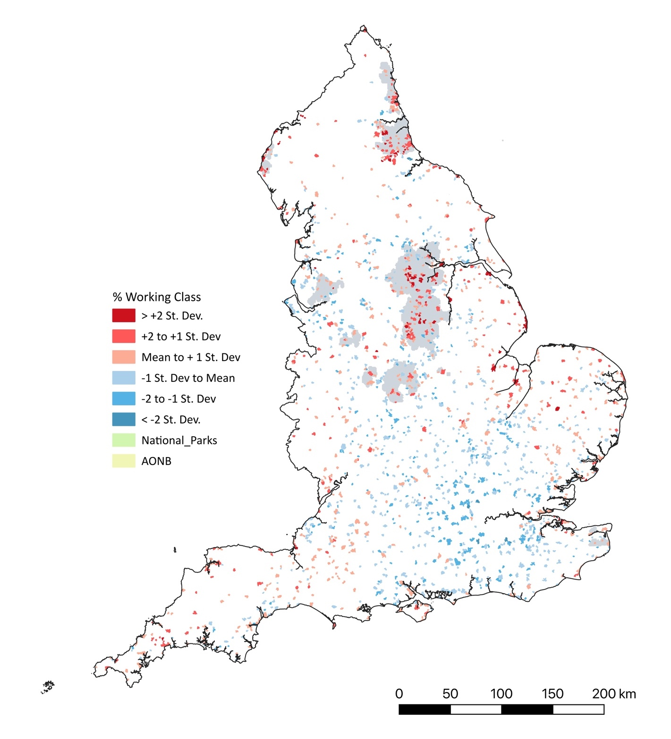

Proportion of Population in Built-Up Areas of between 1,500 and 40,000 residents employed in Routine and Semi-Routine Occupations, 2021
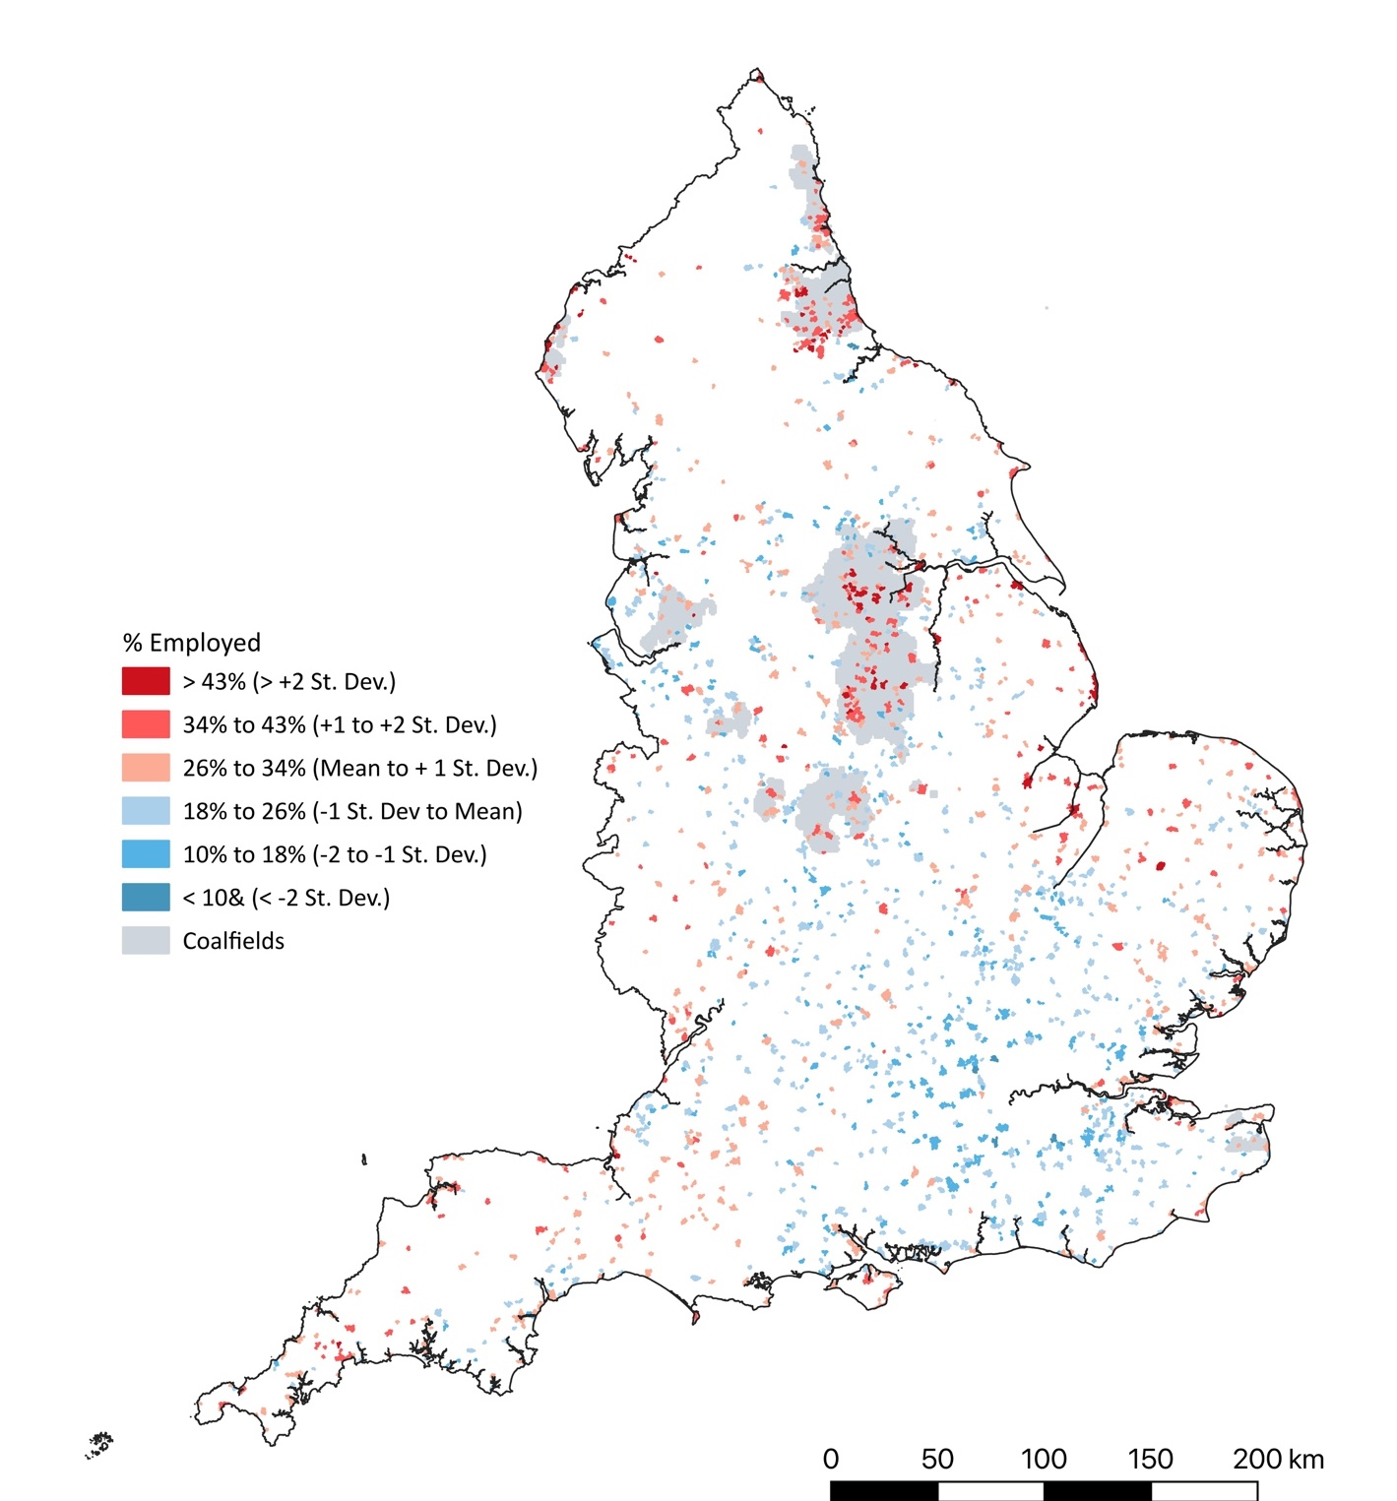

Proportion of Households Living in Rented Accommodation in Built-Up Areas of Between 1,500 and 40,000 Residents, 2021

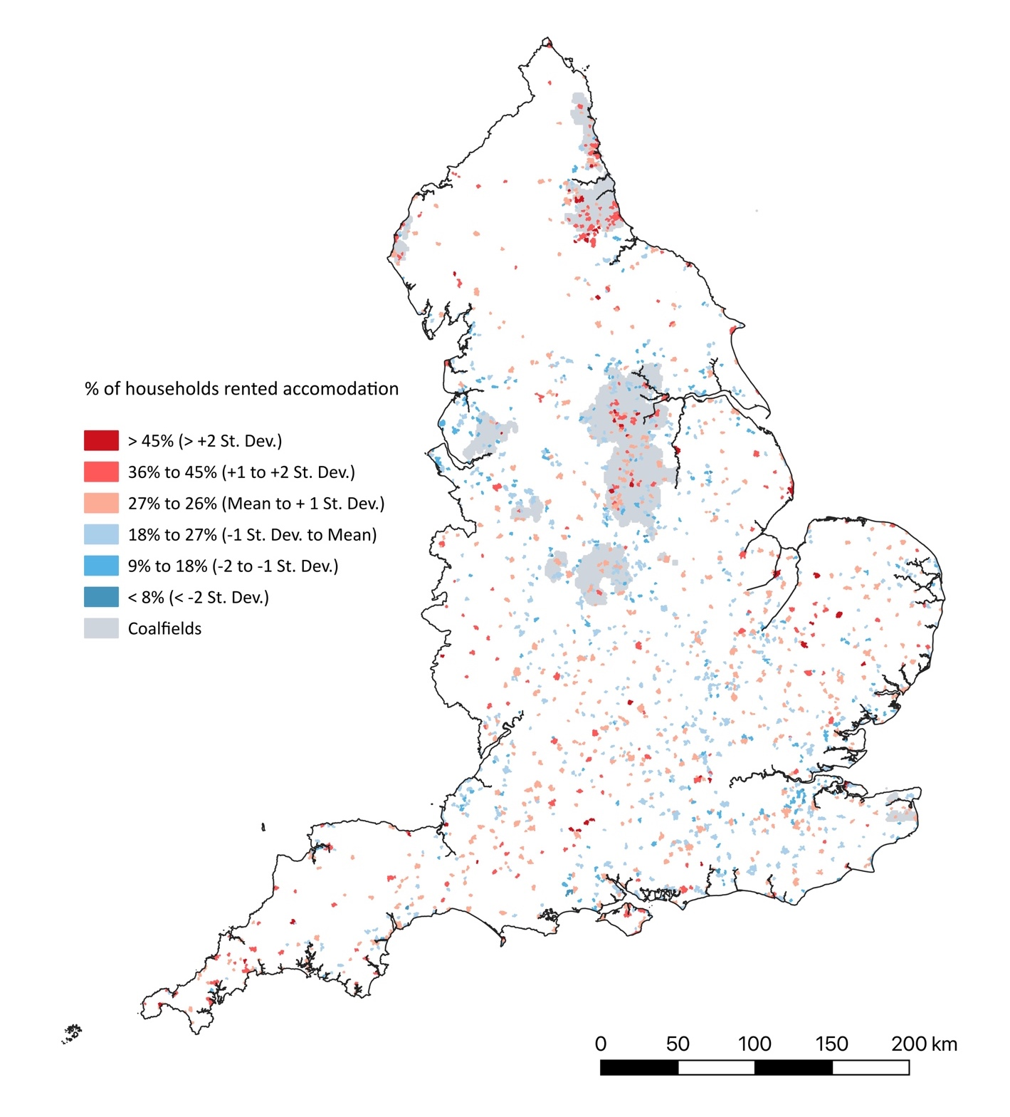

References
Addy R. (2014) Cider restructure threatens jobs as Heineken invests £58M Beverage Daily 4th April. Available at: https://www.beveragedaily.com/article/2014/04/04/heineken-s-58m-cider-restructure-to-hit-ledbury-jobs; last accessed 16/2/2024.
Association of Convenience Stores (2023) The Local Shop Report 2023 (Farnborough: Association of Convenience Stores).
Baker C. (2018) City and Town Classification of Constituencies & Local Authorities. House of Common Library Briefing Paper 8322 (London: Housing of Common Library).
Bański J. (2021) The functions and local linkages of small towns: a review of selected classifications and approaches to research. In Bański J. (eds.) The Routledge Handbook of Small Towns (Abingdon: Routledge) 7-19.
Bardsey Parish Council (2016) About Bardsey Cum Rigton. Available at: https://bardseyvillage.org.uk/about/village-history/; last accessed 3/1/2024.
BAS Consultancy (2020) Holsworthy Town Action Plan (London and Bristol: BAS Consultancy).
BBC (2022) Bishop Auckland: Jonathan Ruffer halts regeneration funding, BBC North East and Cumbria News, 15th March. Available at: https://www.bbc.co.uk/ news /uk-england-tees-60757998; last accessed 29/1/2024
Bell D. and Jayne M. (2010) The creative countryside: policy and practice in the UK rural cultural economy. Journal of Rural Studies 26: 209–218.
Batel, S., Devine-Wright, P., Wold, L., Egeland, H., Jacobsen, G. and Aas, O. (2015) The role of (de-) essentialisation within siting conflicts: an interdisciplinary approach. Journal of Environmental Psychology 44: 149-159.
BEIS (2021) Hospitality Strategy: Reopening, Recovery, Resilience (London: Department for Business, Energy and Industrial Strategy)
Beatty C. Fothergill S. & Gore T. (2019). The State of the Coalfields: Economic and Social Conditions in the Former Mining Communities of England Scotland and Wales (Sheffield: Centre for Regional Economic and Social Research Sheffield Hallam University).
Beatty C. Fothergill S. & Wilson I. (2008). England’s Seaside Towns: A ‘Benchmarking’ Study (London: HMSO).
Bentley D.and McCallum A. (2019). Rise and Fall: the Shift in Household Growth Rates since the 1990s (London: Civitas)
Boston Parish Council (2020) Boston Spa Neighbourhood Plan: Planning for a Successful Future 2012-2028 (Boston Spa: Boston Spa Parish Council).
Bridport Town Council (2019) Bridport Area Neighbourhood Plan Consultation Statement 2019 (Bridport: Bridport Town Council).
Bridport Town Council (2020) The Bridport Area Neighbourhood Plan 2020-2036 (Bridport: Bridport Town Council).
Bromley R.D.F. and Thomas C.J. (1995). Small town shopping centre decline: dependence and inconvenience for the disadvantaged. International Review of Retail Distribution and Consumer Research 5 433–456.
Bugel, S. (2022) ‘There is no safety net’: music festivals in UK raise ticket prices as costs soar, The Guardian, 21 October. Available at: https://www.theguardian.com/ music/2022/oct/21/music-festivals-uk-raise-ticket-prices-costs-soar; last accessed 28/2/2024.
Bunting T. and Mitchell C. (2001) Artists in rural locales: market access landscape appeal and economic exigency. The Canadian Geographer 45: 268–284.
Callington Town Council (2021) Callington and Kelly Bray Neighbourhood Development Plan (Callington: Callington Town Council).
Cloke P. Milbourne P. and Widdowfield R. (2000) Homelessness and rurality: ‘out-of-place’ in purified space? Environment and Planning D 18.: 715-735.
Coles B. (2014) Making the market place: a topography of Borough Market London. Cultural Geographies 21: 515-523.
Coles B and Crang P. (2011) Placing alternative consumption: commodity fetishism in Borough Fine Foods Market London. In: Lewis T and Potter E (eds) Ethical Consumption: a Critical Introduction (London: Routedge) 87–102.
Connected Coast (2020) Mablethorpe Investment Plan (Horncastle: Connected Coast and East Lindsey District Council).
Connors, P. (2010) Transition Towns and community capacity building. In: Kenny, S. and Clarke, M. (eds) Challenging Capacity Building: Comparative Perspectives (Basingstoke: Palgrave Macmillan) 229-247.
Courtney P. and Errington A. (2000) The role of small towns in the local economy and some implications of development policy. Local Economy 15: 280-301.
Courtney P. Mayfield L. Tranter R. Jones P. and Errington A. (2007) Small towns as ‘sub-poles’ in English rural development: investigating rural–urban linkages using sub-regional social accounting matrices. Geoforum 38: 1219–1232.
Cumberland Council (2024) Cleator Moor Innovation Quarter. Available at: https://www.copeland.gov.uk/cmiq; last accessed 16/2/2024.
Dargay J.M. and Clark S. (2012) The determinants of long distance travel in Great Britain. Transportation Research Part A 46: 576–587.
Day G. Rees G. and Murdoch J. (1989). Social change rural localities and the state: the restructuring of rural Wales. Journal of Rural Studies 5: 227-244.
Defra (2017a). The 2011 Rural-Urban Classification for Local Authority Districts in England (London: Government Statistical Services).
Defra (2017b) The 2011 Rural-Urban Classification for Output Areas in England (London: Government Statistical Services).
DETR/MAFF 2000: Our Countryside: the Future - A Fair Deal for Rural England. (London: HMSO).
DLUHC (2020) Reopening High Streets Safely Fund: Guidance (London: Department for Levelling Up, Housing and Communities)
DLUHC (2021a) Future High Streets Fund: successful and unsuccessful applications (London: Department for Levelling Up, Housing and Communities); Available at: https://www.gov.uk/government/publications/future-high-streets-fund-successful-and-unsuccessful-bids/future-high-streets-fund-successful-and-unsuccessful-applications; last accessed 28/2/2024.
DLUHC (2021b) Welcome Back Fund: Guidance (London: Department for Levelling Up, Housing and Communities).
DLUHC (2023) Our Long-Term Plan for Towns (London: Department for Levelling Up, Housing and Communities);
Distressed Town Centre Property Taskforce (2013) Beyond Retail: Redefining the Shape and Purpose of Town Centres. (London: Distressed Town Centre Property Taskforce).
Durham Country Council (2013) Newton Aycliffe Regeneration Masterplan (Durham: Durham County Council
ERS Consulting (2016) Leicestershire Market Town Research: Final Report (Bristol: ERS Consulting).
Fielding T. (1998). Counterurbanisation and social class. In P. Boyle and K. Halfacree (eds.) Migration into Rural Areas: Theories and Issues (Chichester: John Wiley & Sons) 31-60.
Findlay A.M. Stockdale A. Findlay A. and Short D. (2001) Mobility as a driver of change in rural Britain: an analysis of the links between migration commuting and travel to shop patterns. International Journal of Population Geography 7: 1-15.
Florida R. Rodrigues-Pose A. and Storper M. (2021) Cities in a post-COVID world. Urban Studies OnlineFirst 1-23.
Furey S. Strugnell C. and McIlveen H. (2001) An investigation of the potential existence of “food deserts” in rural and urban areas of Northern Ireland. Agriculture and Human Values 18: 447–457.
Gibson, C., Waitt, G., Walmsley, J. and Connell, J. (2010) Cultural festivals and economic development in nonmetropolitan Australia. Journal of Planning Education and Research 29: 280–293
Gonzalez S. (2019) (ed.) Contested Markets Contested Cities: Gentrification and Urban Justice in Retail Spaces (London: Routledge).
Gonzalez S. (2020) Contested marketplaces: Retail spaces at the global urban margins. Progress in Human Geography 44: 877–897.
Gonzalez S. and Dawson G. (2015) Traditional markets under threat: why it’s happening and what traders and customers can do. Available at: http://tradmarketre search.weebly.com/uploads/4/5/6/7/45677825/tradi tional_markets_under_threat-_full.pdf; last accessed 16/2/2024.
Gonzalez S. and Waley P. (2013) Traditional retail markets: the new gentrification frontier? Antipode 45: 965-983.
Grimwood G.G. Clark A. Hutton G. Sandford M. and Ward M. (2021) Town Centre Regeneration: Research Briefing (London: House of Common Library).
Guy C.M. (1990) Out-shopping from small towns International Journal of Retail and Distribution Management 18: 3-13.
Hanley N. and Nevin C. (1999) Appraising renewable energy developments in remote communities: the case of the North Assynt Estate Scotland. Energy Policy 27 (9) 527–547.
Hardisty Jones Associates (2022) Urban Renewal in Devon Towns: Bideford Regeneration Strategy. Report for Bideford Regeneration Board (Bristol and Cardiff: Hardisty Jones Associates)
Healey M. and Ilbery B. (eds.). (1985). The Industrialisation of the Countryside (Norwich: GeoBooks).
Hendersen S. (2005) Tension strains and patterns of concentration in England’s city-regions. In Hoggart K. (ed.) The City’s Hinterland: Dynamism and Divergence in Europe’s Peri-Urban Territories (Aldershot: Ashgate) 119-153.
High Streets Expert Panel (2018) The High Street Report. (London: Ministry of Housing Communities & Local Government). Available at: https://assets.publishing.service.gov.uk/media/5c1a7322e5274a4685bfbb28/The_High_Street_Report.pdf; last accessed 21/2/2024.
Hincks S. Kingston R. Webb B. and Wong C. (2018) A new geodemographic classification of commuting flows for England and Wales International Journal of Geographical Information Science 32:4 663-684
Hoggart K. (1997) The middle classes in rural England 1971-1991. Journal of Rural Studies 13(3) 253-273.
Holmes, G., Clemoes, J., Marriot, K. and Wynne-Jones, S. (2022) The politics of the rural and relational values: contested discourses of rural change and landscape futures in West Wales. Geoforum 133: 153-164
Hopkins, R. (2008) The Transition Handbook: From Oil Dependency to Local Resilience. (Totnes:Green Books)
House of Commons Public Accounts Committee (2020) Selecting towns for the Towns Fund: Twenty-Fourth Report of Session 2019–21. HC 651. (London: House of Commons).
HM Treasury (2018) Our Plan for the High Street (London: HM Treasury) Available at: https://assets.publishing.service.gov.uk/media/5bd6eb7140f0b604c46becc2/HighStreets_web.pdf; last accessed 20/2/24.
Hubbard P. (2017a) The Battle for the High Street: Retail Gentrification Class and Disgust (London: Palgave Macmillan).
Hunter I. (2006) A Cultural Strategy for Rural England: Investing in Rural Community Creativity and Cultural Capital. (Ambleside: Littoral Arts Trust)
Keeble D.and Tyler P. (1995) Enterprising behaviour and the urban-rural shift. Urban Studies 32: 975-997.
Kirwan J. (2004) Alternative strategies in the UK agro‐food system: interrogating the alterity of farmers' markets. Sociologia Ruralis 44: 395-415.
Knutsford Town Plan Steering Group (2010) Knutsford Town Plan (Knutsford: Knutsford Town Council).
Launceston Town Council and Cornwall Council (2020) Launceston Southern Growth Area Concept Plan Document (Truro: Launceston Town Council and Cornwall Council).
Lewis G. (1998) Rural migration and demographic change. In B. Ilbery (ed.) The Geography of Rural Change (Harlow: Longman) 131-160.
Lincolnshire County Council North Kesteven Council and Homes and Communities Agency (2011) Sleaford Master Plan (London: Gillespies)
Lumpkin J.R. Hawes J.M. and Darden W.R. (1986) Shopping patterns of the rural consumer: exploring the relationship between shopping orientations and outshopping. Journal of Business Research 14: 63-81.
Mahon, M. and Hyyryläinen, T. (2019) Rural arts festivals as contributors to rural development and resilience. Sociologia Ruralis 59: 612-635.
Mason, K. and Milbourne, P. (2014) Constructing a ‘landscape justice’ for windfarm development: The case of Nant Y Moch, Wales. Geoforum 53: 104–115
May J. Williams A. Cloke P. and Cherry L. (2020). Still bleeding: the variegated geographies of austerity and food banking in rural England and Wales Journal of Rural Studies 79: 409-424.
Marjanen H. (2000) Retailing in rural Finland and the challenge of nearby cities International Journal of Retail & Distribution Management 28: 194-206.
Milbourne P. (2014) Poverty place and rurality: material and sociocultural disconnections Environment and Planning A 46: 566–80.
McQuaid R.W. (2003) The changing nature of work and transport. In: Hine J. and Preston J. (eds.) Integrated Futures and Transport Choices (Aldershot: Ashgate Publishing) 55–67.
Ministry of Housing Communities and Local Government (2018) Future High Street Fund: Call for Proposals. Available at: https://assets.publishing.service.gov.uk/ media/5c7e5ec4e5274a3f8d20d754/Future_High_Streets_Fund_prospectus. pdf. Last accessed: 20/2/24.
Ministry of Housing Communities and Local Government (2019) Towns Fund Prospectus. Available at: https://assets.publishing.service.gov.uk/media/ 5f7c5814e90e070dea12efa9/20191031_Towns_Fund_prospectus.pdf
Ministry of Housing Communities and Local Government (2021) Policy Paper: Build Back Better High Streets. Available at: https://www.gov.uk/government/publications/build-back-better-high-streets. Last accessed: Last accessed: 20/2/24.
National Association of British Markets (2022) National Markets Survey 2022 (Oswestry: National Association of British Markets)
National Audit Office (2020) Review of the Town Deals Selection Process, HS 576 (London: House of Commons).
National Mission for Markets (2018) Mission for Markets: Survey Results (Barnsley and Oswstry: National Markey Traders Association and National Association of British Markets)
North Devon Council and Torridge District Council (2022) Flourishing Culture: the Northern Devon Culture Strategy 2022-2027 (Pitsea: Things Made Public CIC).
ONS (2019) Understanding Towns in England and Wales: An Introduction (Newport: Office for National Statistics).
ONS (2022) Families and households in the UK: 2022. (Newport: Office for National Statistics).
Osborne H. and Butler S. (2019) Death of the high street: how it feels to lose your job when a big chain closes. The Guardian 6 March. Available at: https://www.theguardian.com/business/2019/mar/06/death-of-the-high-street-how-it-feels-to-lose-your-job-when-a-big-chain-closes; last accessed 20/2/2024.
O'Sullivan, D. and Jackson, M.J. (2002) Festival tourism: a contributor to sustainable local economic development? Journal of Sustainable Tourism 10: 325-334.
Pannal and Burn Bridge Parish Council (2022) Pannal and Burn Bridge Neighbourhood Development Plan 2021-2035 (Pannal: Pannal and Burn Bridge Parish Council)
Pendle Borough Council (2023) Pendle Retail and Leisure Capacity Study: Final Report (Nelson: Borough Council and Nathaniel Lichfields and Partners Ltd.).
Phillips M. (2019) Challenges and Policies to Support Rural Environmental and Energy Transitions. Background Paper at OECD and European Commission (DG REGIO) Workshop on Managing Environmental and Energy Transitions in Cities and Regions (Paris: OECD)
Phillips M. and Dickie J. (2019) Post carbon ruralities. In Scott M. Gallent N. and Gkartzios M. (eds.) Routledge Companion to Rural Planning (London: Routledge) 521-547.
Phillips M. and Swaffin-Smith C. (2004). Market towns - victims of market forces? International Journal of Retail and Distributional Management 32(11): 557-568.
Powe N. (2018) Non-amenity business growth and small town revival. Journal of Rural Studies 62: 125–133
Powe N. and Hart T. (2007) Market town characteristics. In Powe N. Hart T. and Shaw T. (eds.) Market Towns: Roles Challenges and Prospects (Abingdon: Routledge) 11-42.
Powe N. and Hart T. (2008) Market towns: understanding and maintaining functionality. The Town Planning Review 79: 347-370.
Powe N. and Shaw T. (2004) Exploring the current and future role of market towns in servicing their hinterlands: a case study of Alnwick in the North East of England. Journal of Rural Studies 20: 405-418.
Pragmatix Advisory (2021) Cultivating Rural Growth: Recognising and Addressing the Post-Pandemic Rural Productivity Challenge (Craven Arms: Rural Services Network).
RoseRegeneration (2021a) Bromyard Investment Plan 202 1 (Lincoln: RoseRegeneration).
RoseRegeneration (2021b) Kington Economic Investment Plan 202 1 (Lincoln: RoseRegeneration).
RoseRegeneration (2021b) Ross-on-Wye Investment Plan 2021 (Lincoln: RoseRegeneration).
RoseRegeneration (2022a) Ledbury Investment Plan 2021 (Lincoln: RoseRegeneration).
RoseRegeneration (2022b) Leominster Town Economic Investment Plan (Lincoln: RoseRegeneration).
Rural England (2022) State of Rural Services 2021: the Impact of the Pandemic (Rural England)
Rural Services Network (2021a) A Rural Perspective on Government’s Place-Based Funds Covering the Towns Fund, Levelling Up Fund, Community Renewal Fund and Shared Prosperity Fund (Craven Arms: Rural Services Network).
Rural Services Network (2021b) Rural Lens Review: Build back Better High Streets (Craven Arms: Rural Services Network)
Secretary of State for Business Energy & Industrial Strategy (2021) Hospitality Strategy: Reopening Recovery Resilience (London: Department for Business Energy and Industrial Strategy)
Secretary of State for Levelling Up Housing and Communities (2022) Levelling Up the United Kingdom (London: HM Government)
SERRL (South East Regional Research Laboratory) (2004) The role of rural settlements as service centres CRN 84 (Cheltenham: Countryside Agency).
Seyfang G. (2007) Growing sustainable consumption communities: the case of local organic food networks International Journal of Sociology and Social Policy 27: 120-134.
Shepherd J. (2009) A Typology of the Smaller Rural Towns of England (London: Rural Evidence Research Centre Birkbeck Collage)
Shropshire Council (2021a) Bridgnorth Market Town Profile (Shrewsbury: Shropshire Council).
Shropshire Council (2021b) Cleobury Mortimer Market Town Profile (Shrewsbury: Shropshire Council).
Shropshire Council (2021c) The Cultural Sector in Shropshire: Key Metrics (Shrewsbury: Shropshire Council).
Shropshire Council (2022a) Albrighton: Village Centre Audit Analysis 2022 (Shrewsbury: Shropshire Council).
Shropshire Council (2022b) Bishop’s Castle: Town Centre Audit Analysis 2022 Profile (Shrewsbury: Shropshire Council).
Shucksmith M. Glass J. Chapman P. and Atterton J. (2022) Rural Poverty Today: Experiences of Social Exclusion in Rural Britain (Bristol: Policy Press)
Smith D. Phillips M. Kinton C. 2018. Wilderness gentrification. In Lees L. & Phillips M. (eds.) Handbook of Gentrification Studies (Cheltenham: Edward Elgar) 363–387.
Smith D. Phillips M. Kinton C. & Culora A. (2019). Rural population geographies in a changing differentiated countryside. In Scott M. Gallent N. and Gkartzios M. (eds.) Routledge Companion to Rural Planning (London: Routledge) 239-260.
Smith I. (2017). Demographic change in European towns 2001–11: a cross-national multi-level analysis. Tijdschrift voor Economische en Sociale Geografie 108: 424–437.
Stevenson R. and Richardson T. (2003) Policy integration for sustainable development: exploring barriers to renewable energy development in post devolution Wales Journal of Environmental Policy and Planning 5: 95-118.
Stockdale A. (2010) The (UK) Retirement Transition and Rural Areas. In Winchell D.G. Koster R. Ransey D. and Robinson G. (eds.) Geographical Perspectives on Sustainable Rural Change (Manitoba: Bandon University (Rural Development Institute) 243-262.
Talen E. (2020) The future of Main Street: Built Environment 48: 30-47.
Taylor P.J. Evans D.M. Hoyler M. Deruuder B. and Pain K. (2009) ‘The UK space economy as practised by advanced producer service Firms: identifying two distinctive polycentric city-regional processes in contemporary Britain. International Journal of Urban and Regional Research 33 (3) 700-718.
Thomas C.J. and Bromley R.D. (2003) Retail revitalization and small town centres: the contribution of shopping linkage. Applied Geography 23: 47–71.
Thurrock District Council (2018) Thurrock Town and Local Centre Health Check Assessment 2018 (Grays: Thurrock District Council)
Townsend L. Wallace C. Fairhurst G. and Anderson A. (2017) Broadband and the creative industries in rural Scotland. Journal of Rural Studies (54) 451-458.
van der Horst, D. (2007) NIMBY or not? Exploring the relevance of location and the politics of voiced opinions in renewable energy siting controversies. Energy Policy 35: 2705–2714.
Watson S. and Wells K. (2005) Spaces of nostalgia: the hollowing out of a London market Social and Cultural Geography 6: 17-3.
Whitby Town Deal Board (2020) Whitby Town Deal: Town Investment Plan 2020 (Whitby: Whitby Town Deal Board).
Woods, M. (2003) Conflicting visions of the rural windfarm development in Mid Wales. Sociologia Ruralis 43, 271–288.
Woods, M. (2006) Redefining the ‘rural question’: the new ‘politics of the rural’and social policy. Social Policy and Administration 40: 579-59
Wychavon District Council (2022a) Droitwich Spa Town Centre: Investment Prospectus (London: CBRE).
Wychavon District Council (2022b) Evesham Town Centre: Investment Prospectus (London: CBRE).
Wychavon District Council (2022c) Pershore Town Centre: Investment Prospectus (London: CBRE).

Notes

The 2011 Rural Urban Classification was employed because, as yet, there has been no subsequent classification produced from the 2021 Census.
‘Rural hamlets and isolated dwellings’ appeared in the IMD analysis because this was based on LLSOAs that lay with or across the boundaries of the built-up areas used to delimit small towns. In the Census based analysis usw was made of the smaller spatial unit of output areas, which more closely connect to the boundaries of built-up areas. As a result, no areas classified as ‘Rural hamlets and isolated dwellings’ appeared in those analysis, whilst some did figure within the LLSOAs used for the IMD analysis.
The missing group is ‘Large regional retail and leisure destinations’, which are likely to be located in large urban centres.

